The properties of alcohols
This investigation is part of the Nuffield practical collection, developed by the Nuffield Foundation and the Royal Society of Chemistry. Delve into a wide range of chemical concepts and processes with this collection of over 200 step-by-step practicals: rsc.li/43bjGql

Learning objectives
- Make and record experimental observations.
- Use your results to explain the properties of the alcohols.
- Understand that members of the same homologous series behave in a similar way.

Introduction
In this lesson, ethanol and propan-1-ol are tested for:
- pH
- reaction with sodium
- combustion
- oxidation with acidified dichromate(VI) solution.

Teaching notes
Both alcohols are fully miscible with water. This is because the $-OH$ groups hydrogen bond with the water. Higher alcohols are less soluble since the hydrocarbon chain starts to break an appreciable number of hydrogen bonds in water.
The pH of both alcohols will show as neutral. Note that, if indicator solution is used instead of paper, ethanol at least will give an acid colour. This is because ethanol is the solvent used to prepare the indicator solution, and diluting the dyes puts the mixture out of balance. The $RO^{-}$ anion is very unstable in aqueous solution, so virtually none of the reaction $ROH + H_{2}O ↔ RO^{-} + H_{3}O^{+}$ occurs.
Both alcohols will burn with a fairly clean, blue flame.
$$C_{2}H_{5}OH + 3O_{2} → 2CO_{2} + 3H_{2}O \\ C_{3}H_{7}OH + 4½O_{2} → 3CO_{2} + 4H_{2}O$$
Both alcohols will fizz with sodium to form hydrogen.
$$C_{2}H_{5}OH + Na → C_{2}H_{5}ONa (sodium ethoxide) + ½H_{2} \\ C_{3}H_{7}OH + Na → C_{3}H_{7}ONa (sodium propoxide) + ½H_{2}$$
Both alcohols are oxidised to aldehydes, which have a sour but fruity smell.
$$C_{2}H_{5}OH + [O] → CH_{3}CHO (ethanal) + H_{2}O \\ C_{3}H_{7}OH + [O] → CH_{3}CH_{2}CHO (propanal) + H_{2}O$$
These experiments show that alcohols react similarly in all these reactions. They make clear the concept of functional group in organic chemistry. The $-OH$ functional group behaves in the same way whether it is attached to $C_{2}H_{5}$ or $C_{3}H_{7}$. Further oxidation turns primary alcohols into acids, while secondary alcohols are only oxidised to ketones under these conditions. However, tertiary alcohols are not oxidised under these conditions but can be oxidised by stronger oxidising agents, resulting in the $C-C$ bond breaking.

Scaffolding
Integrated instructions are provided in the lesson slides (rsc.li/3UaInmj) as an alternative to the full written method, designed to reduce cognitive load, read more at rsc.li/47bIKi5.
There is also a challenge question in the lesson slides for learners who would like to extend the learning further.

Technician notes
Read our standard health and safety guidance (rsc.li/3zyJLkx) and carry out a risk assessment before running any live practical.

Equipment (per group)

Apparatus

- Test tubes x 2
- Boiling tubes x 2
- Test tubes/boiling tubes rack
- Beakers (100 cm³) x 2 (see note 1)
- Can lid (see note 2)
- Wooden splints, matches or gas lighter
- Heat-resistant mat
- Bunsen burner
- Boiling tube holder
- Dropping pipette (for water)
- Universal indicator paper (full range, pH 1–14)
- Forceps for sodium
- Filter paper for sodium
- White tile
- Spotting tile
- Spill tray (optional)

Chemicals (refer to Preparation for safety information)
- Ethanol (or Industrial denatured alcohol, IDA), 15 cm³
- Propan-1-ol, 15 cm³
- Acidified potassium dichromate(VI) solution, 0.1 mol/dm³ in 1.4 mol/dm³ sulfuric acid, 3 cm³
- Sodium, 2 small pieces in oil (about 2 x 2 x 2 mm) (see Safety and hazards)
- Access to distilled water bottles

Safety equipment
- Eye protection: splash-proof goggles to EN166 3 or (EN) ISO 16321 3 as per CLEAPSS guide GL061.
- Container filled with tap water (e.g. washing-up bowl) to place the spotting tiles after use.

Equipment notes
- The beakers must be dry.
- Use a magnet to check your can lid is made from steel. Wash the can thoroughly to remove any food residues or oils. Using a Bunsen burner and in in a fume cupboard, burn off any paper or plastic coating on the can (this might generate a lot of smoke) and leave to cool down. The can is now ready to use. Tin lids tend to rust if left to air dry from wet, so after cleaning ensure they are dried with a tissue or cloth.

Safety and hazards
- It is important that all containers of flammable substances are kept stoppered and away from naked flames. Consider using a gas lighter instead of a Bunsen burner to light the alcohol in step 2 of the experiment. In case this is not possible, try reducing the number of Bunsen burners by having clear designated areas for learners to light a splint away from flammable substances. Alternatively, individual stations for different steps of this practical can be set up around the laboratory.
- Learners must be supervised in the use of sodium.

Preparation
Chemical supplied for the practical | Preparation
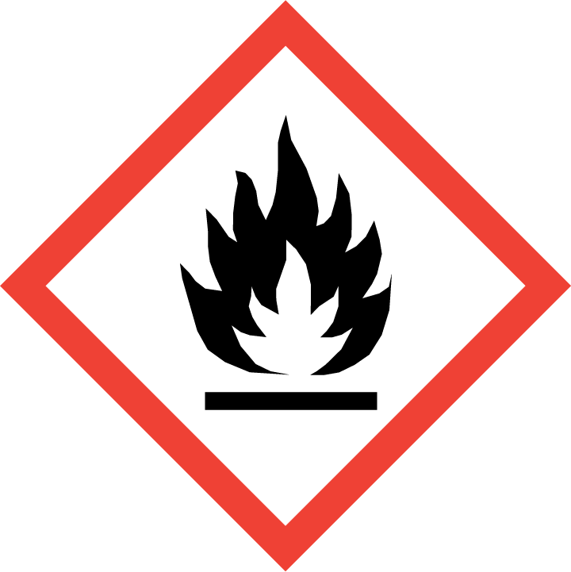  Industrial denatured alcohol (IDA)  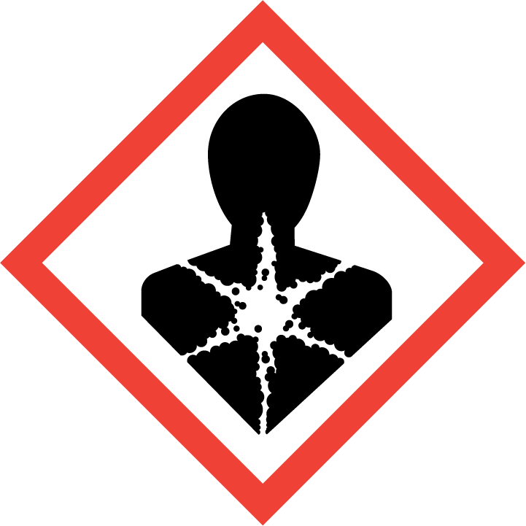    DANGER: Highly flammable. Harmful by ingestion. May cause damage to organs.  Or  Ethanol, $C_{2}H_{6}O(l)$  DANGER: Highly flammable.  Refer to CLEAPSS Hazcard HC040a, SSERC or contact your local safety advisory body. | N/A
Propan-1-ol, $C_{3}H_{8}O$(l)  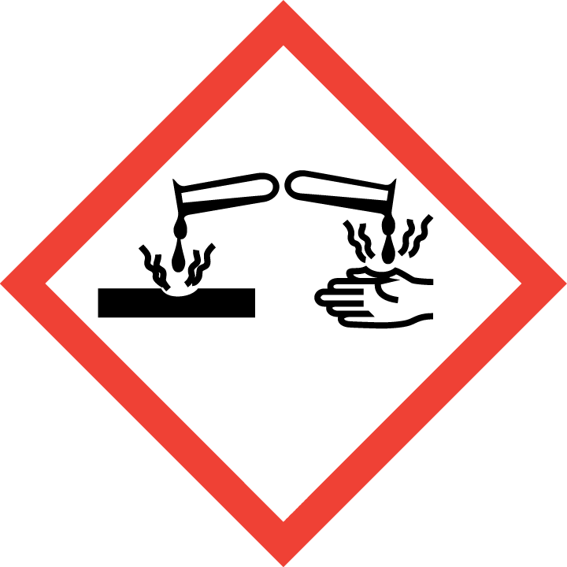  DANGER: Highly flammable liquid and vapour. Causes serious eye damage. May cause drowsiness or dizziness.  Refer to CLEAPSS Hazcard HC084a, SSERC or contact your local safety advisory body. | N/A
Acidified potassium dichromate (VI) 0.1 mol/dm³ in 1.4 mol/dm³ sulfuric acid, $K_{2}{Cr}_{2}O_{7}(aq)$in $H_{2}SO_{4}(aq)$    DANGER: Corrosive (skin, eyes). Harmful (ingestion). Irritant (respiratory). Sensitiser (skin, respiratory). Serious Health Hazard (RE). Serious Health Hazard (CMR).  Refer to CLEAPSS Hazcard HC078c and HC098a, SSERC or contact your local safety advisory body. | Potassium dichromate (VI)(s), $K_{2}{Cr}_{2}O_{7}7(s)$  MW = 294.19 g/mol  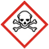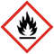  DANGER: May intensify fire; oxidiser. Toxic if swallowed. Harmful in contact with skin. Causes severe skin burns and eye damage. May cause an allergic skin reaction. Fatal if inhaled. May cause allergy or asthma symptoms or breathing difficulties if inhaled. May cause genetic defects. May cause cancer. May damage fertility. May damage the unborn child. Causes damage to organs through prolonged or repeated exposure. Very toxic to aquatic life with long lasting effects.  Sulfuric acid, 2.0 mol/dm³ , $H_{2}SO_{4}(aq)$  DANGER: Corrosive (skin, eye)  To prepare 100 cm³ of 1.4 mol/dm³ sulfuric acid by dilution* of a 2.0 mol/dm³ solution:  - Wear splash-proof goggles.  - Measure 70 cm³ of 2.0 mol/dm³ acid and make up to 100 cm³ with distilled/deionised water.  Refer to CLEAPSS recipe sheet RB098, refer to SSERC or contact your local safety advisory body.  To prepare 100 cm³ of acidified potassium dichromate(VI) solution:  - Wear splash-proof goggles.  - Dissolve 2.94 g of potassium dichromate(VI) in 60 cm³ of 1.4 mol/dm³ sulfuric acid.  - Make up to 100 cm³ with more 1.4 mol/dm³ sulfuric acid.  - Store in a labelled container with appropriate hazard warnings.  Refer to CLEAPSS recipe sheet RB070, refer to SSERC or contact your local safety advisory body.
Sodium metal, $Na(s)$  DANGER: Reacts violently with water. In contact with water releases flammable gases which may ignite spontaneously. Causes severe skin  burns and eye damage.  Refer to CLEAPSS Hazcard HC088, SSERC or contact your local safety advisory body. | Prepare the small pieces of sodium in advance of the lesson. Using forceps, remove a large piece of sodium from the oil, and place on a tile. Ensure that conditions are dry. Using a scalpel or sharp knife, cut some of the sodium into a few small pieces no larger than 2 x 2 x 2 mm. Place these small pieces in a separate bottle of oil. Return the larger piece to its bottle.

*The formula and explanation for dilution are as follows:

Formula: C1 x V1 = C2 x V2

Explanation:

C1 is the initial concentration of the solution (in mol dm⁻³) before dilution.

V1 is the volume of the initial solution that we need to measure (in dm³).

C2 is the desired final concentration of the solution after dilution (in mol dm⁻³).

V2 is the final volume of the diluted solution (in dm³).

Calculate V1 by rearranging the formula: V1 = (C2 x V2)/C1

Dilute the solution:

Using adequate equipment, measure the volume (V1) of solution of initial concentration and add solvent to achieve the desired final volume (V2).

Reminder: 1 dm³ is equivalent to 1000 cm³ and to 1 litre.

Tip: you can make your calculation using the volume V2 in cm³ and the unit for V1 will be cm³.

Disposal
- Dispose of any small pieces of unused sodium by dissolving them in propan-2-ol until all trace has disappeared and the fizzing has stopped. Dilute the propan-2-ol with water to a concentration below 5% v/v then pour down a foul-water drain with further dilution.
- Dilute the ethanol or IDA and the propan-1-ol with water to a concentration below 5% v/v then pour down a foul-water drain with further dilution.
- Rinse the tin lids with water and leave to dry before re-using.
- The washings from the spotting tiles can be flushed away down a foul-water drain with plenty of water. Clean the spotting tiles as usual.

Method
The method also appears in the lesson slides (rsc.li/3UaInmj), alongside integrated instructions.

Carry out each of these tests firstly with ethanol and then propan-1-ol:
- Place a few drops of the alcohol in a test-tube and add an equal number of drops of water. Do the liquids mix fully?
- Place a drop of the alcohol on a piece of full-range indicator paper. Note the pH.
- Place a few drops of alcohol on a tin lid on a heat-resistant mat. Make sure that all the bottles of alcohols are closed and kept far away from the tin lid. Ignite the alcohol with a lit splint and observe the flame.
- Using forceps, take two small pieces of sodium and place them on a piece of filter paper. Dab the pieces of sodium with the filter paper to remove any excess oil.
- Place about 0.5 cm depth of each of the alcohols in a separate, dry, 100 cm³ beaker. To each, add a small piece of sodium (using forceps) and observe the reaction.
- Place 3 drops of acidified potassium dichromate(VI) solution into two wells of the spotting tile and add 2 drops of ethanol to the first well and 2 drops of propna-1-ol to the second well. Observe the colour change(s) in each well over 5–10 minutes. Do you notice a change of smell that could come from a new compound?

Answers to the follow-up questions
- All observations for each alcohol are similar/the same.
- (a) $C_{2}H_{5}OH$ (b) $C_{3}H_{7}OH$
- (a) miscible (b)neutral (c) carbon dioxide
- Fizzing and traces of a white solid. Butanol belongs to the same homologous series (or is an alcohol) so behaves in the same way as ethanol and propanol – it has the same functional group.
- (a) propanal (b) butanal

Challenge question
- (a) $C_{2}H_{5}OH + 3O_{2}→ 2CO_{2}+ 3H_{2}O$
(b) $2C_{3}H_{7}OH + 2Na →2C_{3}H_{7}ONa + H_{2}$

