Composite decking material sequesters carbon dioxide

Original article by Rebecca Trager. Adapted by Nina Notman.

Replacing decking materials sold annually in the US with the carbon-negative composite would be equivalent to taking more than 50,000 cars off the road

Researchers at the US Department of Energy’s Pacific Northwest National Laboratory have created a carbon-negative decking material that locks away more carbon dioxide than is released during its manufacture.

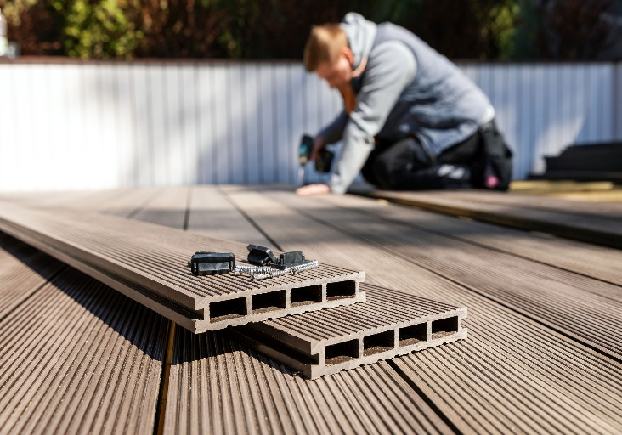
Construction materials have notoriously high carbon emissions and significant efforts have gone into developing more sustainable building supplies. However, these sustainable alternatives are more expensive or can’t match the strength or durability of traditional materials.

Source: © Ronstik/Getty Images

Could using different garden decking materials be a sustainable solution for reducing carbon emissions in the construction industry?

Decking boards made from wood–plastic composite, instead of wood, are a popular choice with home owners due to their long life spans. Usually, such composite materials consist of a blend of wood chips or sawdust and plastic like high-density poly(ethene), HDPE.

The US scientists’ composite contains low-quality brown coal and lignin, a wood-derived product used in papermaking, fillers instead of the standard wood chips and sawdust. The team modified these fillers by adding waste carbon dioxide to their surface, which made them stickier, enabling them to make stronger composites. The carbon dioxide makes up about 4% by weight of the filler. The scientists then mixed these modified fillers with HDPE.

Building a green future

Now, The team’s testing revealed that a composite containing 80% of the modified filler and 20% HDPE maximised carbon dioxide sequestration while also demonstrating sufficient strength and durability to satisfy international building codes for decking materials.

The team used this composite to make three metre-long boards that have a similar look and feel to standard wood composites used for decking or garden furniture. It is also significantly more cost-effective, estimated to be 18% cheaper than typical composite decking.

According to one of the composite’s inventors David Heldebrant, if all the 1.1 billion metres of decking sold in the US every year were replaced with this carbon-negative composite decking, more than 230,000 tonnes of carbon dioxide could be sequestered each year. That figure is equal to the annual emissions from about 54,000 cars.

The team is now working on commercialising these decking boards. It is also developing other carbon-negative composite formulations for other kinds of building materials, including fencing and siding.

Maksud Rahman, a materials scientist at Rice University in Texas who was not involved in this research, is optimistic. ‘The composite decking idea is innovative,’ he says. The abundance of the materials means the production could be scalable and is feasible, he adds.

This is adapted from the article ‘Carbon-negative decking could lock up CO2 equivalent to taking 50,000 cars off the road’ Chemistry World. Read the full article: rsc.li/3W8RAtW.

