- This question is about condensation polymerisation.
Indicate whether the following statements are true or false.
Write a ‘T’ for true or ‘F’ for false in the boxes.
- Polyester and nylon are examples of condensation polymers.  - Monomers must have a carbon double bond.  - A polymer and a small molecule like water or hydrogen chloride are formed.  - There is normally one type of monomer.  - A monomer normally has a particular functional group at both ends of the molecule.  - If A is one monomer, and B is the other, the structure of the condensation polymer could be shown as:  -A-B-A-B-A-B-A-B-A-B-A-B-A-B- | F  T  F  T  T  T

- A student draws two different diagrams to model two types of polymerisation, 1 and 2.
Polymerisation type 1
Polymerisation type 2

- Name each type of polymerisation.
Polymerisation type 1 | Answer: Addition.
Polymerisation type 2 | Answer: Condensation.
- Give an example of a monomer that could form a polymer in polymerisation type 1.
Answer: Ethene, propene etc.
- What essential structural feature of the monomer is important when forming the polymer type in part b)?
Answer: A carbon double bond.
- Michelle and Dave discuss the model in polymerisation type 2.
Michelle suggests that there should be 15 small molecules (as shown) produced as well as the polymer, whereas Dave suggests there should be 16.
Who is correct? Give a reason.
Answer: There are 16 monomer molecules, so the number of bonds linking together each monomer in the polymer will be 15. Each link also results in the formation of a small molecule, so there should be 15 of these.
- The molecules below form a condensation polymer and water.
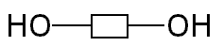
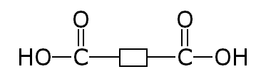

Monomer 2
Monomer 1

- State the names of the functional groups present in these molecules.
Monomer 1 | Answer: Carboxylic acid.
Monomer 2 | Answer: Alcohol.
- Draw a circle around the parts of the monomers that form water.
Answer: See answer above.
- Draw the repeat unit of the polymer formed from these monomers.
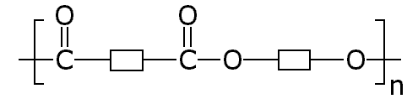

- What is the name of the polymer formed using these monomers?
Answer: Polyester.

- The nylon rope trick is a demonstration that you may have seen.
(Discover it at: edu.rsc.org/755.article)

In this reaction, two different molecules react together to make nylon, and hydrogen chloride.

The structures of the molecules in the reaction are:

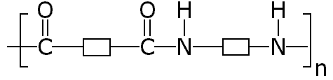
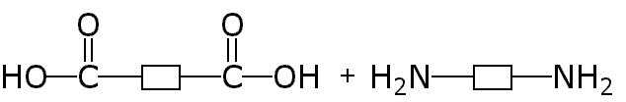
n
n

- What other substance is formed in this reaction?
Answer: Water.
- What is the name given to this type of polymerisation?
Answer: Condensation polymerisation.
- Ring the parts of the two monomer molecules that would make the substance in part a).
Answer: See blue circle above.
- The symbol ‘n’ is a whole number, and is placed on the structure of the polymer.
State how the rest of the chemical equation would be balanced.
Answer: An ‘n’ would be placed at the beginning of each of the molecules on the left-hand side, as shown.

