Dissolving and disappearing
Education in Chemistry
September 2019
rsc.li/2YCB8Se
Asking students to predict mass and explain what happens when a substance is added to water can help you understand pupils’ preconceptions and to unpick them. Some students will not expect the mass to be conserved on dissolving, even though many will recognise that the solute is still there in some form. Students who do expect the mass to be conserved might have vague ideas about why. Often dissolving is confused with disappearing, because at the macroscopic level the solute can’t be seen.

Sugar and water
Some water is placed in a beaker and its mass measured using a balance. The mass of the beaker and water is 200g.
10g of sugar is added to the water. It sinks to the bottom. Ten minutes later the sugar can’t be seen.
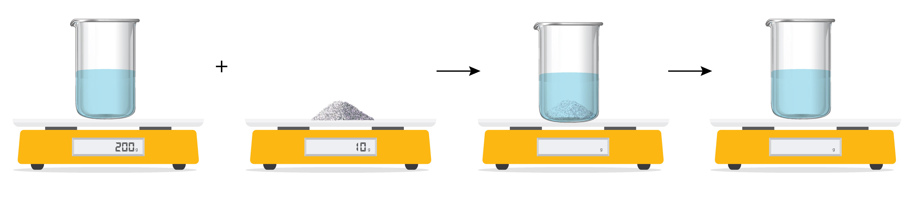
  - What do you think the mass of the beaker and its contents would be when the sugar was first added, and then when it could no longer be seen?
  - Where did the sugar go?

Salt and water
Some water is placed in a beaker and its mass measured using a balance. The mass of the beaker and water is 150g.
10g of salt is added to the water. It sinks to the bottom. Ten minutes later the salt can’t be seen.
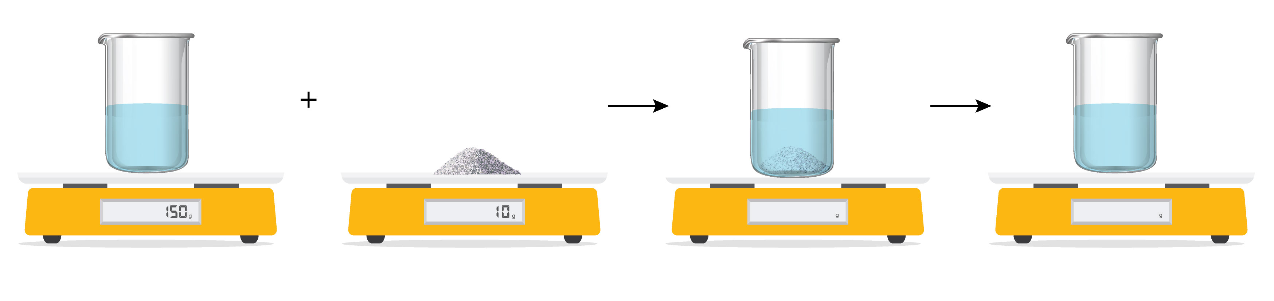
  - What do you think the mass of the beaker and its contents would be when the salt was first added, and then when it could no longer be seen?
  - Where did the salt go?

Copper sulfate and water
Some water is placed in a beaker and its mass measured using a balance. The mass of the beaker and water is 250g.
5g of blue crystals of copper sulfate is added to the water. It sinks to the bottom. 20 minutes later the copper sulfate can’t be seen, and the liquid has turned blue.
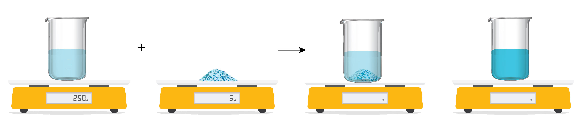
  - What do you think the mass of the beaker and its contents would be when the copper sulfate was first added, and then when it could no longer be seen?
  - Why did the water turn blue?
  - Where did the copper sulfate go?

Particles in sugar and water
The diagrams represent the particles present at different stages when sugar is dissolved in water. Not all the particles are shown.
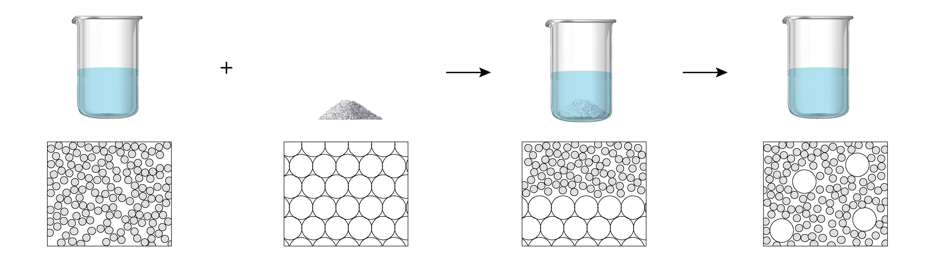
  - Why does the liquid taste sweet when sugar is added to water?

