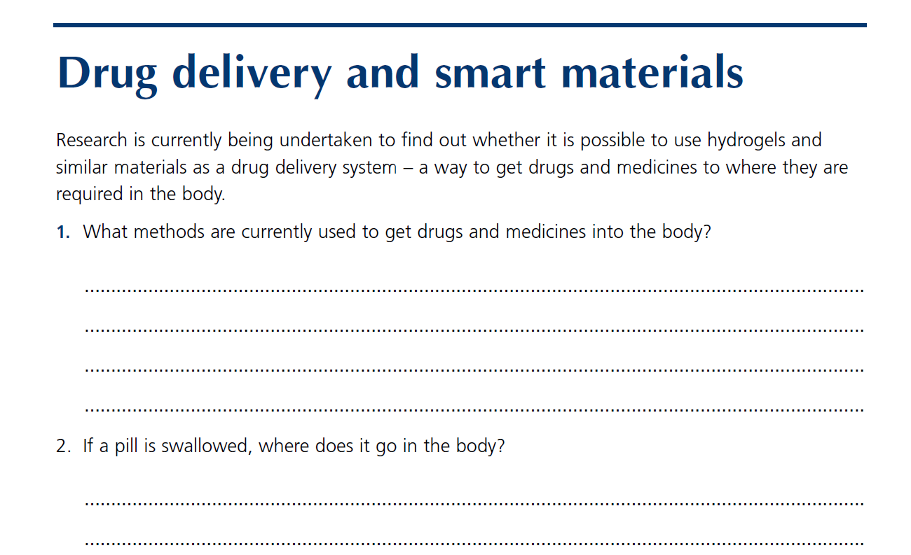

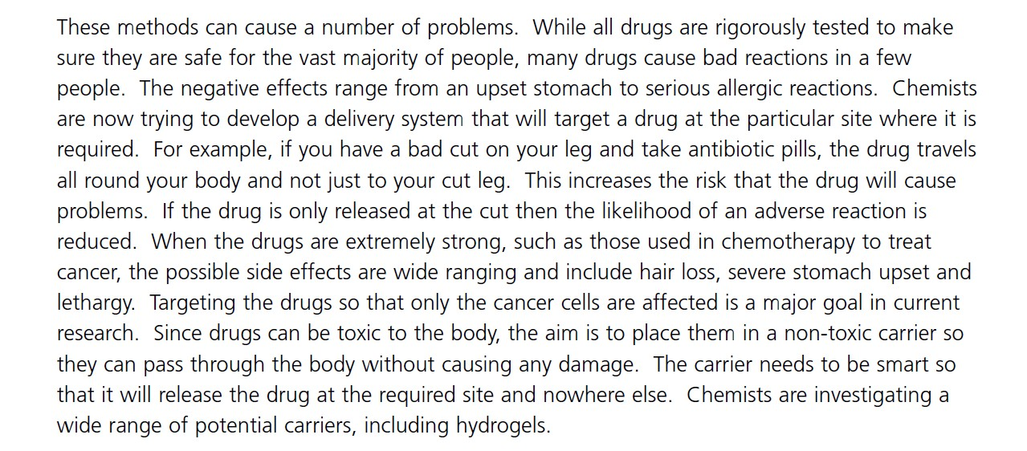

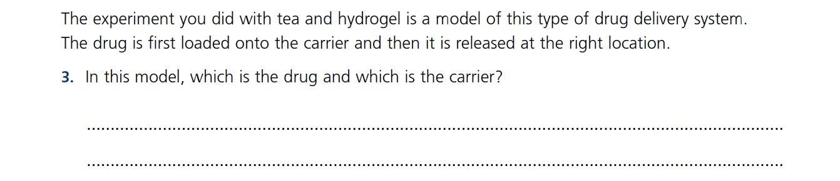

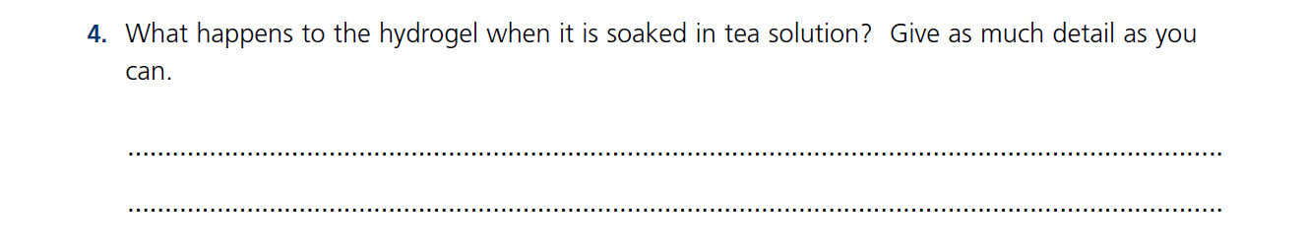

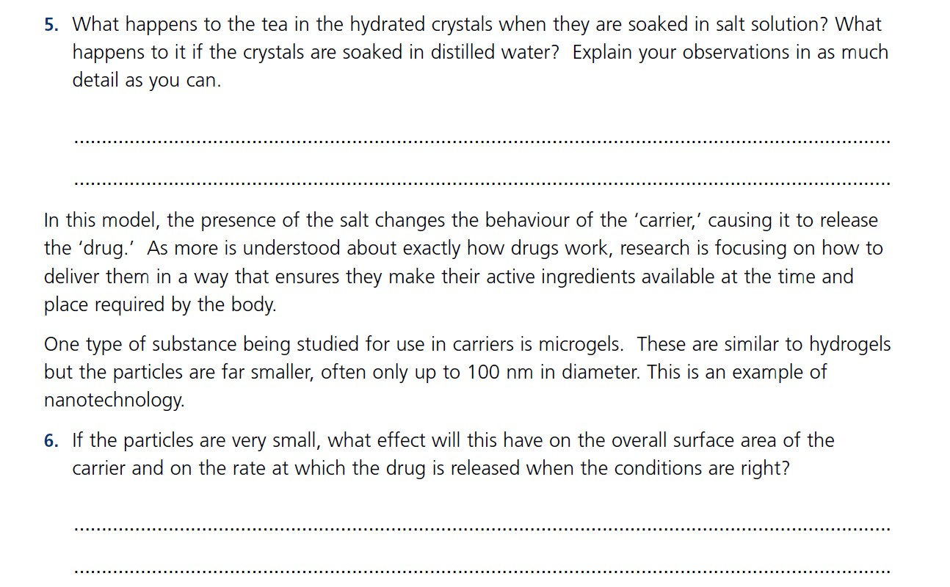

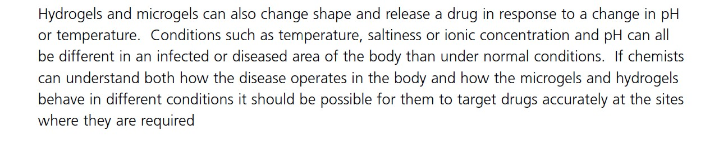

This Practical Chemistry resource was developed by the Nuffield Foundation and the Royal Society of Chemistry.
© Nuffield Foundation and the Royal Society of Chemistry

