Carbonyl chemistry

Oxidation of alcohols

Adam set up the following apparatus in order to prepare some ethanoic acid.
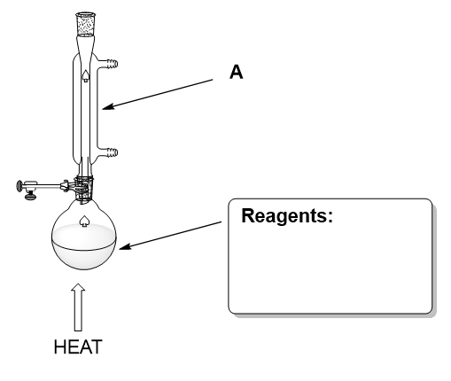
- What reagent(s) will Adam need to put in the round bottomed flask?
(1 mark)
- What colour change will Adam observe?
(1 mark)
- How does the experimental set up shown ensure a high yield of ethanoic acid?
(2 marks)
- Name the piece of apparatus labelled A
(1 mark)
- Draw a sketch of how the apparatus can be adapted to be used to produce and collect ethanal.
Label any new pieces of apparatus you may need.
(2 marks)
- Bottles A, B and C contain pure samples of either ethanol, ethanal or ethanoic acid but the chemical labels have been lost. Suggest 2 reagents that can be used to determine which is which.
(2 marks)

Tests for aldehydes and ketones

Aldehydes and ketones can be distinguished using a variety of oxidising agents.

- Complete the table of observations for each test
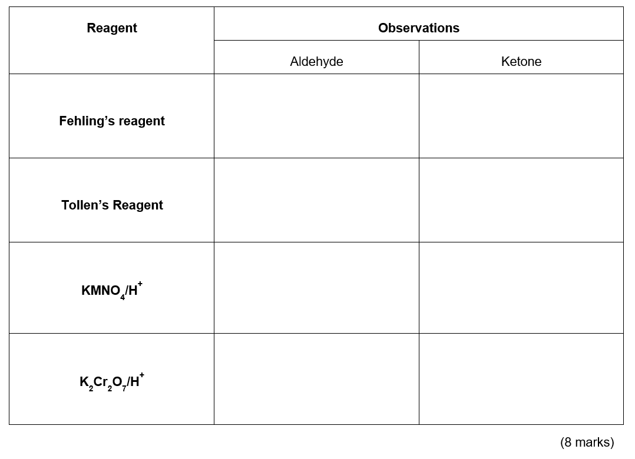
- Write an equation using [O] for the oxidant to show the oxidation of propanal.

(1 mark)
- Tollen’s reagent works by the reduction of Ag⁺ ions. Write an equation for this reaction.
(1 mark)

Carbonyl functional groups
The diagrams below show a range of functional groups containing a carbonyl group. For each one give the general name for the functional group (1 mark each). The last diagram shows a functional group which is beyond most A-level specifications. Indicate which two functional groups are present (half a mark each) and try and deduce its name (1 mark)

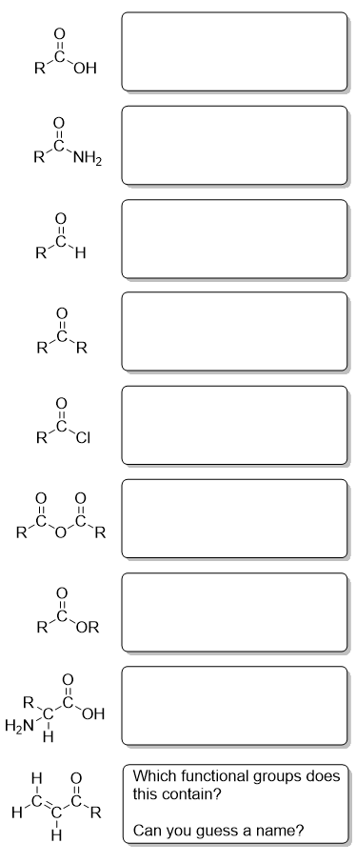

Reactions of carboxylic acids

Fill in the diagram to show the products formed when the carboxylic acid, propanoic acid, reacts with the reagents shown.
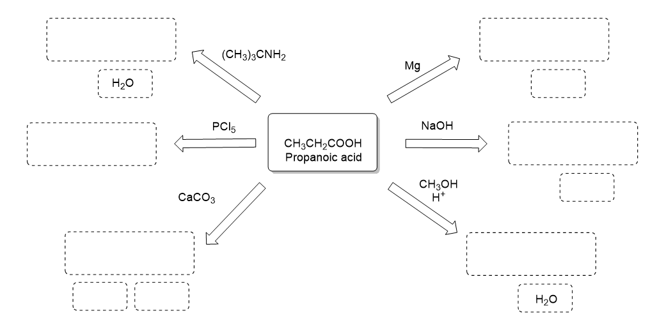

Carbonyl reductions

The reducing agents sodium borohydride (NaBH₄) and lithium aluminium hydride (LiAlH₄) are used to reduce aldehydes and ketones to their corresponding alcohols. In mechanistic terms they are considered a source of the H⁻ ion.

- Outline a mechanism to show the reduction of butanone using H⁻.
(5 marks)

Lithium aluminium hydride is prepared as a solution in dry ether. It reacts with moisture to form lithium hydroxide, aluminium hydroxide and hydrogen. Sodium borohydride is soluble in water and does not decompose except in acidic solution.

- Write a balanced symbol equation for the reaction of lithium aluminium hydride with water and explain the potential hazard if a laboratory solvent is not dried prior to use with lithium aluminium hydride.
(4 marks)

- Suggest in what circumstances a chemist would use sodium borohydride rather than lithium aluminium hydride to achieve the reduction of an aldehyde or ketone group in a molecule.
(1 mark)

Esters
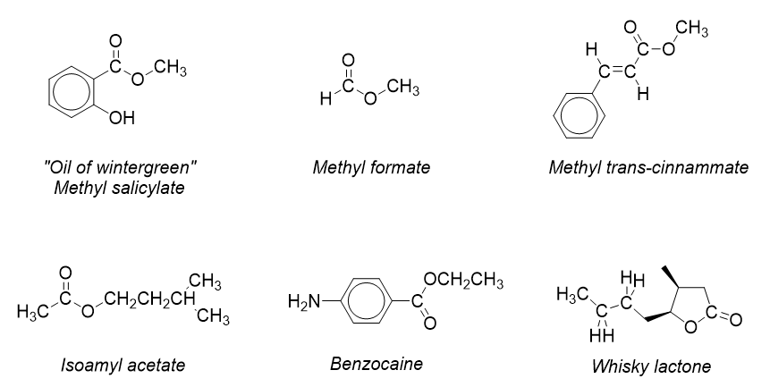

1. Oil of wintergreen is a naturally occurring ester with a strong scent which is often used in muscle rubs. It is formed from the reaction of salicylic acid and methanol. Using the structure shown, write an equation for this esterification and give the IUPAC name for salicylic acid.
- marks)

2. Methyl formate is the methyl ester of formic acid and the simplest possible ester structure. Looking at the structure, give the IUPAC name for methyl formate and formic acid.
(2 marks)

3. Methyl trans-cinnammate is used in the production of strawberry flavouring and perfume.
(a) Draw the displayed formula of the acid used to form methyl trans-cinnammate.
(1 mark)

(b) There is another geometric isomer with the structural formula PhCH=CHCOOCH₃, draw this isomer and state which feature of the molecule gives rise to these isomers.
- marks)
4. Benzocaine is a topical anaesthetic used to produce a numbing effect in throat sweets. It is sparingly soluble in water. Suggest a solvent for benzocaine.
(1 mark)
5. Whisky lactone is an example of a circular ester.
Suggest what the starting material for this ester is.
(1 mark)

Preparing esters

The following text describes a simple qualitative synthesis of an ester commonly used in secondary schools.

2 drops of hexan-1-ol, 2 drops of propanoic acid and 1 drop of concentrated phosphoric acid were added to a test tube and this was placed in a bath of boiling water for 5 minutes. The mixture was then poured onto 10 cm³ of cold, saturated sodium hydrogen carbonate solution and a characteristic sweet smell of an ester was observed.

- Write an equation for the reaction described in the text and name the ester formed
(5 marks)
- State the role of the phosphoric acid in this reaction
(1 mark)
- Why was the reaction mixture poured onto sodium hydrogen carbonate solution?
(2 marks)
- The same product can be formed when an acid chloride is used in place of the carboxylic acid. The conditions for the reaction need to be changed. State the change needed and explain why it is necessary.
(2 marks)

Saponification

Saponification is the process used to make soaps from fats and oils. The general scheme for saponification is shown below.

- Draw a scheme to show the saponification of a generic triglyceride using sodium hydroxide
(4 marks)
- Draw a scheme to show the saponification of a generic triglyceride using potassium hydroxide
(2 marks)
- State and explain the reaction conditions necessary to ensure the safety of the soap formed
(2 marks)
- Which alkali is used to create liquid soaps such as those used in handwashes? Explain why this type of soap is formed with your chosen alkali
(2 marks)

Acids, acid chlorides and acid anhydrides

Carboxylic acids, acid chlorides and acid anhydrides all carry out the same reactions. They are used by chemists under different circumstances depending in the desired yield, plant conditions and potential by products.

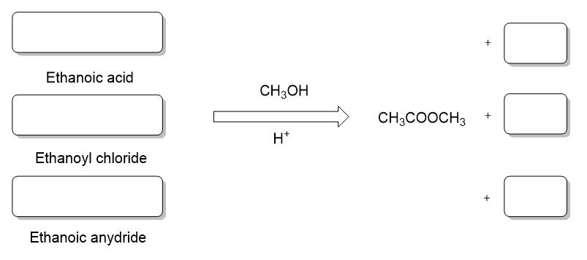

- Complete the diagram to show the reactions of ethanoic acids, ethanoyl chloride and ethanoic anhydride with methanol and an acid catalyst.
(6 marks)

Ethanoic anhydride is a colourless liquid (boiling point 140°C) that smells strongly of vinegar. It is impossible to make an aqueous solution of ethanoic anhydride. In terms of reactivity in acylation it is more reactive than ethanoic acid but less reactive than ethanoyl chloride.
- Explain why ethanoic anhydride smells strongly of vinegar.
(1 mark)

- Explain why it is impossible to prepare and aqueous solution of ethanoic anhydride?
(1 mark)

- Discuss why ethanoic anhydride may be used as a compromise reagent in an acetylation reaction
(2 marks)

Carbonyl chemistry - Answers

Oxidation of alcohols

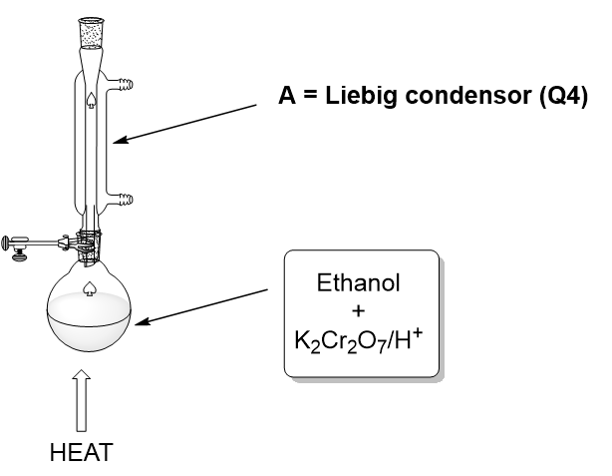
1 as shown on the diagram (3 marks)
2 Orange to green (just goes green insufficient) (1 mark)
3 The reaction is set to reflux (1 mark, QoL)
Volatile oxidation products/aldehyde formed initially/ethanol evaporates then condenses and is returned to the reaction mixture (1 mark)
4 (Liebig) condenser
5
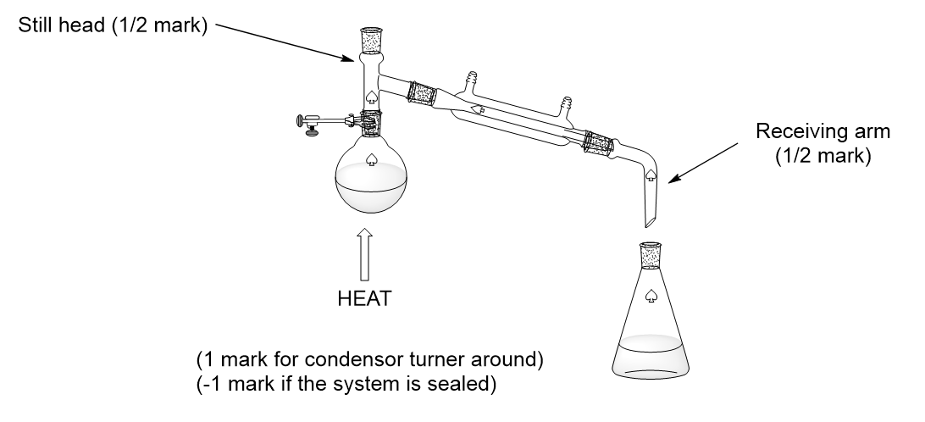
6 Sodium bicarbonate/Sodium hydrogen carbonate solution (will identify the acid) (1 mark)
Tollens’ reagent (will identify the aldehyde) (1 mark)

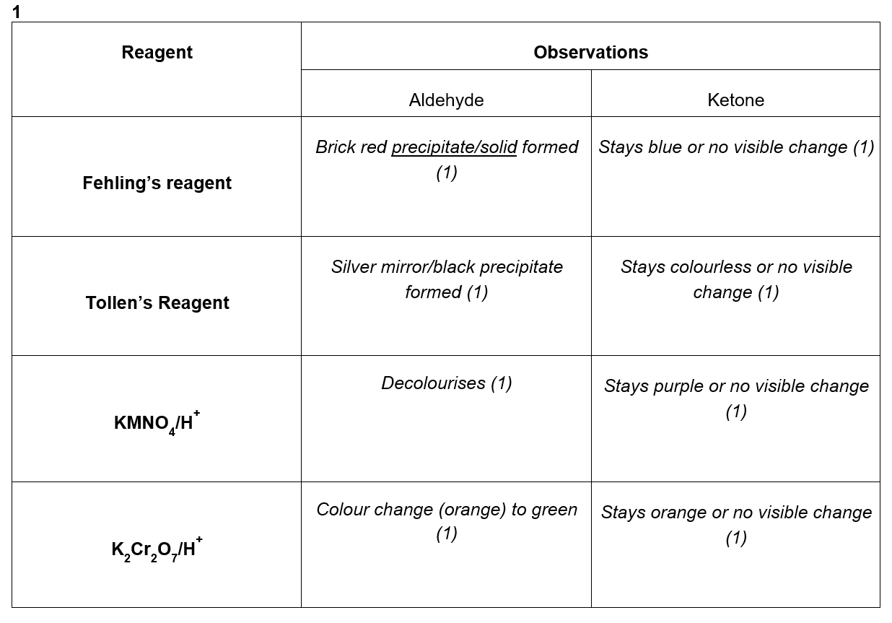
Tests for aldehydes and ketones
2 CH₃CH₂CHO + [O] CH₃CH₂COOH (1 mark)
3 Ag⁺(aq) + e⁻ Ag(s) state symbols required (1 mark)

Carbonyl functional groups
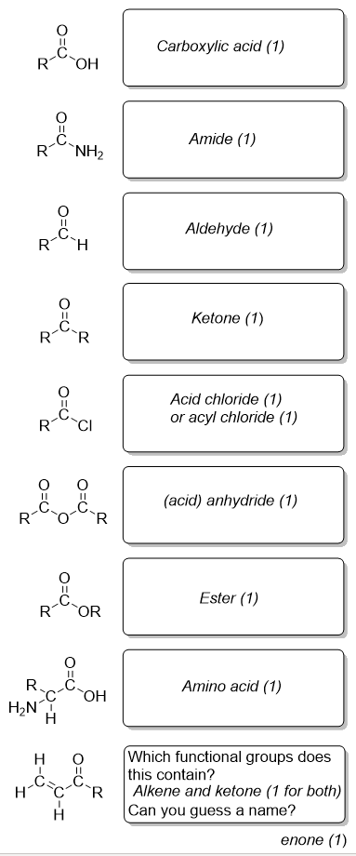

Reactions of carboxylic acids
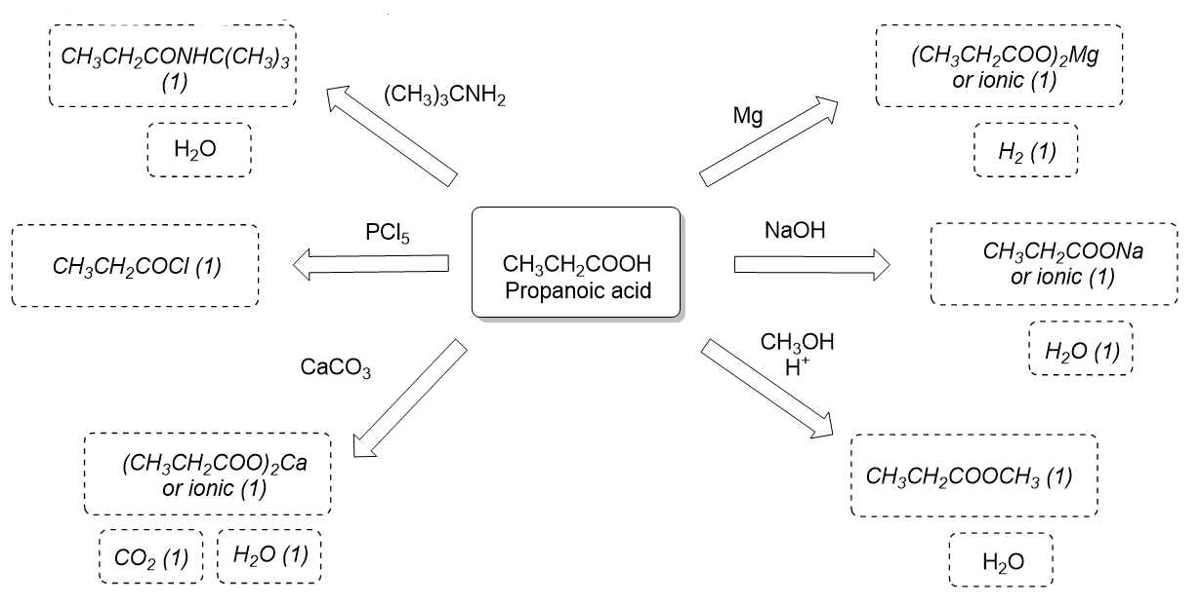

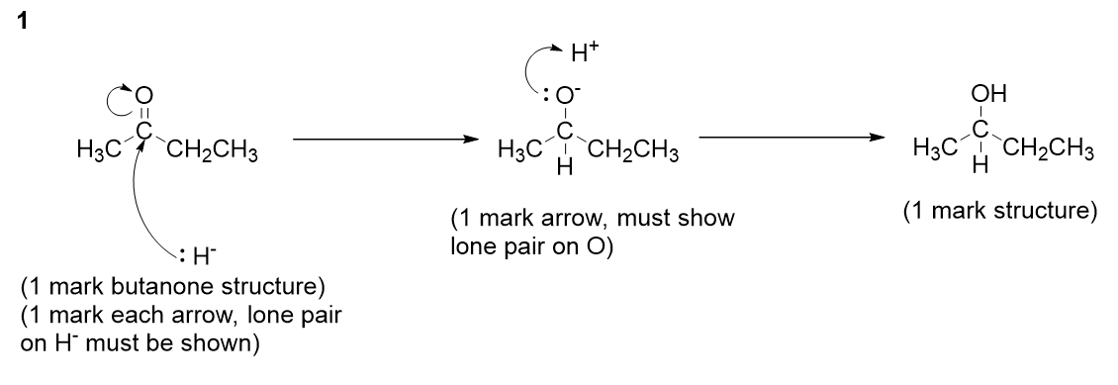
Reductions of carbonyl groups
2
3
1 mark for any of the following:
To prevent reduction of another carbonyl group in the molecule
Because the molecule to be reduced is soluble in water
To control the reduction
For named (appropriate) safety reason eg, difficult to ensure dry conditions

Esters
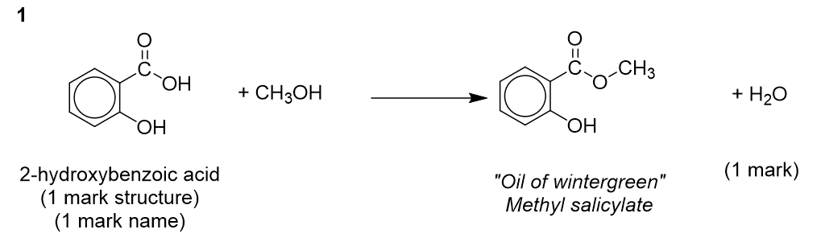

2 Methyl formate = methyl methanoate, formic acid = methanoic acid

3
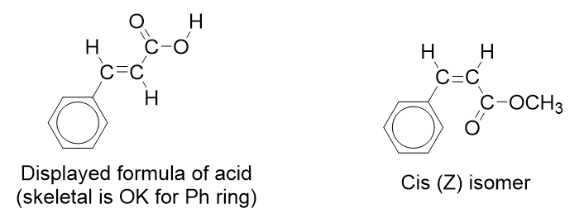

4 Ethanol or any other sensible suggestion

5
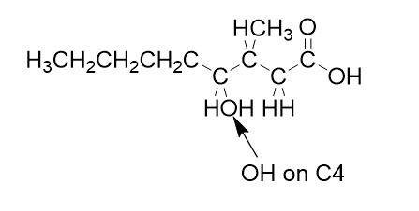
Preparing esters
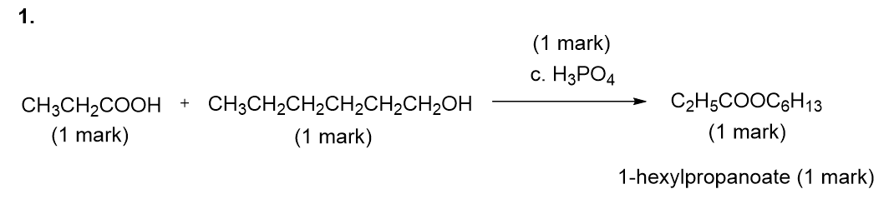
2. Catalyst (1 mark)
3. To quench/stop the reaction (1 mark)
To neutralise/remove the acid or names acid (1 mark)
4. No hot water bath (1 mark)
The reaction would be more vigorous/the acid chloride is more reactive than the carboxylic acid (1 mark)

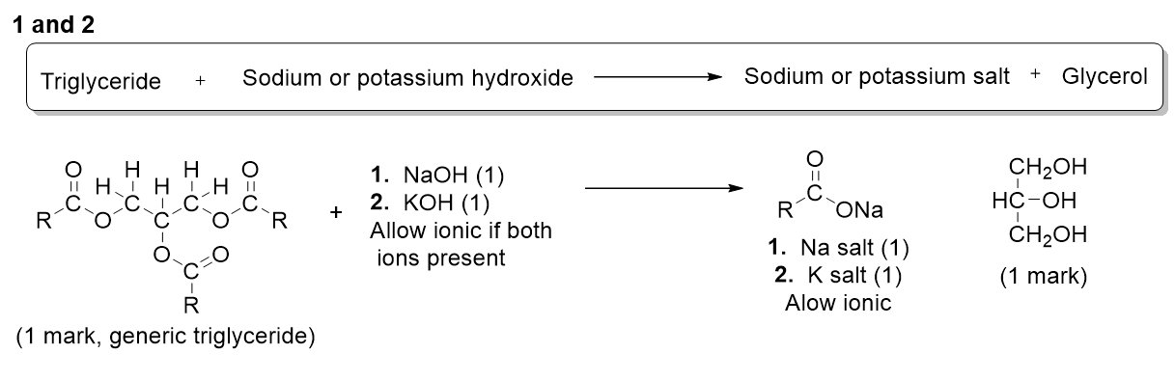
Saponification
3 No excess alkali (1 mark)
Metal hydroxides/names hydroxide corrosive (1 mark)

4 The reaction with potassium hydroxide produces liquid soap (1 mark)
The potassium salt/potassium carboxylate is more soluble than the sodium salt/sodium carboxylate (comparison needed 1 mark)

Acids, acid chlorides and acid anhydrides

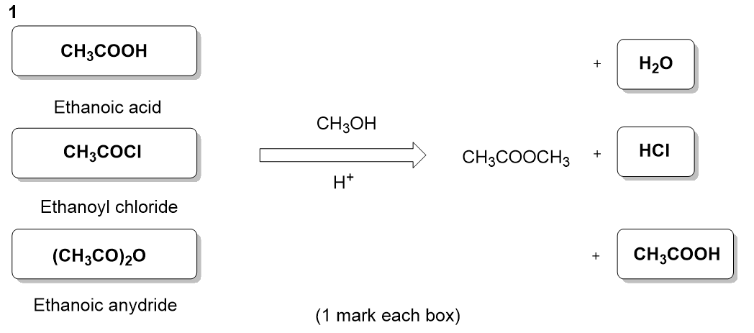
2 Ethanoic anhydride reacts with moisture in the air/in the nostrils to produce ethanoic acid (vinegar) (1 mark)
3 Ethanoic anhydride is hydrolysed by water (1 mark, QoL)
4 Reactivity is higher than ethanoic acid (1 mark) but by product is less toxic/corrosive than acetylation with ethanoyl chloride (1 mark)

