Fight fire! Fill up with foam

Learning objectives
- Plan an investigation to identify the reagent that produces the largest quantity of carbon dioxide foam.
- Record the investigation results and make a conclusion.
- Design a ‘foam launcher’ suitable for delivering the foam to a fire.

Introduction

Three things are needed for fire: heat, fuel and oxygen. By removing any one of these, a fire can be extinguished.

Carbon dioxide is widely used in fire extinguishers. Because carbon dioxide is denser than air, it smothers and extinguishes fires by preventing further oxygen from reaching the source of the flames.

One of the difficulties with putting out big fires in the open air is that the wind blows away the carbon dioxide gas, allowing more oxygen to reach the fire and keeping it burning. Therefore, ideally, we should apply carbon dioxide as a blanket of thick foam, not a gas.

Your task

Working in small groups, your task is to investigate which reagent produces the largest quantity of carbon dioxide foam.

Your first two reagents will be:
- Sodium hydrogen carbonate (6 spatulas)
- Sulfuric acid, 1.4 mol dm⁻³ (20 cm³) (WARNING: irritant to eyes and skin)

The sodium hydrogen carbonate and sulfuric acid react together to produce carbon dioxide gas.

Then, you must investigate which one extra reagent produces the largest quantity of foam. The reagents to investigate are:
- Washing detergent powder (6 spatulas) (WARNING: irritant to eyes and skin)
- Washing up liquid solution (20 cm³)
- Water (20 cm³)

The reagents can be added in any order but must not be shaken or stirred. Once you have decided the order of the reagents, keep this the same in each reaction to make it a fair test.

Equipment and materials

Safety glasses.

Per group
- One litre plastic measuring cylinder or one litre drinks bottle with the top cut off
- Spatula
- Measuring cylinder (25 cm³)
- Non-permanent marker pen and ruler

Reagents (with quantities to be used in each experiment)
- Sodium hydrogen carbonate (6 spatulas)
- Sulfuric acid, 1.4 mol dm⁻³ (20 cm³) (WARNING: irritant to eyes and skin)
- Washing detergent powder (6 spatulas) (WARNING: irritant to eyes and skin)
- Washing up liquid solution (20 cm³)
- Water (20 cm³)

Method

Plan an investigation to identify the extra reagent that produces the largest quantity of carbon dioxide foam.

Your plan must include:
- The reagents used and their quantities.
- The order in which the reagents will be added.
- What you will measure.
- What safety precautions you will take to avoid eye and skin contact.

Results

Draw a suitable table to record your results. Include quantities for the reagents used, along with units for all measurements.

Conclusion

Based on your results, identify the extra reagent that produced the largest quantity of carbon dioxide foam.

Questions
- This question is about carbon dioxide and how it can be produced.
- Carbon dioxide is a compound made up of one carbon atom and two oxygen atoms. Which option shows the chemical formula for carbon dioxide written correctly?

A. CO²

B. CO2

C. C2O

D. CO₂

- Carbon dioxide is produced from the reaction of an acid and a metal hydrogen carbonate. A salt and water are also produced. Write a word equation to represent this reaction.

___________________________________________________________________________

___________________________________________________________________________

- Which test can be used to prove that the gas produced is carbon dioxide?

A. Damp litmus paper is bleached.

B. A glowing splint relights.

C. Limewater turns cloudy when the gas is bubbled through it.

D. A lit splint burns with a squeaky pop.

- Carbon dioxide extinguishes fires by preventing oxygen from reaching the source of the flames. Oxygen is one of three essential things needed for combustion.
- Complete the fire triangle to show the three things needed for combustion.

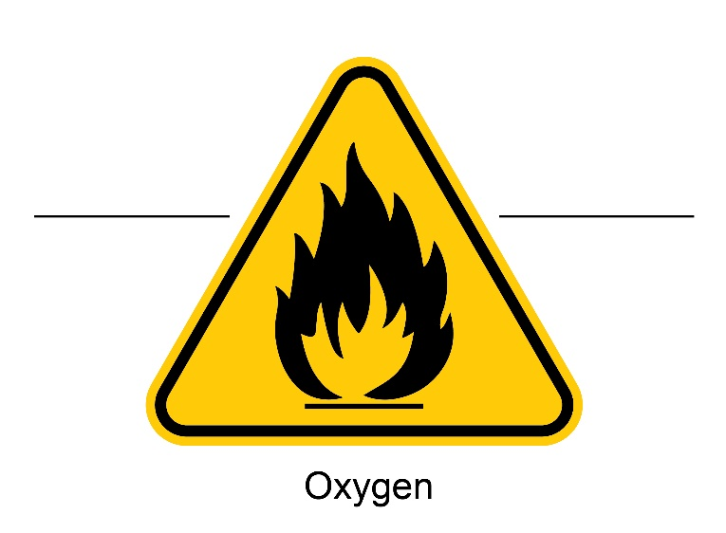

Image: © Fast_Cyclone/Shutterstock

Depending on the source of the fire, different methods can be used to extinguish it.
- For each of the methods below, identify which of the three components of the fire triangle is removed. For example, switching off the gas supply to a gas fire removes the fuel.
- A forest fire extinguished using water.

___________________________________________________________________________
- Chopping down trees to create a fire break in a woodland fire.

___________________________________________________________________________
- A chip pan fire extinguished by placing a fire blanket over the pan.

___________________________________________________________________________

Challenge

Once you have determined the best combination of reagents, design a ‘foam launcher’ that could be used to safely deliver the foam to put out a fire.

Prepare a pitch to promote your foam launcher to a panel of industry experts.

Top tips for success:
- Have a clear, compelling opening that introduces your product.
- Briefly explain your design and the reason behind some of the key design features.
- Prove it will work!
- Explain why you, and your foam launcher are the best on the market.

