The chemistry of chemical weapons: answers
Education in Chemistry
November 2019
rsc.li/36092UV

1. a. Molecular formula of mustard gas C₄H₈SCl₂
Chlorine has two isotopes; 75% Cl-35 and 25% Cl-37
Explanation of peak Explanation of abundance
m/z 158 = C₄H₈S³⁵Cl³⁵Cl 3 × 3 = 9
m/z 160 = C₄H₈S³⁵Cl³⁷Cl (3 × 1) × 2 = 6
m/z 162 = C₄H₈S³⁷Cl³⁷Cl (1 × 1) = 1
b. m/z 109/111 [ClCH₂CH₂SCH₂]⁺
m/z 63/65 [ClCH₂CH₂]⁺
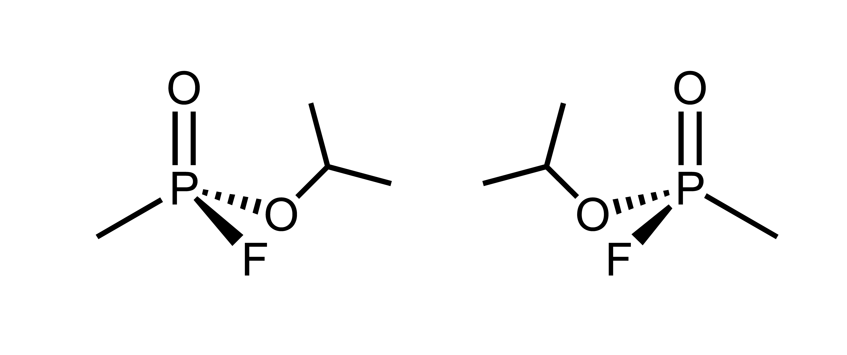
2. a.

b. 10,000 l = 10 m³
Air breathed in per minute = 10 m³ / (24 × 60) = 6.94 × 10⁻³ m³ min⁻¹
Sarin inhaled per minute = 6.94 × 10⁻³ m³ min⁻¹× 100 mg m⁻³ = 0.694 mg min⁻¹
Time taken to inhale 0.5 mg = 0.5 mg / 0.694 mg min⁻¹ = 0.72 min = 43 s

