Thin-layer chromatography – teacher notes

Introduction
It is useful to introduce this activity by discussing the use of painkillers and their other effects: antipyretic, anti-inflammatory and antirheumatic. Establish which brands are most commonly used and use these in the analysis.

Apparatus
- Thin-layer chromatography plate and a pencil (not a biro or felt tip pen)
- Test tubes in a stand: method of labelling the test-tubes
- Capillary tubes for use as micropipettes
- Chromatography chamber. Either a screw top jar tall enough to take the tlc plate, a small beaker with a petri dish for a lid or a commercial tank
- Access to a fume cupboard and short wavelength UV lamp.
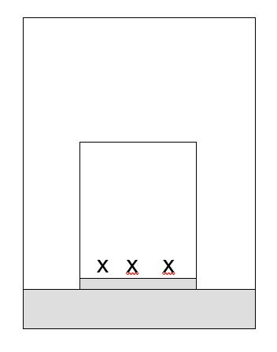

Chemicals
- Dissolving solvent: ethanol and dichloromethane
- Aspirin standard: 1 g aspirin in 20 cm³ dissolving solvent
- Caffeine standard: 1 g of caffeine in 20 cm³ dissolving solvent
- Reference standard: a 1:1 mixture of the aspirin and caffeine standards
- Ethyl ethanoate as chromatography medium.

Health, safety and technical notes
- Read our standard health and safety guidance here https://rsc.li/4411Q9b
- Wear eye protection
- Ethanol is flammable, see CLEAPSS Hazcard HC040a
- Dichloromethane is harmful by inhalation. Avoid breathing vapour and avoid contact with skin and eyes, see CLEAPSS Hazcard HC028
- Ethyl ethanoate is volatile, highly flammable and the vapour may irritate the eyes and respiratory system. Avoid breathing the vapour and avoid contact with the eyes. Keep away from flames. See CLEAPSS Hazcard HC043a
- Short wave UV may cause skin cancer and eye damage. Do not observe directly. The viewer should be screened from direct radiation.

Conclusion
- Analgesics contain aspirin and should produce a spot corresponding to the known aspirin standard.
- Analgesics containing caffeine should produce a spot corresponding to the known caffeine reference.
- Any spots not corresponding to aspirin or caffeine represent other medicines such as ibuprofen. This is less polar than aspirin and therefore moves further up the tlc plate.
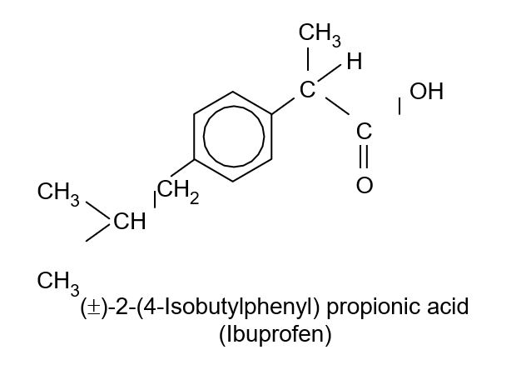
- Caffeine is a central nervous system stimulant and, in low doses, induces wakefulness and improves mental sharpness.
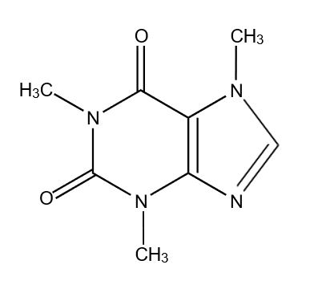
Advantages of tlc in medicine analysis:
- able to separate closely related compounds;
- only small samples required;
- quick and easy to carry out; and
- cheap

Further investigations
- Give the students an unknown sample to identify.
- Do starch tests on tablets to verify the nature of the binder. Why is starch used?

