Identifying the products of combustion
Student sheet

Introduction

Hydrocarbons produce carbon dioxide and water when they burn. In this experiment, you will capture and test the products of combustion.

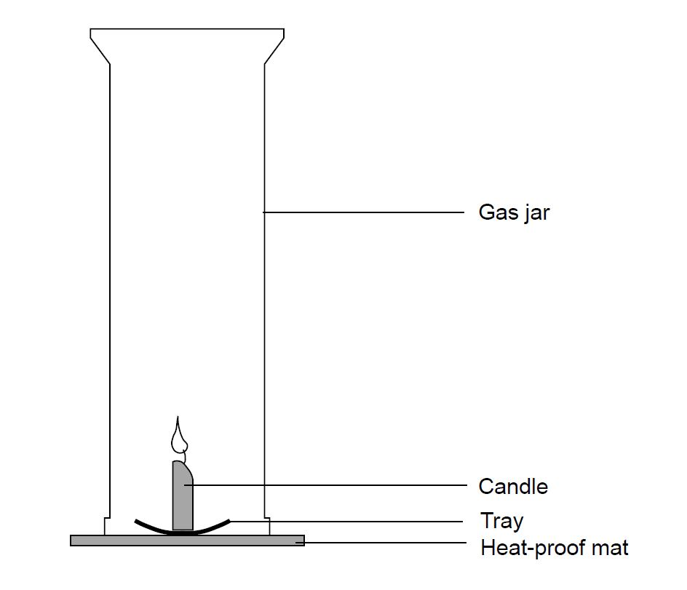
What to record

What was done and what was observed.

What to do

- Set up the apparatus as shown in the diagram. The gas jar should be placed over the lit candle on a heatproof mat.
- When the candle goes out, put a lid on the gas jar.
- Test to see if the candle made water by adding a piece of blue cobalt chloride paper, test the sides of the jar. If it turns pink, water is present.
- Now test to see if carbon dioxide was produced. Pour a little limewater into the gas jar. Swill it around a little. If carbon dioxide is present, the limewater turns cloudy.

Safety

Wear eye protection.

Questions

- What is the gas that reacts with the hydrocarbon when it burns?
- What gases does the candle produce when it burns?
- Name another fuel that produces the same gases when it burns.

