Electrochemical cells misconception buster

Learning objectives
- Describe how to set up an electrochemical cell, including:
  - The function and use of a salt bridge.
  - The relative positions of half cells according to their E⊖ values.
  - The use of a platinum electrode where necessary.
  - The components and use of the standard hydrogen electrode.
- Write and apply the conventional representation of an electrochemical cell.
- Use E⊖ values to predict the direction of simple redox reactions.
- Calculate the EMF (E_{cell}) and use this value to predict the feasibility of the cell.

Introduction

Read each multiple choice question carefully in Activity 1 and use the diagrams and data provided to tick the correct answer. There is one correct answer per question.

After marking your multiple choice questions, complete the suggested follow-up tasks to target areas for improvement and increase your understanding of certain topics. The questions cover setting up electrochemical cells, redox equations and calculations. If you answered a question correctly but you were uncertain or guessed, make sure you complete the relevant follow-up task.

Activity 1: multiple choice questions
- The diagram below shows:

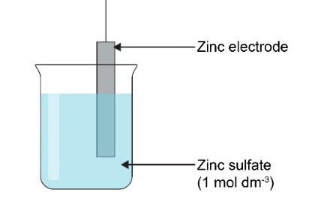
A | A half-cell.
B | An electrochemical cell.
C | A battery.
D | A salt bridge.

- Which concentration of sulfuric acid would you use for a standard hydrogen electrode?

A | 1.0 mol dm⁻³
B | 2.0 mol dm⁻³
C | 0.5 mol dm⁻³
D | 0.25 mol dm⁻³

- You make an iron(II)/iron(III) half-cell. Which answer shows the IUPAC conventional representation of this half-cell when it is acting as the anode?

A | Fe²⁺(aq) | Fe³⁺(aq) | Pt(s)
B | Fe²(aq), Fe³⁺(aq) | Fe(s)
C | Fe³⁺(aq), Fe²⁺(aq) | Pt(s)
D | Fe²⁺(aq), Fe³⁺(aq) | Pt(s)

- Which is the correct IUPAC convention for representing electrochemical cells?

A | Reduced form at edges, more negative cell on the left-hand side.
B | Reduced form at edges, more positive cell on the left-hand side.
C | Oxidised form at edges, more negative cell on the left-hand side.
D | Oxidised form at edges, more positive cell on the left-hand side.

- Which are the correct conditions for the standard hydrogen electrode?

A | 298°C, 100 kPa, 1 mol dm⁻³ acid solution, graphite electrode.
B | 298 K, 100 kPa, 1 mol dm⁻³ H⁺ solution, graphite electrode.
C | 298 K, 100 kPa, 1 mol dm⁻³ H⁺ solution, platinum electrode.
D | 298 K, 100 kPa, 1 mol dm⁻³ acid solution, platinum electrode.

- Why is a salt bridge used in an electrochemical cell?

A | It completes the cell.
B | It allows inert ions to transfer between half-cells to maintain electrical neutrality.
C | It allows electrons to transfer between half-cells to maintain electrical neutrality.
D | It allows current to flow between half-cells to maintain charge neutrality.

- Which of these salts would be appropriate for producing a salt bridge?

A | NaCl
B | KCl
C | KNO₃
D | NH₄Cl

- According to IUPAC convention, how is a salt bridge represented in an electrochemical cell?

A | ||
B | |
C | ,
D | /

- The diagram represents a standard hydrogen electrode. What should the missing label read?

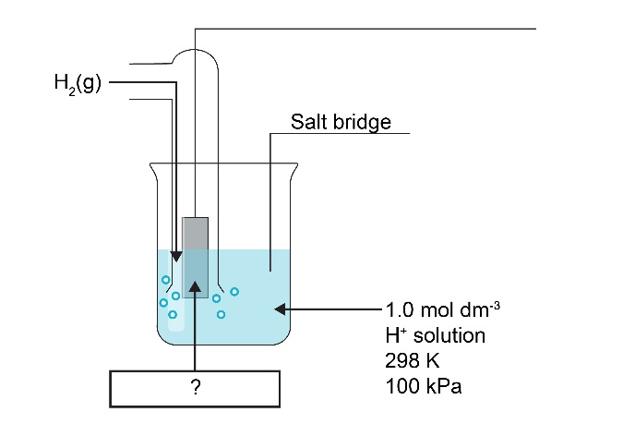

A | H₂(s)
B | H⁺(aq)
C | Pt(s)
D | C(s)

- The diagram below shows a zinc/copper electrochemical cell. What should the missing label read?

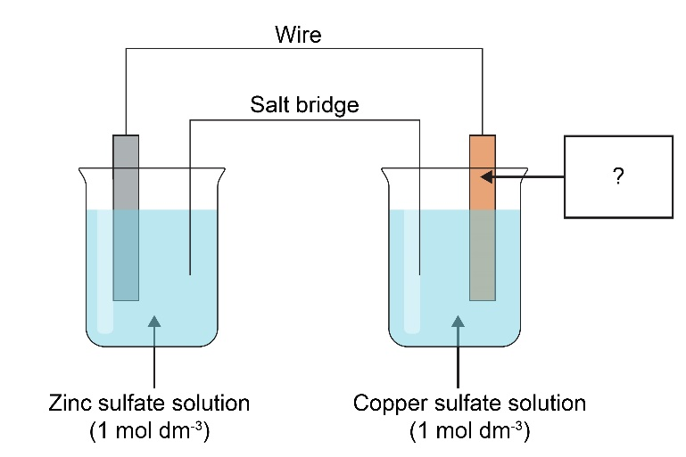
A | Zinc electrode
B | Platinum electrode
C | Graphite electrode
D | Copper electrode

- According to IUPAC convention, which half-cell should go on the left-hand side of a cell diagram?

A | The cell with the positive E⊖ value.
B | The cell with the negative E⊖ value.
C | The cell with the more positive E⊖ value.
D | The cell with the more negative E⊖ value.

- An iron(II)/iron(III) and zinc electrochemical cell is set up. Electrons will flow:

A | From the zinc half-cell to the iron half-cell; Zn is oxidised and Fe³⁺ is reduced.
B | From the zinc half-cell to the iron half-cell; Zn²⁺ is oxidised and Fe²⁺ is reduced.
C | From the zinc half-cell to the iron half-cell; Fe²⁺ is oxidised and Zn²⁺ is reduced.
D | From the iron half-cell to the zinc half-cell; Fe²⁺ is oxidised and Zn²⁺ is reduced.

- Which of the standard notations below is correct according to IUPAC convention, given that E⊖ (Fe³⁺/Fe²⁺) = 0.77 V and E⊖ (Zn²⁺/Zn) = -0.76 V?

A | Zn(s) | Zn²⁺(aq) || Fe³⁺, Fe²⁺(aq)| Pt(s)
B | Zn²⁺(aq) | Zn(s) || Fe³⁺, Fe²⁺(aq)| Pt(s)
C | Zn(s) | Zn²⁺(aq) || Fe³⁺(aq) | Fe²⁺(aq)
D | Zn(s) | Zn²⁺(aq) || Fe²⁺(aq) | Fe³⁺(aq)

A chlorine/chloride half-cell is joined to a bromine/bromide half-cell.
Cl₂ + 2e⁻ ⇌ 2Cl⁻ E⊖ = + 1.36 V Br₂ + 2e⁻ ⇌ 2Br⁻ E⊖ = +1.09 V

Use the information provided to answer questions 14–18.

- Identify the oxidising agent.

A | Cl⁻
B | Br₂
C | Cl₂
D | Br⁻

- Which species is oxidised?

A | Br₂
B | Br⁻
C | Cl₂
D | Cl⁻

- Which ionic equation represents the feasible direction of the reaction?

A | Cl₂ + 2Br⁻ ⇌ 2Cl⁻ + Br₂
B | 2Cl⁻ + Br₂ ⇌ Cl₂ + 2Br⁻
C | Cl₂ + Br₂ ⇌ 2Cl⁻ + 2Br⁻
D | 2Cl⁻ + 2Br⁻ ⇌ Cl₂+ Br₂

- Which is the positive electrode?

A | Cl₂/Cl⁻, as electrons flow towards it.
B | Br₂/Br⁻, as electrons flow towards it.
C | Cl₂/Cl⁻, as electrons flow away from it.
D | Br₂/Br⁻, as electrons flow away from it.

- Calculate the EMF of the cell.

Cl₂ + 2e⁻ ⇌ 2Cl⁻ E⊖ = + 1.36 V Br₂ + 2e⁻ ⇌ 2Br⁻ E⊖ = +1.09 V

A | +2.45 V
B | +0.27 V
C | -0.27 V
D | -2.45 V

Reduction | E⊖/ V
Ni²⁺ + 2e⁻ ⇌ Ni | -0.25
Cu²⁺ + 2e⁻ ⇌ Cu | +0.34
Fe³⁺ + e⁻ ⇌ Fe²⁺ | +0.77
Mg²⁺ + 2e⁻ ⇌ Mg | -2.33

- Given the E⊖ values in the table, which species is the strongest reducing agent?

A | Ni²⁺
B | Cu
C | Fe³⁺
D | Mg

- Given the E⊖ values in the table, which of the following reactions are feasible?

- Cu + Ni²⁺ ⇌ Cu²⁺ + Ni
- Mg + 2Fe³⁺ ⇌ Mg²⁺ + 2Fe²⁺
- Ni²⁺ + 2Fe²⁺ ⇌ Ni + 2Fe³⁺
- Cu²⁺ + Ni ⇌ Ni²⁺ + Cu

A | i, ii, iii, and iv
B | i and iii only
C | ii and iv only
D | None of the reactions are feasible.

Activity 2: follow-up tasks

Your teacher will give you the answers and explanations to the multiple choice questions. Using your responses to Activity 1, you will complete the suggested follow-up tasks to target areas for improvement and increase your understanding of certain topics.
Area for improvement | Follow-up task
Setting up electrochemical cells  You should be able to:  - Explain how to construct an electrochemical cell.  - Describe the standard hydrogen electrode and explain when it is used.  - Write and apply the conventional representation of an electrochemical cell and the half-equation for electrode reactions. | - Constructing simple cells  A student wants to measure the electrode potential between a zinc half-cell and a silver half-cell. Describe how the student could carry this out. You should use a labelled diagram in your answer and include relevant reagents, conditions and all components of the cell.  E⊖ (Zn²⁺/Zn) = -0.76 V and E⊖ (Ag⁺/Ag) = +0.80 V
- Standard hydrogen electrode

We measure standard electrode potentials using the standard hydrogen electrode (SHE). By definition, the SHE has an E_{cell} of 0.00 V.

We measure the standard electrode potential for the reduction of iron(III) ions into iron(II) ions by connecting a suitable half-cell to a SHE: E⊖ (Fe³⁺/Fe²⁺) = 0.77 V

Draw clearly labelled diagrams to show the components and reagents, including their concentrations, in this electrochemical cell. You should include:
- A diagram of the standard hydrogen electrode.
- The relative positions of each half-cell in the connected electrochemical cell.
- All relevant reagents, conditions and components of each half-cell.
- IUPAC convention

The IUPAC convention for the zinc/silver cell is given below.
E⊖ (Zn²⁺/Zn) = -0.76 V and E⊖ (Ag⁺/Ag) = +0.80 V
Zn(s) | Zn²⁺(aq) || Ag⁺(aq) | Ag(s)

When drawing conventional representations of electrochemical cells:
- Which cell goes on the left?
- Which cells require platinum electrodes?
- Why are platinum electrodes used as electrodes, rather than graphite electrodes?
- Which side should the standard hydrogen electrode be placed on?
- Which side of the conventional representation shows the cathode?
- Which direction do electrons flow in an electrochemical cell?
- What are the key components of a shortened IUPAC conventional representation?
Redox  You should be able to:  - Use E⊖ values to predict the feasible direction of a reaction.  - Write half-equations for the reactions occurring in electrochemical cells and combine them to give the feasible direction.  - Identify the anode and cathode in an electrochemical cell.  - Identify oxidising and reducing agents in reactions. | - Feasible direction of reactions  Step 1: identify the half-reactions. The half-reaction at the anode involves oxidation. The half-reaction at the cathode involves reduction.  Step 2: assign electrode potentials to each half-cell.  Step 3: calculate the EMF of the cell. E_{cell} = E⊖_{red ─} E⊖_{ox}  Step 4: evaluate the cell potential. If E_{cell} is positive, the reaction is feasible and the electrons flow from the anode to the cathode. If E_{cell} is negative, the reaction is not feasible in these conditions.  Go through the steps for the chlorine/chloride and bromine/bromide electrochemical cell provided for questions 14–18 and explain the feasible direction of the reaction. In your answer, you should:  - Give the overall ionic equation for the reaction.  - Identify the direction of electron flow.  - Identify the cathode and anode.  - Explain why the reaction is feasible under these conditions.
- Writing and combining half-equations

For the reactions in Q20:
- Use relevant half-equations and E⊖ values to show how the ionic equations for the two feasible reactions were formed.
- Use the half-equations and E⊖ values to correct the non-feasible cells. Give the appropriate direction for each half-cell and construct the full ionic equation for a feasible reaction between these half cells.
- Identifying oxidation, reduction, oxidising/reducing agents, anode, cathode and direction of electron flow

Remember: AN OX RED CAT – oxidation occurs at the anode; reduction occurs at the cathode.

- Define:
- Oxidation.
- Reducing agent.
- Cathode.

- For the two feasible equations in multiple choice question 20:
- Identify the oxidising and reducing agents.
- State which half-cells are the anodes and cathodes.
Calculations  You should be able to:  - Use values to predict the direction of simple redox reactions.  - Calculate the EMF of a cell. | - Calculating EMF (E_{cell})  E_{cell} = E⊖_{red ─} E⊖_{ox}  Calculate the EMF of the electrochemical cell:  Mg²⁺(aq) + 2e⁻ ⇌ Mg(s) E⊖ = -2.38 V  Ag⁺(aq) + e⁻ ⇌ Ag(s) E⊖ = +0.80 V
- Using E⊖ values to predict feasibility

You connect the following half-cells. Calculate the EMF for the feasible direction of this reaction.
Cr³⁺(aq) + e⁻ ⇌ Cr²⁺(aq) E⊖ = -0.41 V
Pb²⁺(aq) + 2e⁻ ⇌ Pb(s) E⊖ = -0.13 V

Extension

Consider the reaction of bromine in water under acidic conditions:

2Br₂ + 2H₂O → 2HBrO + 2Br⁻ + 2H⁺ E⊖ = +1.36 V

- Identify the oxidation states of bromine in each species.
- Give the half-equations for the oxidation and reduction processes.
- Identify the oxidising and reducing agent in the reaction.
- Name this type of reaction.
- The standard electrode potential for the reduction of bromine to bromide ions is +1.07 V. Calculate the standard electrode potential for the oxidation process.
- Under alkaline conditions, the oxidation half-equation is:

2Br₂ + 6OH⁻ → BrO₃⁻ + 3Br⁻ + 3H₂O + 2e⁻

Write the overall equation for the reaction.

