Self-pouring polymer
These notes accompany the video demonstration Illustrate polymer properties with a self-siphoning solution from Education in Chemistry, which you can view at: rsc.li/3TaTHKv.

Although chemistry textbooks typically depict substances as consisting of particles that are spherical in shape, the reality is somewhat more complicated. From proteins to plastics, we can better explain the properties of many materials that we encounter every day in terms of particles resembling chains of beads. You can demonstrate this idea with a liquid that behaves in a way that you can only explain by such a model, namely in how you can cut it, and how it siphons out of a beaker.

Curriculum links

Use this demonstration when teaching polymers and their properties to learners aged 11–16. You could also use it when teaching hydrogen bonding at post-16.

Kit
- 4 g high molecular weight poly(ethylene glycol), PEG, also known as polyox (see tips)
- 25 cm³ propan-2-ol
- Stirring rod
- 100 cm³ beaker
- 1000 cm³ beaker
- 2 x 600 cm³ beakers
- Food dye
- Scissors
- Clamp and stand

Preparation
- Add 3–4 g of PEG to a 100 cm³ beaker.
- Add 25 cm³ of propan-2-ol to the beaker and stir rapidly to disperse the powder.
- Add 10 drops of a food dye to the mixture at this stage to help you see the effect more clearly.
- Add approximately 400 cm³ of water to a 1000 cm³ beaker and tip the dispersed mixture as quickly as possible into the water.
- Mix with a stirring rod until the solution thickens and begins to climb the rod.
- Leave it for a few hours to fully hydrate before use.

You can keep the solution in a sealed bottle for several months. If the viscosity drops on standing, you can revive it by sprinkling some extra PEG powder onto the surface of the solution, shaking and leaving it for 24 hours to dissolve.

Health, safety and disposal

Read our standard health and safety guidance, available from rsc.li/4a0NS9J, and carry out a risk assessment before running any live practical.
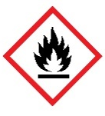
- Wear eye protection.
- Propan-2-ol is a highly flammable liquid and the vapour may cause drowsiness/dizziness. CLEAPSS members should consult HC084A, available from: bit.ly/492WA5Z.
- Poly(ethylene glycol) solid is classed as low hazard. The solution can be rather slippery and has some unusual/unexpected properties so you should handle it with care – including clearing up any spills. Hazard classification may vary depending on supplier. Dilute the solution and pour it down a foul-water drain.

In front of the class

Self-siphoning liquid

Fill one of the 600 cm³ beakers with your PEG solution. Place the clamp stand in your demonstrating space and put the second 600 cm³ beaker (dry and empty) next to the base of the clamp stand. Clamp the PEG solution beaker with its spout above the empty beaker Tip the upper beaker gently until the liquid starts to pour out of the spout into the second beaker. Keep the angle of the upper beaker constant and carefully elevate it by moving the clamp’s height to lengthen the stream.

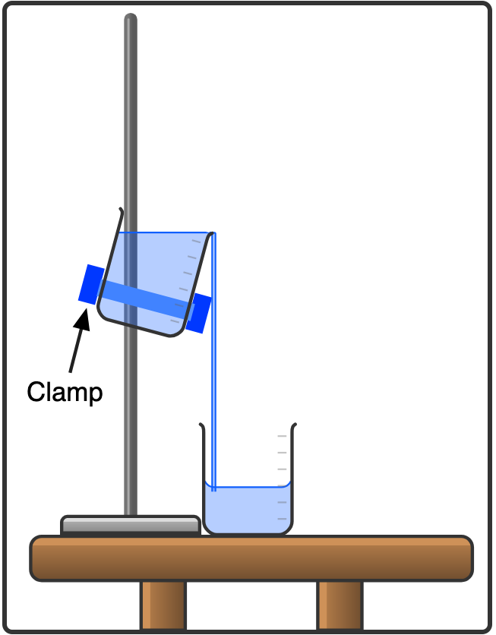

Source: © Declan Fleming created with Chemix (https://chemix.org)

Even as the level of liquid in the upper beaker drops beneath the level of its spout, the liquid will continue pouring out until it is nearly empty.

Cuttable liquid

Demonstrate the unusual cohesive forces in the liquid by cutting the liquid. To do this, place an empty 600 cm³ beaker in your demonstrating space, hold the beaker with your PEG solution above it and pour the liquid into the empty beaker. Pour over the edge, not the spout, of the beaker. Once you have established a good flow of liquid, return the upper beaker nearly to vertical (less than 30° of tilt). Using sharp scissors in your other hand, cut through the liquid approximately 1 cm from the rim of the upper beaker and keep the blade moving as you cut for best results. You will see the part of the liquid just above the cut spring back into the upper beaker.

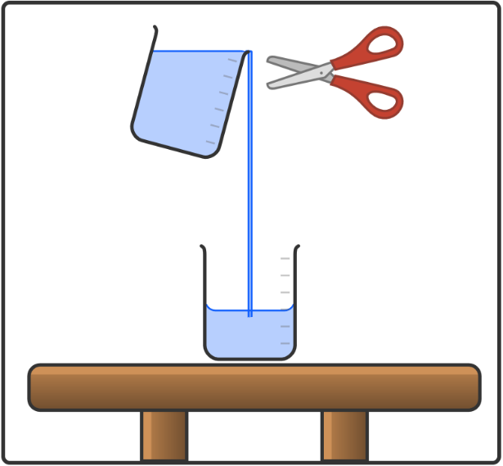

Source: © Declan Fleming created with Chemix (https://chemix.org)

Teaching goal

Poly(ethylene glycol), is used widely in drug delivery, wound dressings, artifact conservation, creams, pastes, cosmetics, and more recently mRNA vaccines. The effects seen here result from the solution’s viscoelastic properties – it acts a bit like a liquid and a bit like a solid. The material is viscous, a property of liquids that you can experience in the resistance when you try to stir it. It is also elastic (resists deformation), a property more associated with solids.

The poly(ethylene glycol) particles are more like long chains than small sphere-like molecules. Chemists make the chains by condensation addition polymerisation of ethane-1,2-diol (better known as ethylene glycol) as shown. Read more at: bit.ly/43uTtCL.

$$nHO–CH_{2}–CH_{2}–OH → HO–(CH_{2}–CH_{2}–O)_{n}–H + nH_{2}O$$

Every third atom in the chain is an oxygen, which can accept hydrogen bonds from water, and this helps the two substances to mix.

These chains become entangled as you apply a force – like the weight of the liquid pulling down on the stream of fluid – causing them to display more elastic properties. You can model this with a pile of rope or Christmas bead decorations: if you pull quickly, the material will knot up (modelling elastic behaviour), but if you pull slowly the chains will disentangle and separate (modelling viscous behaviour).

Tips
- Educational suppliers sell the colourless solid required for this demonstration as polyox, but you can also buy it from chemical suppliers as PEG, poly(ethylene glycol), or PEO, poly(ethylene oxide).
- This demo requires chains of approximately 90,000 repeating units that weigh 4,000,000 g mol^{–1}. Suppliers may label this PEG–90M, where M is thousands-of-monomers, or WSR 301.
- Do not use products that contain shorter chains labelled simply with a number, such as PEG 400. Here the number indicates the molecular weight. Solutions made from these shorter chains will not produce the effect described here.

