Making ice

This resource accompanies the article Supercool water in Education in Chemistry which can be viewed at: rsc.li/4a2yo5u

The practical investigation is part of the In search of more solutions collection, available from: rsc.li/3T4R7aO. Use these problem-solving activities to contextualise chemistry and engage learners in small group work.

Learning objectives
- Plan a method to investigate how quickly ice forms.
- Make careful observations and accurately record them in a table.
- Use experimental data to draw conclusions.
- Write an investigation report.

Learners will cover learning objective 1 during their initial discussions about how to solve the question and plan an experiment. They will meet all the other objectives during and after the investigation.

Introduction

This activity is based on an article by Martin Sherwood that appeared in Physics Education. Francis Bacon reported in 1620 that ‘Water slightly warm is more easily frozen than quite cold’, and some people may have come across the folklore ‘Never pour hot water down a frozen drain because the water will only freeze faster’. The problem challenges the perception of scientific ‘facts’.

Erasto Mpemba was a student at Magamba Secondary School in Tanzania when he discovered the phenomenon, now known as the Mpemba effect, while making ice cream.

One day, to get a free space in the refrigerator, Erasto put his ice cream mixture into the fridge without letting it cool first. At the same time, one of his friends, who had let his mixture cool, also put his mixture into the fridge. To everyone’s surprise, Erasto’s ice cream froze first after about one hour, while his friend’s remained liquid for longer.

Learners will investigate: ‘Which makes ice faster, hot or cold water?’. This is an open-ended problem-solving activity, so the guidance given is necessarily incomplete. Task your class to use their method writing and planning skills to answer the question using the equipment listed. For more advice on teaching practical planning, read the Teaching science skills article: rsc.li/47EhEQo. Learners must decide how to heat their water so we have not included any apparatus to do so in the equipment list.

Planning
Time | Lesson 1  10–20 minutes to set the scene. You can use the student worksheet questions as part of this.  30 minutes to plan the experiment in groups.  If appropriate, you can ask learners to plan the investigation on their own as a homework task.  Lesson 2  50 minutes to carry out the experiment.  Learners will need access to a fridge/freezer to monitor their results. If they use small volumes of water, their ice will form within a lesson.  Set completion of the report as homework.
Group size | 2–3
Curriculum links | States of matter and their properties.  Changes of state.  Energy – exothermic and endothermic reactions.
Alternative approach | Use this activity as a STEM club task over several sessions.

Scaffolding

There are two versions of the student sheet. The scaffolded student sheet (one star in the header) provides support with the planning process. Get learners to work through the questions together to write a method. The sheet also includes a sample table and spaces for learners to record their results and make their conclusion.

Give the unscaffolded student sheet (two stars in the header) to groups to work through planning the investigation on their own without prompts.

Refer to the equipment available during your introduction to the investigation and display it using the PowerPoint slide while the class plan. You can also encourage learners to try out their method before writing it down. Check all methods and correct them where needed before learners do the practical.

Use the questions in both versions of the student sheet to get learners thinking about changes of state and particle theory before the investigation or as a follow-up activity. There are two challenge questions at the end of the unscaffolded student sheet (two stars).

Technician notes

Safety and hazards

Read our standard health and safety guidance (available from rsc.li/3MwtYKg) and carry out a risk assessment before running any live practical.

Remind learners to wear safety glasses and to take care when dealing with hot or boiling water.

Equipment

Materials (per group)
- Deionised water

Apparatus (per group)
- Beakers, 100 and 250 cm³
- Thermometers, –5 to +100°C
- Access to a refrigerator and freezer
- Safety glasses (one pair per learner)

Explanation

Learners will find that hot water freezes more quickly than cold water – more precisely, water freezes more slowly if the initial temperature is below room temperature.

The phenomenon is still puzzling scientists but may be because a hot liquid has a ‘hot top’ of mobile molecules with high kinetic energy. These molecules can escape from the liquid phase more easily than colder molecules with lower kinetic energy in a cooler liquid. This is due to the hotter molecules having more energy to overcome the intermolecular forces. Therefore, the rapid cooling of the hot liquid may be due to the evaporation from this ‘hot top’.

Read more about research into the Mpemba effect here: bit.ly/3N9qE7Q.

Answers

Scaffolded student sheet (one star)

Planning your method

As it is a free investigation, these answers are suggestions only. Learners will have their own ideas.

- Accept either hot or cold water.
- Accept any reasonable answer that refers to particles/energy.

- Independent variable – temperature of water at the start of the experiment.
- Dependent variable – temperature after a known amount of time; or at regular intervals; estimation of how much ice has appeared.
- Control variable – volume of water used, size of beaker, level of insulation used.

- Measuring cylinder/beaker
- Beaker/insulated beaker
- Thermometer
- Kettle/Bunsen burner
- Stopwatch/stop clock

- In the range of three to five.

- Twice.

- Accept a method where the steps are in an appropriate sequence and that takes account of all the variables.

Recording your results and conclusions

- Table needs to have correct headings and units.

- The one which was hottest/highest temperature at the start – this answer should be consistent with the recorded results.
- The one which was hottest/highest temperature at the start – this answer should be consistent with the recorded results.

- The conclusion should be based on their answers from question 8.

Answers

These follow-up questions are adapted from Review my learning: the particle model. For more questions and activities go to: rsc.li/3uE96ui.
- Solid liquid gas
- In ice, the particles are very close together in a regular pattern. The particles vibrate around a fixed position. Solids have a fixed shape. Solids cannot be easily compressed because their particles are close together with no space to move into.
- In water, the particles are very close together and are randomly arranged but still touching. The particles move around each other and have more energy than in a solid but less than in a gas.

Liquids do not have a fixed shape. Liquids can flow and take the shape of their container because their particles can move around each other. Liquids cannot be easily compressed because their particles are close together with little space to move into.
- Freezing.
- Decreases, exothermic.

Unscaffolded student sheet (two stars)

Investigation planning and report
Learners to produce a group report using the headings:
- Problem or investigation question
- Prediction
- Method
- Results
- Evaluation
- Conclusion

You can assign sections to members of the group. Encourage the use of diagrams, photographs and graphs where appropriate.

Answers

These follow-up questions are adapted from Review my learning: the particle model. For more questions and activities go to: rsc.li/3uE96ui.

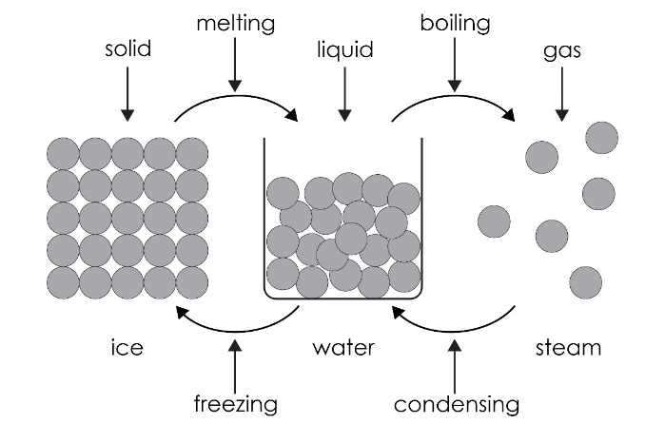
- The particles in water are close together and randomly arranged with most touching.
- Particles move randomly and can flow around each other because they have enough kinetic energy.
- The particles in ice are close together and touching.
- The particles in ice vibrate around a fixed point because they don’t have enough kinetic energy to flow over each other.
- Freezing.
- It decreases. Exothermic change.
- In solid iron, the particles are very close together giving it a higher density than liquid iron, where the particles randomly flow over each other. The density of ice must be lower than the density of water otherwise it would sink. Therefore, the particles in ice must have strong forces between the particles, giving a more open structure.
- Accept any reasonable suggestion here including the idea that the particles must lose their kinetic energy more quickly if the water is hotter.

