- Each of the organic molecules below belongs to a different functional group.
There is a carboxylic acid, an alcohol, an alkene and an alkane but they are muddled up.

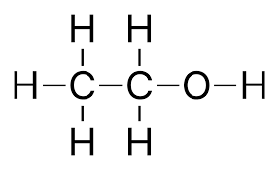
B
A

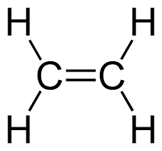
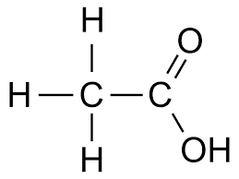
D
C

Complete the table by writing each letter (A–D) into the correct box.
Carboxylic acid | Alcohol | Alkene | Alkane
Answer: C | Answer: A | Answer: D | Answer: B

- George is asked by his teacher to draw out the structure of ethanoic acid.
He gives four possible structures, but only one is correct.
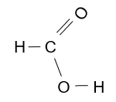
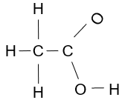
Which one is correct?
B
A

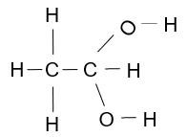
C
D

Answer: molecule C.

- This question is about naming carboxylic acids.
A student has named the carboxylic acids below, but he has made some mistakes.
How many correct answers can you see?
Give him a mark out of 5 – one mark for each correct answer.
For any incorrect answers, add the correct names.

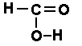  …Methanol… | Answer: Methanoic acid.
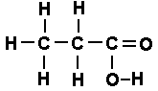  …Pentanoic acid… | Answer: Propanoic acid.
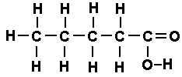  …Propanoic acid… | Answer: Pentanoic acid.
…Ethanoic acid… | Answer: Ethanoic acid.
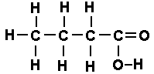  …Butanoic acid… | Answer: Butanoic acid.

Overall score: 2/5

- Sarah and Dean carry out an experiment with ethanoic acid solution.
They add the substances in the left-hand boxes, and test any gas formed.
Draw straight lines to link together the substance added with the correct observation.
Substance being added Observation
Magnesium
Gas formed that turns limewater milky

Sodium hydroxide solution – an alkali
Gas formed that gives a squeaky pop

Chalk – calcium carbonate
No gas formed

