Six markers: modelling alternative approaches
Education in Chemistry
January 2020
rsc.li/2DAAfk4
Try this sample question with your students. You could model how you would answer it, using prose (example A) or with a flow chart (example B). You could also give them the indicative content so they can concentrate on answering the question in the time, then move onto answering it completely.

Question

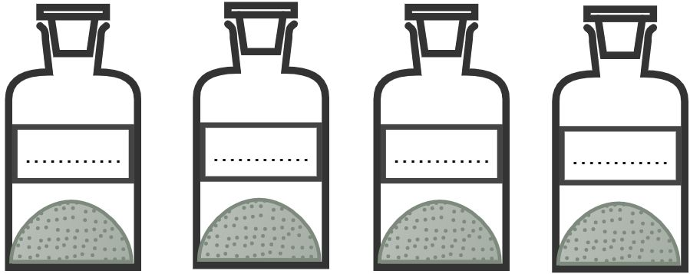
In the back of the chemical store the technician finds four bottles of white solids. Their labels have faded but the list of stock chemicals suggests they may contain the following substances:
- aluminium chloride
- magnesium chloride
- potassium carbonate
- potassium sulfate
- copper sulfate
Describe how you would analyse the solids to determine their identity. You can use standard laboratory reagents and you may also use flame tests. There is more than one way to carry out this analysis but you should try to minimise the number of different tests being used.
Give the results of any tests you would carry out.

Example A: written in prose

Example B: a flow diagram approach

