Mass and dissolving

Target level
This exercise is primarily aimed at the 11–14 age range, although it may also be used
to check the understanding of 14–16 year old students.

Topic
Conservation of mass on dissolving.

Rationale
Younger students may be satisfied with the idea that solutes ‘disappear’ when they dissolve, and even when the process of dissolving is appreciated students may not expect the mass of the solute to register in any measurements. This exercise asks students to predict the masses of solutions from given masses of solute and solvent, and also asks students to explain what happens to the solute, and to explain the emergent properties of the solution.

These ideas are discussed in Chapter 6 of the Teachers’ notes.

When this exercise was piloted in schools it was found that some students did not expect mass to be conserved on dissolving (even though most recognised that the solute was still present in some form), and that students who conserved mass in their responses often had only vague ideas about how the properties of solutions arose.

The exercise was described by teachers as ‘very good’ and ‘easy to follow’ and was considered to be an effective diagnostic tool. It was suggested that the exercise could be used as an introductory activity before formally teaching about the topic at this level.

Instructions
It is suggested that this exercise may be used as a prelude to classroom discussion of the answers, although some teachers may wish to formally ‘mark’ students’ responses.
The precise level of an acceptable response will clearly depend upon the age and nature of the group.

Resources
– Student worksheet
– Mass and dissolving

Feedback
A suggested answer sheet is provided for teachers.

Mass and dissolving – answers

1. Sugar and water
a) 210, 210
b) The sugar dissolved - it is still present, but as part of the solution.
(The molecules of sugar, which are much too small to be seen, are mixed with the molecules of water.)

2. Salt and water
a) 160, 160
b) The salt dissolved, and is now part of the solution. The salt particles are mixed with the water particles in the solution.

Note: If students have studied ionic bonding then it is worth emphasising that the sodium ions and chloride ions are separate in the mixture.

3. Copper sulfate and water
a) 255, 255
b) The blue colour is a property of the particles in the copper sulfate. The water turned blue as the copper sulfate dissolved to give a solution. The copper sulfate particles are mixed with the water particles. As the copper sulfate particles are spread throughout the solution the whole solution looks blue.
c) The copper sulfate dissolved - it is still present, but as part of the solution.
(The particles of copper sulfate, which are much too small to be seen, are mixed with the molecules of water.)

Note 1. Students commonly believe that the properties of a substance are due to its particles having that same property (see Chapter 6 of the Teachers’ notes). This idea is usually not correct, so although in this case the colour may be seen to be a property of both the particles and the bulk material, the teacher should consider emphasising that this is unusual, and that most bulk properties are not shared by the particles.
Note 2. If students have studied ionic bonding then it is worth emphasising that the copper ions and sulfate ions are separate in the mixture. (The colour is due to the hydrated copper(II) ions.)

4. Particles in sugar and water
The liquid tastes sweet because the molecules of sugar are dissolved in the solution. Sugar has a sweet taste, so the solution tastes sweet because it contains the sugar molecules.

Mass and dissolving

This exercise is about what happens when solids dissolve in liquids.

- Sugar and water

Some water was placed in a beaker, and its mass was measured using a balance. The mass of beaker and water was 200 g. Then 10 g of sugar was weighed out. The sugar was added to the water, and sank to the bottom. 10 minutes later the sugar could not be seen.

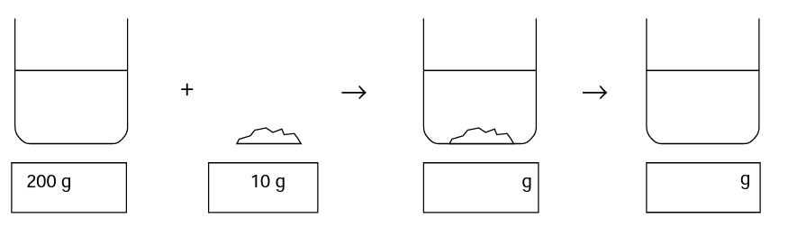

- Fill in the boxes to show what you think the mass of the beaker and its contents would be when the sugar was first added, and then after it could no longer be seen.

- Where did the sugar go? Explain your answer.
_____________________________________________________________________________________________________________________________________________________________________________________________________________________________________________________________________________________________________________________________________________________________________________

- Salt and water

Some water was placed in a beaker, and its mass was measured using a balance. The mass of beaker and water was 150 g. Then 10 g of salt was weighed out. The salt was added to the water, and sank to the bottom. 10 minutes later the salt could not be seen.

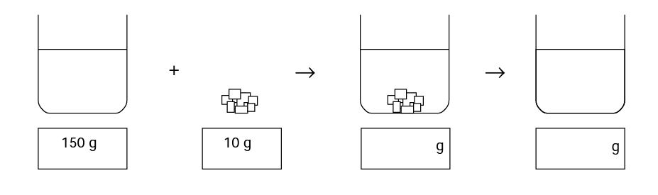

- Fill in the boxes to show what you think the mass of the beaker and its contents would be when the salt was first added, and then after the salt could no longer be seen.
- Where did the salt go?
_____________________________________________________________________________________________________________________________________________________________________________________________________________________________________________________________________________________________________________________________________________________________________________

- Copper sulfate and water

Some water was placed in a beaker, and its mass was measured using a balance. The mass of beaker and water was 250 g. Then 5 g of blue crystals of copper sulfate was weighed out. The copper sulfate was added to the water, and sank to the bottom. 20 minutes later the copper sulfate could not be seen, but the liquid had turned blue.

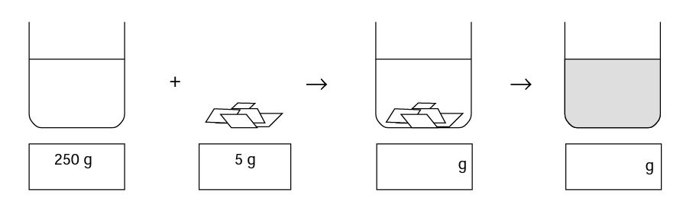
- Fill in the boxes to show what you think the mass of the beaker and its contents would be when the copper sulfate was first added, and when it could no longer be seen.

- Why did the water turn blue?

_____________________________________________________________________________________________________________________________________________________________________________________________________________________________________________________________________________________________________________________________________________________________________________

- Where did the copper sulfate go?
_____________________________________________________________________________________________________________________________________________________________________________________________________________________________________________________________________________________________________________________________________________________________________________

- Particles in sugar and water

The diagrams below represent the particles present at the different stages when sugar is dissolved in water. Not all the particles are shown.

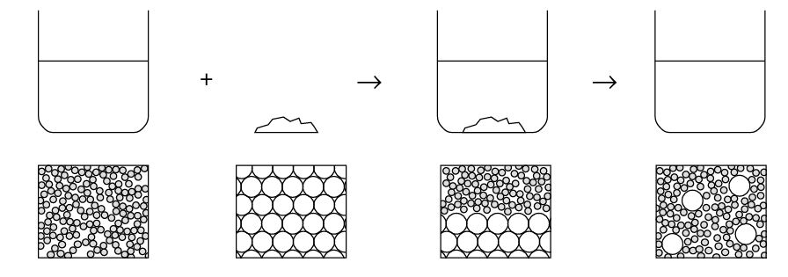

Why does the liquid taste sweet when sugar is added to water?
_____________________________________________________________________________________________________________________________________________________________________________________________________________________________________________________________________________________________________________________________________________________________________________

