Allotropes of carbon: flashcards
Education in Chemistry
January 2021
rsc.li/37VMEhr
Use these flashcards to explore the different properties and uses of four allotropes of carbon – diamond, graphite, graphene and buckminsterfullerene.
These differentiated flashcards are designed to be used alongside the allotropes of carbon infographic poster. Learners extract information from the infographic to complete the cards. Additional prompts are included on some of the flashcards to encourage independent research beyond the infographic.
Flashcards are a great way to organise information for revision. They could also be used for small group work, a market-stall style activity or a homework research task.
The infographic is designed to be displayed as a poster in the classroom. However, this activity could also be carried out with the infographic displayed on a projector or as printed handouts shared amongst small groups. Download the pdf with the link above.

Differentiation
The cards have been differentiated to offer stretch or support as required.
Stretch (blue edge) | Support (yellow edge)
Most answers are free text allowing learners to articulate understanding in their own words. | Answers are in a variety of formats including one word, multiple choice and free text answers.
Questions are at a higher level on Bloom’s taxonomy (describe/explain). | Questions are more structured (state/why?).
Each card has space to add uses beyond those included in the infographic, based on independent research. | All uses can be found on the infographic with the exception of one use of buckminsterfullerene. This could be used as an extension or homework activity.
Learners need to find three uses for each allotrope. | Learners need to find two uses for each allotrope.

Allotrope: |  | DIAMOND
 | 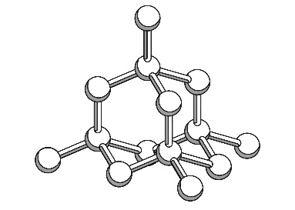 |  |  | Description of structure and bonding: | Diamond has a three-dimensional tetrahedral structure. Each carbon atom forms a single covalent bond with four other carbon atoms. This is a giant covalent structure as it does not contain a fixed number of carbon atoms. The number of atoms will vary depending on the crystal size.
 | Historic or modern discovery? |  | Historic (4th century) |  |  | No of bonds on each carbon atom: | 4
 | Use |  |  | Explanation for use
 | Drill bits for oil exploration |  |  | The tetrahedral structure of diamond makes it very hard so it can cut through rock and concrete.
 | Jewellery |  |  | Diamond has a high refractive index which means light is totally internally reflected. This makes diamonds sparkle.
 | Any other use from learners own research |  |  | Hardness for cutting or abrasion / Translucence for specialist windows / Low thermal conductivity for electronic heat sinks.

Allotrope: |  | BUCKMINSTERFULLERENE
 | 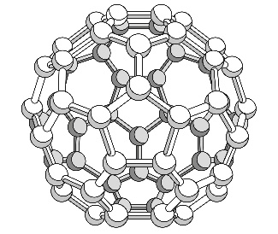 |  |  | Description of structure and bonding: | A football-like sphere made up of 20 hexagons and 12 pentagons. Each carbon atom forms a single covalent bond with three other carbon atoms. This is a large molecule but it is not considered a giant covalent structure as it is made of a fixed number of 60 carbon atoms.
 | Historic or modern discovery? |  | Modern (1984) |  |  | No of bonds on each carbon atom: | 3
 | Use |  |  | Explanation for use
 | Drug delivery |  |  | The cage like structure can carry drug molecules around the body and deliver them to where they are needed.
 | Any other use from learners own research |  |  | Could be used in safety goggles for people working with lasers due to changing opacity when exposed to light.
 | Any other use from learners own research |  |  | Potentially excellent lubricant due to shape / Could help improve catalysts due to high surface area to volume ratio.
Allotrope: |  | GRAPHITE
 | 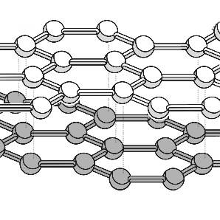 |  |  | Description of structure and bonding: | Flat sheets of hexagons forming multiple layers. Each carbon atom forms a single covalent bond with three other carbon atoms. There are delocalised electrons between the layers. This is a giant covalent structure as it does not contain a fixed number of carbon atoms.
 | Historic or modern discovery? |  | Historic (16th century) |  |  | No of bonds on each carbon atom: | 3
 | Use |  |  | Explanation for use
 | Pencil leads |  |  | The layers of graphite can easily slide over each other and flake off to leave a mark on your paper.
 | Nuclear reactor cores |  |  | Graphite needs to withstand high heat without melting when it is used to moderate the speed of nuclear reactions.
 | Any other use from learners own research |  |  | Used as a lubricant due to the layers / In electronics and batteries due to the delocalised electrons.

Allotrope: |  | GRAPHENE
 | 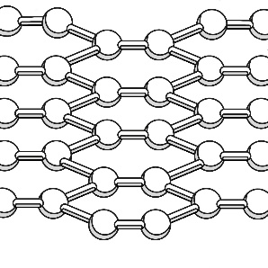 |  |  | Description of structure and bonding: | A single flat sheet of hexagons surrounded by delocalised electrons. Each carbon atom forms a single covalent bond with three other carbon atoms. This is a giant covalent structure as it does not contain a fixed number of carbon atoms.
 | Historic or modern discovery? |  | Modern (2004) |  |  | No of bonds on each carbon atom: | 3
 | Use |  |  | Explanation for use
 | Solar cells |  |  | As it is only a single atom thick, it is both translucent and flexible. Delocalised electrons are able to conduct electricity.
 | Electronic displays or smart glass |  |  | Delocalised electrons are able to conduct electricity and heat. As it is only a single atom thick it is translucent.
 | Any other use from learners own research |  |  | Graphene is lightweight, flexible, strong and an excellent conductor. Uses include transport / medicine / energy etc.

Allotrope: |  | DIAMOND
 |  |  |  | Shape: | Tetrahedral
 |  |  |  | Type of bonds (tick one): | - Giant ionic  - Giant covalent  - Simple covalent
 | Historic or modern discovery? |  | Historic |  |  | No of bonds on each carbon atom: | 4
 | Use |  |  | Why is it a good material for this purpose?
 | Drill bits |  |  | Structure means it is hard so it can cut through other materials.
 | Jewellery |  |  | It reflects and refracts light to give the characteristic sparkle.

Allotrope: |  | BUCKMINSTERFULLERENE
 |  |  |  | Shape: | Sphere made up of hexagons and pentagons
 |  |  |  | Type of bonds (tick one): | - Giant ionic  - Giant covalent  - Simple covalent
 | Historic or modern discovery? |  | Modern |  |  | No of bonds on each carbon atom: | 3
 | Use |  |  | Why is it a good material for this purpose?
 | Drug delivery |  |  | Medicine can be delivered to the right part of the body inside the cage.
 | Any other use from learners own research |  |  | Eg, could be used in safety goggles for people working with lasers due to changing opacity when exposed to light.

Allotrope: |  | GRAPHITE
 |  |  |  | Shape: | Layers of hexagons
 |  |  |  | Type of bonds (tick one): | - Giant ionic  - Giant covalent  - Simple covalent
 | Historic or modern discovery? |  | Historic |  |  | No of bonds on each carbon atom: | 3
 | Use |  |  | Why is it a good material for this purpose?
 | Pencil leads |  |  | The layers or graphite can easily slide over each other and flake off to leave a mark on your paper.
 | Nuclear reactor cores |  |  | Graphite needs to withstand high heat without melting when it is used to moderate the speed of nuclear reactions.

Allotrope: |  | GRAPHENE
 |  |  |  | Shape: | Single layer of hexagons
 |  |  |  | Type of bonds (tick one): | - Giant ionic  - Giant covalent  - Simple covalent
 | Historic or modern discovery? |  | Modern |  |  | No of bonds on each carbon atom: | 3
 | Use |  |  | Why is it a good material for this purpose?
 | Solar cells |  |  | As it is only a single atom thick, it is both translucent and flexible. Delocalised electrons are able to conduct electricity.
 | Electronic displays |  |  | Delocalised electrons are able to conduct electricity and heat. As it is only a single atom thick it is translucent.

