Precipitation reaction

❸ A few crystals of Pb(NO3)2

❹ Push crystals into drop

❷ 10 drops of water

❺ Push crystals into drop

❶ A few crystals of KI

Ensure a suitable risk assessment has been carried out before completing this activity. Teacher and technician notes available from [rsc.li/3dl7WbA](https://rsc.li/3dl7WbA)

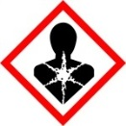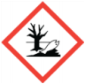Safety symbol indicating moderate warning
Safety symbol indicating eye protection must be wornNeutralisation reaction

1. Add a few crystals of potassium iodide to the left-hand small circle.
2. Add a few crystals of lead(II) nitrate(V) to the right-hand small circle.
3. Add 10 drops of water into the large central circle.
4. Carefully push the crystals into the edges of the drop of water.
5. Observe the dissolution of the crystals and the formation of lead iodide.

❶ A few crystals of Na2CO3

Ensure a suitable risk assessment has been carried out before completing this activity. Teacher and technician notes available from [rsc.li/3dl7WbA](https://rsc.li/3dl7WbA)

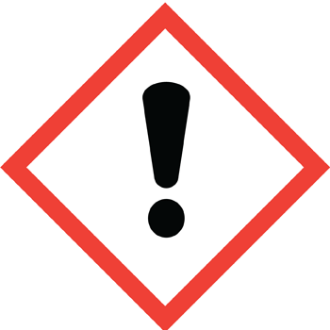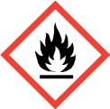

1. Add a few crystals of anhydrous sodium carbonate to the left-hand small circle.
2. Add a few crystals of citric acid to the   
   right-hand small circle.
3. Add 10 drops of water into the large central circle.
4. Add 1 drop of universal indicator solution to the central drop of water.
5. Carefully push the crystals into the edges of the drop of water.
6. Observe the dissolution of the crystals, the change in colour of the indicator, and the formation of carbon dioxide bubbles.

❻ Push crystals into drop

❷ 10 drops of water

❺ Push crystals into drop

❸ 1 drop UI solution

❹ A few crystals of citric acid