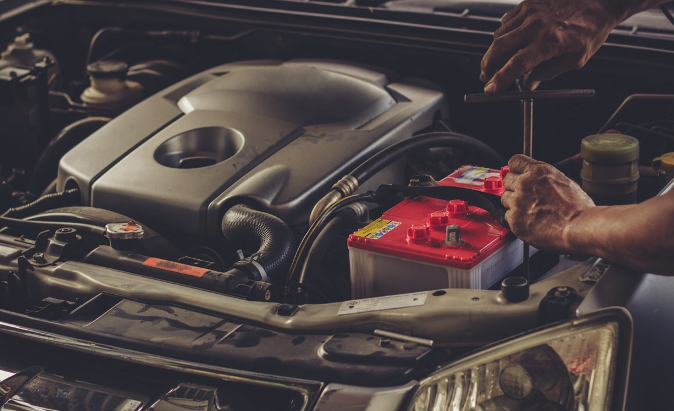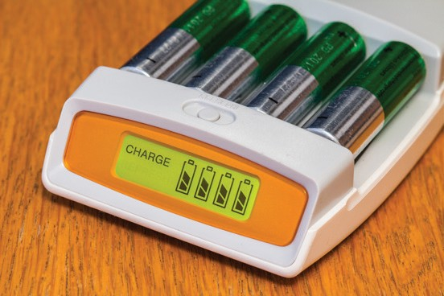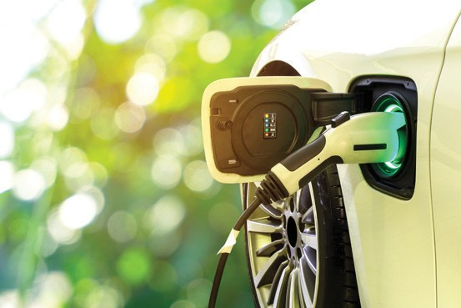



**Make a list of the everyday devices you use that require a battery. Separate your list into devices that use rechargeable batteries and those that don’t.**

**Make a timeline of the development of battery technology. You can watch this short** [**video**](https://www.youtube.com/watch?v=UxlJQ2ZLMIs) **(youtu.be/UxlJQ2ZLMIs) and use this** [**article**](https://phys.org/news/2015-04-history-batteries.html) **(bit.ly/3HVGqhh) to find the information you need.**

**Research different types of batteries and the materials they are made of. Use these websites to get you started:** [**Electronics Hub**](https://www.electronicshub.org/types-of-batteries/) **(bit.ly/3pLKVoj),** [**Components101**](https://components101.com/articles/different-types-of-batteries-and-their-uses) **(bit.ly/3sSrDQm).**

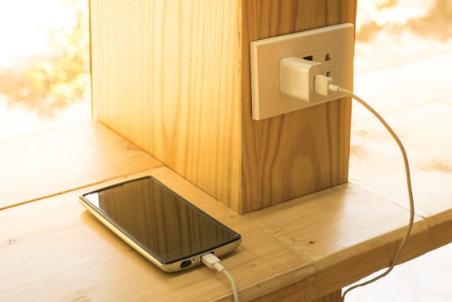

**Battery power**

**A short history of batteries**

Italian physicist Alessandro Volta developed the first working battery. Following a series of experiments during the 1790s, his simple battery, the voltaic pile, was demonstrated in about 1800.

The potential of batteries was quickly recognised and scientists around the world worked on improving the technology.

Experimenting with changing the materials, trying different metals and electrolytes, contributed to Gaston Planté inventing the lead– acid battery in 1859. This was the first rechargeable battery and is still used in modern cars.

*Lead–acid batteries are still used in modern cars*

The 1930s and 40s saw rapid development in battery technology. Zinc–silver oxide and zinc–mercuric oxide alkaline batteries gave a much higher energy output in a smaller battery.

Since the 1950s improved construction, the use of new materials and the improvements in rechargeable technology have made smaller, reusable and more powerful batteries that have widened the potential uses.

**Using batteries**

The first batteries were about proving the principle of being able to store and access ‘portable energy’. Since then, batteries have been developed that are suitable for use in all kinds of equipment, from tiny ear buds and watches to power tools and electric vehicles.

The increased reliance on mobile technology has created a huge commercial market for small, powerful batteries. These are used in spacecraft, laptop computers, mobile phones, and a wide range of other applications.

*Rechargeable batteries are now used in a wide variety of devices*

Take charge: global battery experiment

<https://rsc.li/takecharge>

© 2022 Royal Society of Chemistry

*Source: Shutterstock*

*Source: Shutterstock*

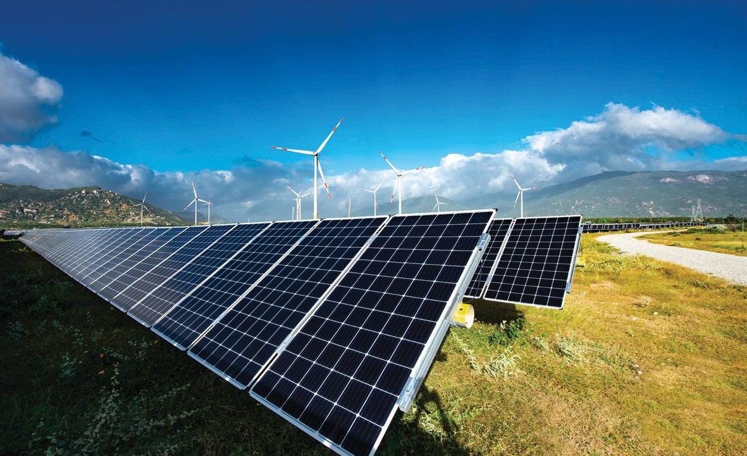

**Find three number-based facts about one of the wind and solar parks featured on this** [**website**](https://group.vattenfall.com/press-and-media/newsroom/2021/hybrid-parks--new-opportunities-with-multi-technology-facilities) **(bit.ly/3CvnR2C).**

**Choose a scientist working on battery technology from this list or find your own example. Explain in your own words what they are working on and why.**

**Design a city of the future that generates all its energy from renewable resources and uses batteries to store the energy as needed.**

*Scientists, like Haydn Francis, are working on batteries for the future*

Lots of scientists are working on developing better batteries. Here are just a few examples:

* [Emma Kendrick](https://www.youtube.com/watch?v=0nWprz72x-M) and her energy materials research group are working on projects to do with sustainability and batteries (youtu.be/0nWprz72x-M)
* [Haydn Francis](https://www.youtube.com/watch?v=u4jnVFFNKNc&list=PL6jpp96E0LS0gFdFGweSrwMv5IjEPSXZb) is researching how to make better performing batteries (youtu.be/u4jnVFFNKNc)
* [M. Rosa Palacín](https://www.youtube.com/watch?v=wx_bRo6avNc) is researching batteries made from different materials (youtu.be/wx_bRo6avNc)

One of the challenges for the battery industry is the disposal, or recycling, of batteries when they have reached the end of their useful life.

* [Zubera Iqbal](https://edu.rsc.org/job-profiles/research-fellow-battery-recycling/4013825.article) is discovering ways to recycle precious materials from electric car batteries (rsc.li/3sUz6OL)



*Source: The Faraday Institute*

*Source: Shutterstock*

The continued development of mobile technology and electric vehicles is driving rapid advances in battery technology. Smaller, lighter batteries that last for longer and can be recharged faster are being developed every year.

**The future of battery technology**

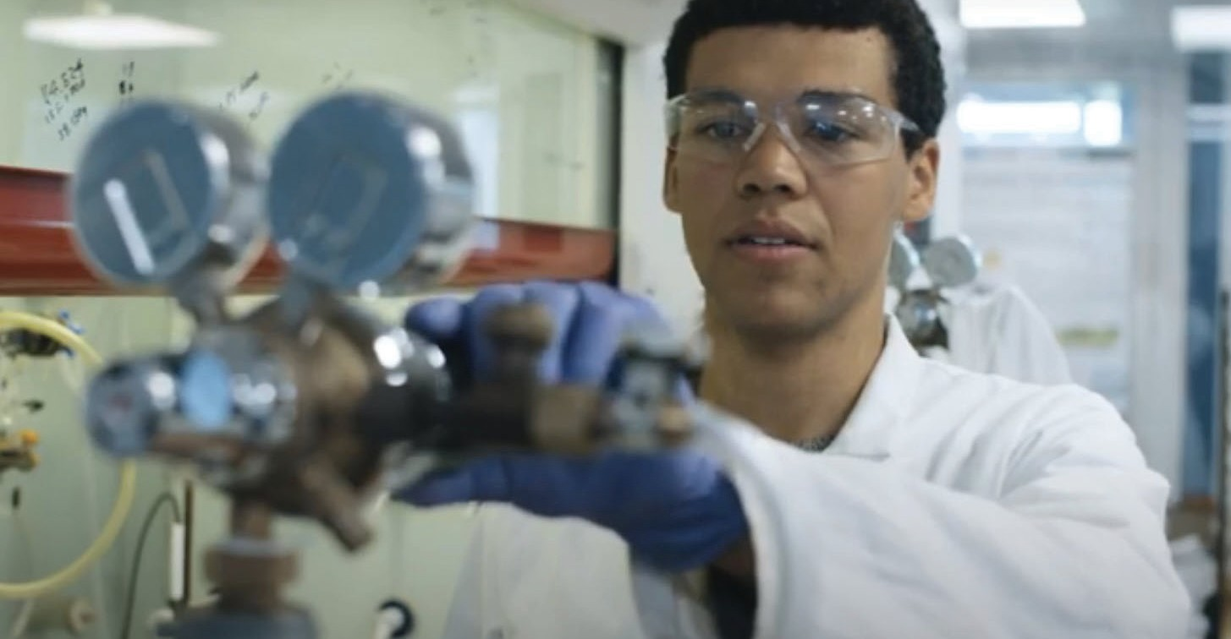

**Batteries and renewable power**

As we switch to renewable energy resources to meet the global demand for energy, we need to use more solar, hydroelectric and wind power instead of fossil fuels.

The disadvantage of solar energy and wind power is that electricity is only generated when the sun shines or the wind blows. To overcome this challenge, we need to be able to store energy as it is generated so it can be used when needed. To do that, battery technology needs to be developed on a huge scale.

Take charge: global battery experiment

<https://rsc.li/takecharge>

© 2022 Royal Society of Chemistry