# Exam wrapper template

***Education in Chemistry***March 2019  
rsc.li/2Uz5mGO

**Did you improve on your previous score?**

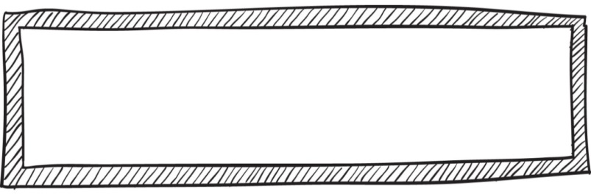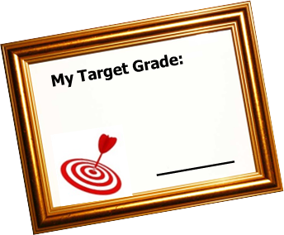An exam wrapper guides students through reflecting on key areas. Use this template to build a suitable exam wrapper for your classes.

## http://www.7questions1answer.com/images/nextStepLrg.gifhttp://www.leadershipplatform.com/new/wp-content/uploads/2013/03/Evaluate.jpgC:\Users\lst\AppData\Local\Microsoft\Windows\Temporary Internet Files\Content.IE5\MUX1EB1E\large-Clipboard-Background-33.3-12658[1].gifhttp://catchat.ca/~catchat/images/stories/vbs/CCVBS2-CDROM/clipart/FootPrints%20-%20all%203%20copy.jpgC:\Users\lst\AppData\Local\Microsoft\Windows\Temporary Internet Files\Content.IE5\JNW5KERL\Check_mark_23x20_02.svg[1].pnghttp://www.7questions1answer.com/images/nextStepLrg.gifC:\Users\lst\AppData\Local\Microsoft\Windows\Temporary Internet Files\Content.IE5\JNW5KERL\loose-leaf-paper[1].pngC:\Users\lst\AppData\Local\Microsoft\Windows\Temporary Internet Files\Content.IE5\MUX1EB1E\120px-Tick-green[1].pngC:\Users\lst\AppData\Local\Microsoft\Windows\Temporary Internet Files\Content.IE5\B05SYUDW\albert_einstein_professor[1].png

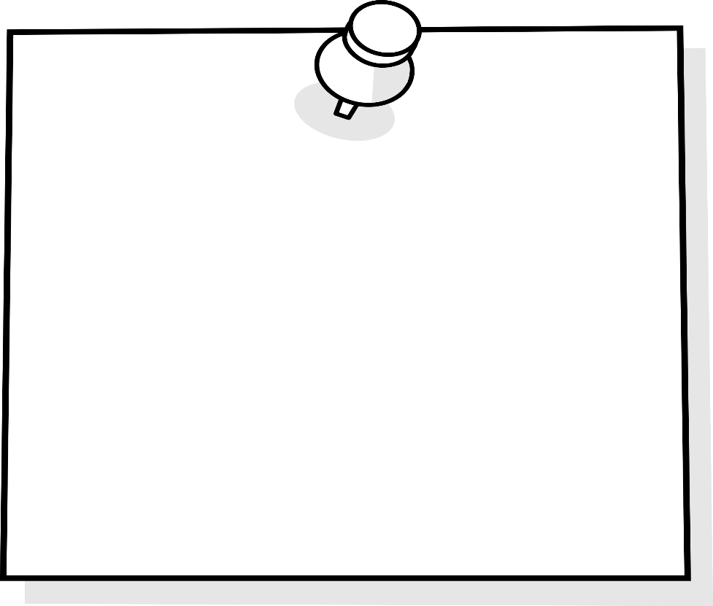

**What percentage of your test-preparation time was spend on each of these activities?**

1. Reviewing next steps from feedback \_\_\_\_\_\_
2. Completing revision guide questions \_\_\_\_\_\_
3. Re-doing exam questions from class \_\_\_\_\_\_
4. Using Seneca or Quizlet \_\_\_\_\_\_
5. Solving problems for practice \_\_\_\_\_\_
6. Getting people to quiz you \_\_\_\_\_\_
7. Flash card quizzes \_\_\_\_\_\_
8. Other \_\_\_\_\_\_

(Please specify \_\_\_\_\_\_\_\_\_\_\_\_\_\_\_\_\_\_)



**Topics to work on:**

Identify what aspects of these questions you struggled with. Put these as your next steps.

**Did you improve on your previous score?**

**Now you have looked over your graded exam, estimate the number of marks you lost due to each of the following:**

1. Not learning all of the equations \_\_\_\_\_
2. Not reviewing the Knowledge organiser definitions \_\_\_\_\_
3. Misunderstanding the question \_\_\_\_
4. Problem with evaluating data from questions \_\_\_\_\_
5. Not showing your working for calculations \_\_\_\_\_
6. Careless mistakes \_\_\_\_\_
7. Other (Please specify) \_\_\_\_\_

**What specifically will you do to improve?**

………………………………………………

………………………………………………

………………………………………………

………………………………………………

………………………………………………

………………………………………………

………………………………………………

………………………………………………

………………………………………………

………………………………………………..

………………………………………………..

………………………………………………..

………………………………………………..

………………………………………………..

…………………………………………………

…………………………………………………

…………………………………………………

**What specifically will you do to improve?**

**Now that you have looked over your graded exam, estimate the number of marks you lost due to each of the following:**

1. Not learning all of the equations \_\_\_\_\_
2. Not reviewing the Knowledge organiser definitions \_\_\_\_\_
3. Misunderstanding the question \_\_\_\_
4. Problem with evaluating data from questions \_\_\_\_\_
5. Not showing your working for calculations \_\_\_\_\_
6. Careless mistakes \_\_\_\_\_
7. Other (Please specify) \_\_\_\_\_

Students sometimes have difficulty with **Biofuels**. Identify what aspects of this questions you struggled with. Put these as your Next steps

**What topics went well:**

**Topics to work on:**

**1st exam 2nd exam**

**Mark: \_\_\_\_ / \_\_\_\_\_ Mark: \_\_\_\_ / \_\_\_\_\_**

**Percentage: \_\_\_\_% Percentage: \_\_\_\_%**