- Crude oil is made of many hydrocarbons.

- Complete the sentence:
Hydrocarbons contain two elements only.
They are called and .
- Which of these molecules are hydrocarbons?
Tick the boxes.

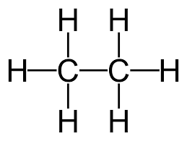 | 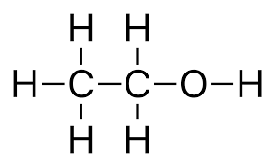 | 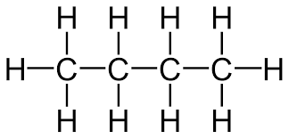

- One family of hydrocarbons found in crude oil is called the alkanes.
Here are the first four members of the alkane homologous series (family):
 | 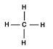 | 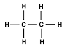 | 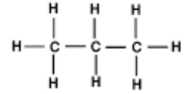 | 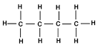
Name
Molecular formula
- Name each of these alkanes.
Write your answers in the table.
- What is the molecular formula for each of these alkanes.
Write your answers in the table.
- What is the molecular formula of the next alkane in the family?

- The alkanes have a general formula.
The letter n is the number of carbon atoms in an alkane molecule.
- How many hydrogen atoms would there be in in alkane?
You may wish to use the information in the table in question 2 to help you.

- Complete the general formula for the alkanes:
General formula for the alkanes = C_{n}H .

- Use the names, formulae or structures to work out which of the molecules are hydrocarbons and which are alkanes.
Place a tick or cross in the box.

 | Hydrocarbon | Alkane
H₂O
C₅H₁₂
C₄H₈
C₂H₅OH
Pentane
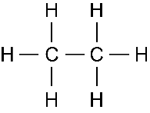
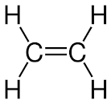

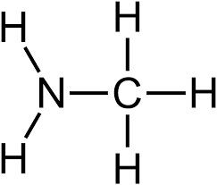

- Alkanes are saturated hydrocarbons.

- What is meant by saturated?

- Which molecules in the table in question 3 are saturated hydrocarbons?

