The formation of 2,4,6-trichlorohydroxybenzene by the reaction between hydroxybenzene and chlorine gas – student sheet

In this experiment you will be generating chlorine gas inside a plastic Petri dish and reacting it with crystals of hydroxybenzene (phenol). You will detect the product by its distinctive smell.

Procedure
- Cover the worksheet with a clear plastic sheet.
- Place the base of the Petri dish over the circle provided below.
- Cut the end off the plastic pipette and place the small cup – the reaction vessel – at the edge of the Petri dish as indicated.
- Using the hydroxybenzene (phenol) sampling technique (ask your teacher) place a small quantity of hydroxybenzene (phenol) in the Petri dish as indicated.
- Add two drops of bleach to the reaction vessel, followed by two drops of hydrochloric acid. Quickly place the lid on the Petri dish.
- Leave for 15 minutes, then take off the lid. Smell briefly and cautiously – avoid inhaling more than you need. What kind of smell do you recognise?
- When you have finished, add a few drops of sodium hydroxide to the reaction mixture to dissolve the solid, and then mop up the solution with tissues.

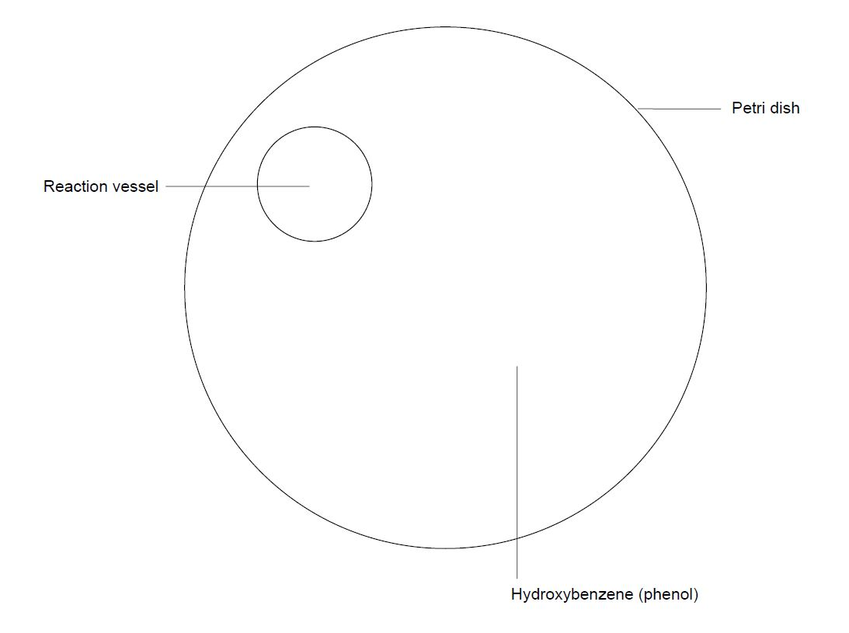

Student questions
What do you observe, and can you write equations for the reactions occurring:
- To produce chlorine?
- How the chlorine reacts with the hydroxybenzene?
- What type of reaction is this?

Health, safety and technical notes
- Students must wear suitable eye protection (Splash resistant goggles to BS EN166 3).
- Hydroxybenzene (phenol) is toxic, corrosive and a mutagen: gloves should be worn (see CLEAPss Hazard HC070a).
- Sodium hydroxide solution, NaOH (aq), 1 mol dm^{—3}, is corrosive (see CLEAPSS Hazcard HC091a).
- Hydrochloric acid, HCl(aq), 1 mol dm^{–3}, is low hazard (see CLEAPSS Hazcard HC047a)
- 2,4,6-trichlorohydroxybenzene is harmful if swallowed, irritant to skin, eyes and respiratory system and a probable carcinogen (category 2) – care should be taken to inhale only the smallest amount needed for identification.
- Household bleach solutions (containing sodium chlorate(I)/sodium hypochlorite) sold for the domestic market may be corrosive but is commonly more dilute and irritant. Check the label. Even quite dilute bleach is irritant if more than NaOCl, 0.15 M.

Some bleaches also contain detergents and thickening agents, which may cause excessive frothing in this experiment so choose a thin bleach.

Note that nowadays some commercially available bleaches do not contain any chlorine and are based on peroxy-compounds. They should not be used here.

