Melting chocolate: Answer sheet and mark scheme
Education in Chemistry
February 2021
rsc.li/3udcF5V

Part 1: Prior knowledge
- a. What do you think happens to the temperature of a liquid as it is cooled beyond its freezing point?
Depending on prior knowledge, possible responses may be:
- turns to solid/it freezes
- nothing, as it’s already a solid
- it gets colder/decreases
- temperature stays the same as it’s freezing

b. Complete a sketch on the graph below to show what you predict will happen:
Depending on answer above, possible sketches may be below (different colours based on different interpretations):
Time (min)
Temperature (°C)

Encourage learners to compare their ideas at the end of the activity to their prediction at the start. How have their ideas changed?
c. Will the temperature carry on falling when the liquid is changing into a solid? Why?
Correct response would be: No, the temperature stays constant during a change of state because energy is being used to form attractive forces between particles, rather than change the temperature of the surroundings.
A more complex explanation linked to physics knowledge may be: During a change of state no energy is lost as attractive forces form. Forces transfer the energy into the particles so the attractive forces can act. After solidification, temperature and energy will continue to be transferred into the surroundings.
However, learners may incorrectly say: Yes, as the surroundings are getting colder/it needs to continue to drop so it’s cold enough to freeze. This is an opportunity to address misconceptions before moving on or to check back to see if progress has been made by the end of the activity.

Part 2: Data table
Juliet heated equal volumes of dark, milk and white chocolate in a boiling tube placed in a water bath until completely melted. She transferred the melted chocolate to an ice-bath to cool and measured the temperature every minute for 20 minutes. She recorded the temperature in the table below:
Time (mins) | Temperature of chocolate (°C)
 | Dark | Milk | White
0 | 45.0 | 45.0 | 45.0
1 | 44.0 | 43.0 | 42.5
2 | 41.0 | 40.0 | 38.0
3 | 39.0 | 36.0 | 35.0
4 | 36.0 | 32.0 | 31.0
5 | 35.0 | 31.0 | 29.0
6 | 34.0 | 30.0 | 26.0
7 | 34.0 | 30.0 | 23.0
8 | 33.0 | 29.0 | 22.0
9 | 31.0 | 28.0 | 21.0
10 | 29.0 | 27.0 | 20.0
11 | 26.0 | 26.0 | 20.0
12 | 24.0 | 25.0 | 19.0
13 | 21.0 | 24.0 | 18.0
14 | 19.0 | 21.0 | 16.0
15 | 16.0 | 19.0 | 14.0
16 | 14.0 | 16.0 | 12.0
17 | 12.0 | 14.0 | 11.0
18 | 10.0 | 11.0 | 8.0
19 | 8.0 | 9.0 | 7.0
20 | 5.0 | 6.0 | 4.0

Part 3: Drawing a graph
- a. Plot a graph of Juliet’s results, choosing appropriate scales for the axes. Your x-axis should be time and the y-axis should be temperature. Make sure you use a different colour or symbol for each type of chocolate.
As all learners may have chosen different scales, below is a checkpoint for learners to self-assess their graph:
- My graph has a title.
- I have included the units on the x-axis: Time (mins).
- I have included the units on the y-axis: Temperature (°C).
- My scale on the x-axis increases by the same increment each time, eg 0, 1, 2, 3 or 0, 2, 4, 6.
- My scale on the y-axis increases by the same increment each time, eg 0, 5, 10, 15.
- There are equal spaces between each number on my scale.
- I have used as much of the paper as possible. (I couldn’t have used a smaller increment as all the data wouldn’t have fit on the paper).
- I have used a different colour/symbol for milk, dark and white chocolate.
- I have included a key to say which colour/symbol is for milk, dark and white chocolate.
- I have joined my points together as a smooth curve of best fit.

If learners used the support axes, below is a copy of the correctly plotted points. You may want to show this as the model answer to learners who haven’t used the support, just with a note to say it may look slightly different if they have chosen different scales.
b. Draw a smooth curve of best fit for each chocolate. Use the same colour as you did when plotting the data. Think carefully about any changes in gradient that occur.
See below for an example of a smooth curve of best fit.
c. Label the region of each curve when the chocolates were freezing. What do you notice about the shape of the graph at this point?
Learners should notice when the different chocolates are freezing, the line/gradient becomes less steep.
A good answer would include a sense of time, eg ‘temperature decreases at a slower rate’.
d. Label the region of each curve where the chocolates were liquid.
See below.
e. Label the region of each curve where the chocolates were solid.
See below.

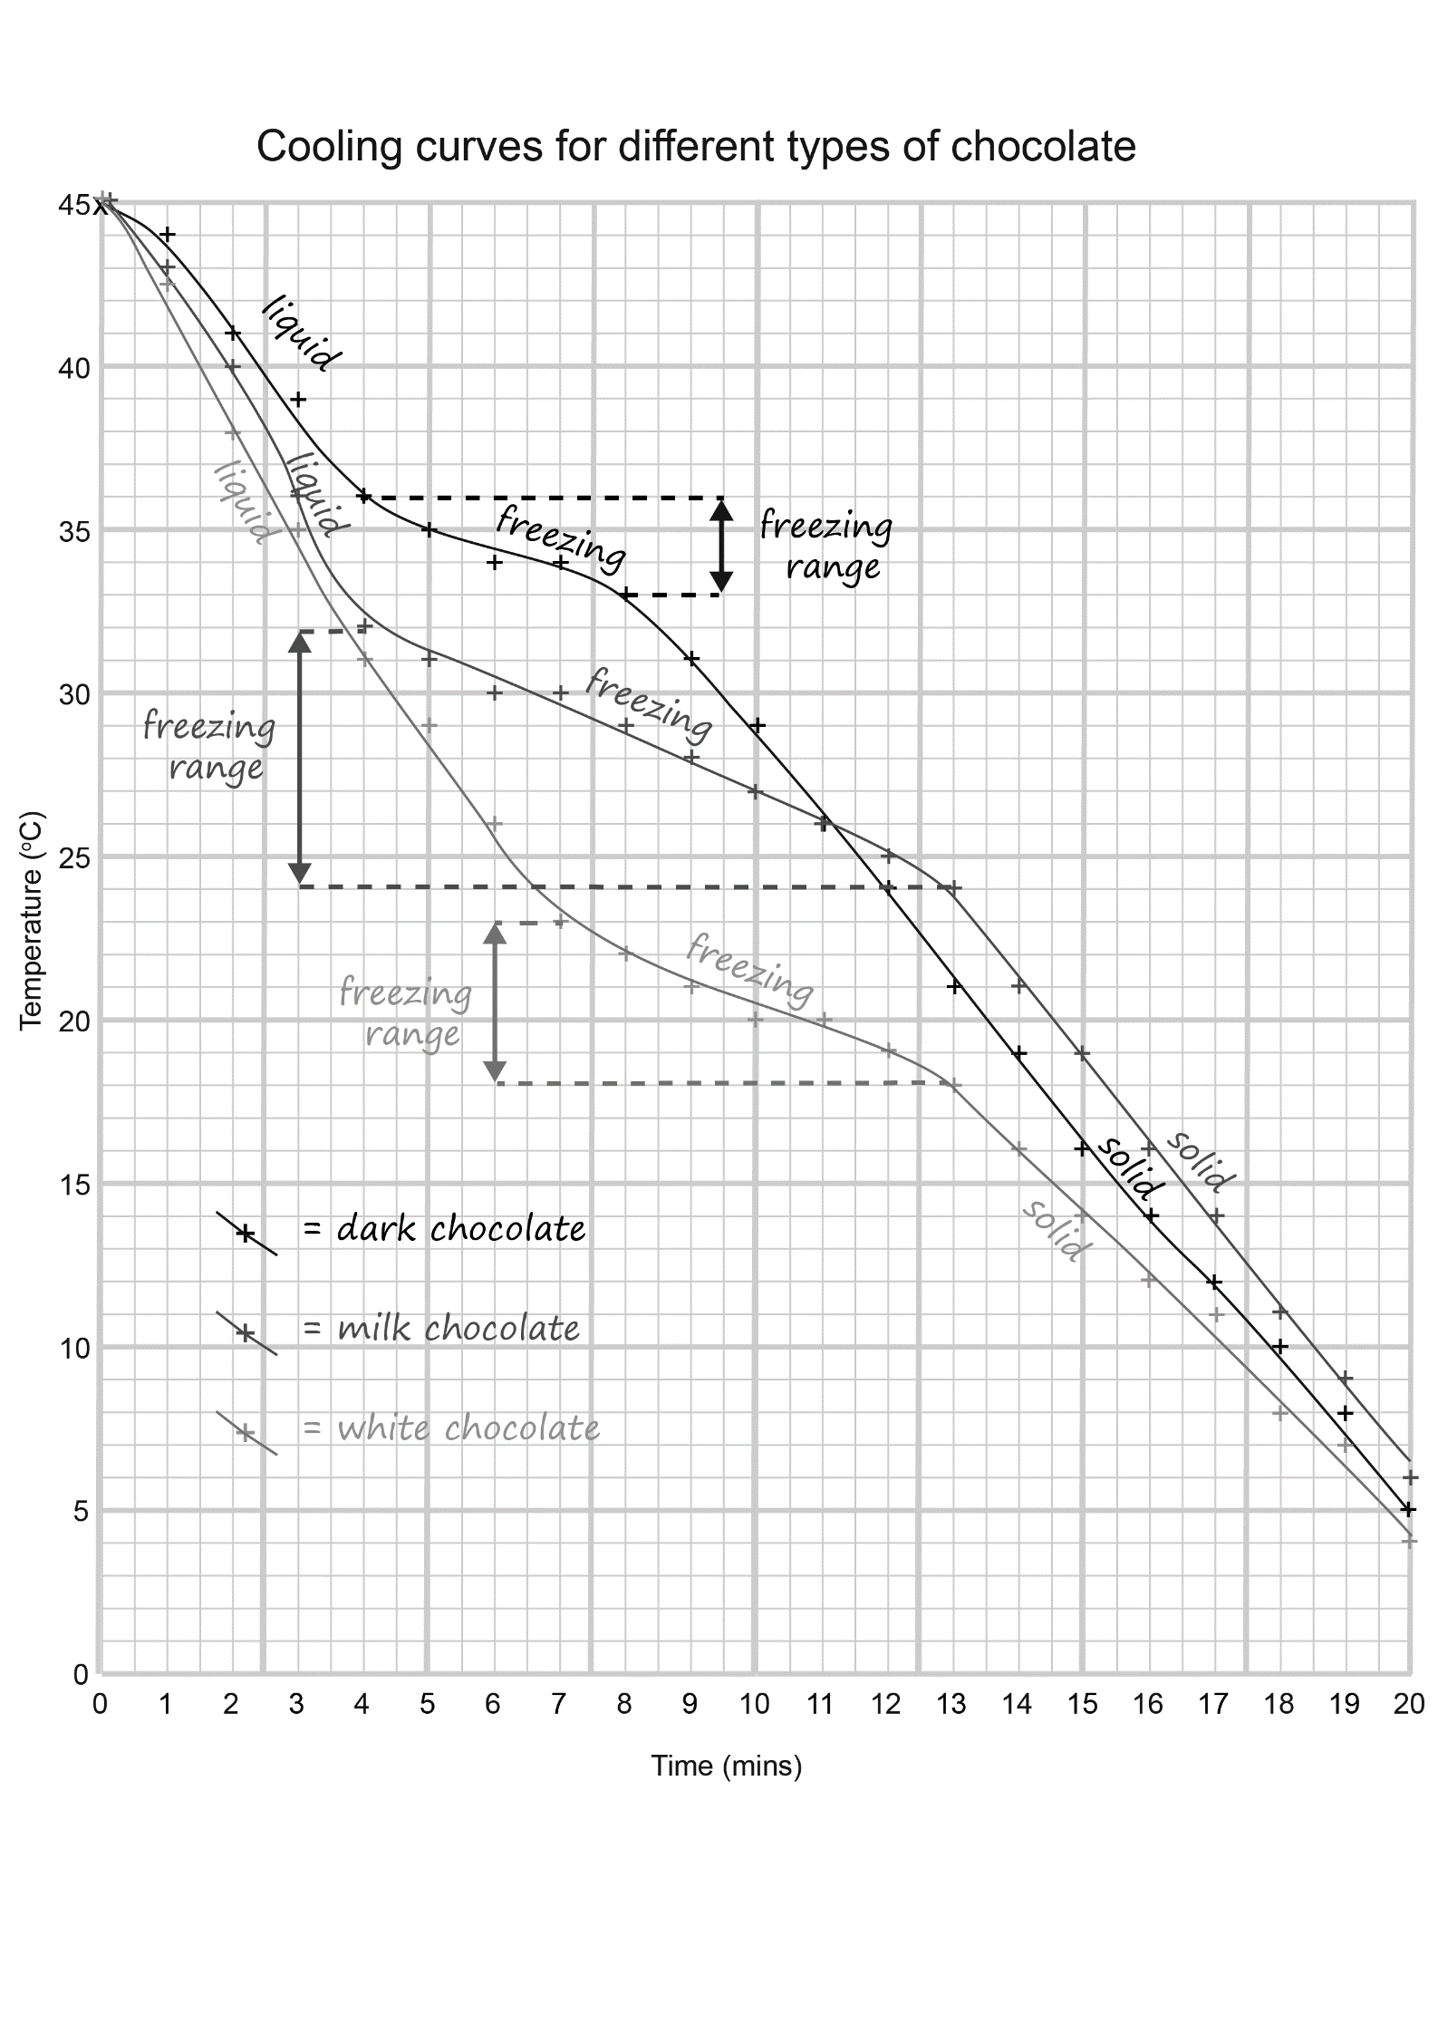

Part 4: Interpreting your graph
- Describe the shape of the graph you have drawn.
The gradient for all three chocolates follows broadly the same trend. The temperature constantly decreases (from 45°C to between 4 and 6°C). When the chocolate is freezing, the temperature decreases at a slower rate/the temperature doesn’t drop as quickly. Learners may have quoted the freezing range – see Q7 for answer.

- Using your graph, can you determine the freezing point of the chocolates? Why?/Why not?
No, as chocolate is not a pure substance it does not have a freezing point. There is no flat region of the graph from which to identify a single temperature. You can, however, determine the freezing range for the mixture as the curve becomes less steep/there is a change to the downwards curve while the chocolate is solidifying.

- Explain the shape of the graph you have drawn. (Remember: chocolate is a mixture).
The chocolate is decreasing in temperature as energy is transferred from the chocolate to the surroundings in order to reach equilibrium with the ice bath it is placed in. The rate of cooling is steeper at first because the liquid chocolate is cooling down quickly. The rate of cooling changes as the chocolate begins to freeze/solidify. When substances change state, there is not a change in temperature as the energy is being used to overcome/form attractive forces between the particles. As chocolate is a mixture, it melts/freezes over a range of temperatures because not all parts will change state at the same time. Once the chocolate has completely set/solidified, the rate of cooling increases again as the solid chocolate cools towards the temperature of the ice bath.

- Complete these sentences below:
  - Mixtures melt over a range of temperatures.

  - A mixture does not have a fixed* melting point whereas a pure substance has a
fixed* melting point.

*Other appropriate answers: definite, exact, specific, precise

Part 5: Comparing the results
Dark, milk and white chocolate contain different amounts of cocoa solids and cocoa butter. This affects the way they behave as they melt and freeze. You need to use data from the graph to compare the behaviour of the three chocolate types as they changed back into solids.
- State the freezing range for each type of chocolate. Indicate the range on your graph.
The range can be seen on the answer graph for Q2.
Learners should see the change in curve for:
- milk chocolate is between 4 and 13 minutes and thus the freezing range is 32–24°C.
- dark chocolate is between 4 and 8 minutes and thus the freezing range is 36–33°C.
- white chocolate is between 7 and 13 minutes and thus the freezing range is 23 –18°C.
Allow error carried forward based on the gradient of the curves drawn.

- Which chocolate started to freeze at the highest temperature? Use evidence from the graph to support your answer.
Dark chocolate because that started to freeze at 36°C whereas milk started at 32°C and white at 23°C.
- Which chocolate took the longest to change from a solid to a liquid? Use at least two sets of data from the graph to support your answer.
Milk chocolate took the longest to change because the change in gradient began at 4 minutes and ended at 13 minutes. This is a difference of 9 minutes. The range for dark chocolate is 4 minutes and for white is 6 minutes.
Leaners may give a correct answer of milk chocolate that is incorrectly supported by temperature ranges.

- Describe what is happening to both the dark and milk chocolate at 11 minutes.
Both the dark and milk chocolate have a temperature of 26°C at 11 minutes.
The dark chocolate has already frozen, so is a solid. The solid is getting colder.
The milk chocolate is freezing – it is changing state from liquid to solid. The chocolate is getting colder but at a slower rate.
The dark chocolate is cooling at a faster rate than the milk chocolate therefore their curves cross at this point.
- Juliet says: ‘White chocolate took the longest to set.’ Do you agree? Use data from the graph to support your answer.
Learners may agree or disagree but their decision must be supported by evidence. For example:
No. Both the white chocolate and the milk chocolate had fully ‘set’ (turned to a solid) by 13 minutes so they took the same amount of time to solidify.
No. The white chocolate began to set at 7 minutes and had fully solidified by 13 minutes, which is a freezing time of only 6 minutes, whereas the milk chocolate began to ‘set’ at 4 minutes and had fully solidified by 13 minutes which is a freezing time of 9 minutes. The milk chocolate took longer to set.
Yes. The white chocolate did not begin to set until 7 minutes, whereas the milk chocolate and dark chocolate had both started to solidify at 4 minutes.

Challenge
- Below is a cooling curve of stearic acid:
Time (min)
Temperature (°C)
a
b
c

Add the labels a, b and c to the graph to show:
  - the freezing point
  - the substance in solid state and cooling down
  - the substance in liquid state and cooling down
- Describe the shape of the graph.
The first part of the graph, labelled c, shows a decrease in temperature. Then for a certain time period, labelled a, the temperature does not change. Then the temperature continues to decrease again, labelled b. The gradient of the graph at b is not as steep as it was at c.

- Explain the shape of the graph.
The first part of the graph shows a decrease in temperature because the average internal/kinetic energy stored in the particles is decreasing. As the particles transfer energy to their surroundings they are slowing down. The gradient of the graph is steep at this point, labelled c, because the difference between the temperature of the liquid stearic acid and the surroundings is largest at the start, therefore the rate of cooling is fastest here.
The temperature then didn’t change for a period of time, labelled a, as this was the change of state. The reason the temperature remained constant was because energy is being used to form attractive forces between the particles. The freezing point is horizontal/fixed because stearic acid is a pure substance.
Once it has become a solid, the temperature continues to fall as the particles slow down further, labelled b. The gradient of the graph is not as steep as it was at c, because the temperature difference between the solid stearic acid and the surroundings is not as large as it was at the start. The rate of cooling is therefore slower during the part labelled b.

- Compare and contrast the stearic acid graph with the melting chocolate graph.
Similarities
- In both graphs, the temperature decreased.
- In both graphs, there was a change to the trend during the change of state.

Differences
- The stearic acid graph shows a horizontal line during the change of state, whereas in the melting chocolate graph the line becomes less steep during the change of state. This is because stearic acid is a pure substance so has a fixed melting/freezing point, but chocolate is a mixture so has a range of temperatures for its melting/freezing point.
- Learners may recall that the freezing temperature for stearic acid is 69.3°C. This is higher than the freezing range for any of the chocolate types.
- The table shows some melting points and boiling points.
Substance | Melting point (°C) | Boiling point (°C)
A | -115 | 80
B | -73 | -37
C | -221 | -189
D | -50 | 340

Complete the table to show the state of each substance at the temperature shown.
Temperature (°C) | A | B | C | D
215 | Gas | Gas | Gas | Liquid
0 | Liquid | Gas | Gas | Liquid
-215 | Solid | Solid | Liquid | Solid

- On the axes below draw a sketch to show the cooling curve of any pure substance and a sketch to show the cooling curve of any mixture.
For a pure substance, a horizontal line for its freezing point.
For a mixture, a less steep line (to show the range in temperature) for its freezing point.
Compare these graphs at the end of the activity with the graph drawn in Q1c. Have any misconceptions been addressed? How has learning progressed?
Pure: Mixture:
Time (mins)
Temperature (°C)
Time (mins)
Temperature (°C)

