Scrutinising shampoo bottles

Introduction

This is an extract from the Education in Chemistry article ‘Cosmetics: what’s on the label?’ Use the information in this extract to help you with the classroom activities.

Cosmetics: what’s on the label?

By Hayley Bennett

Ingredients lists on cosmetics and personal care items can be difficult to make sense of, owing to the large number of chemical names that we don’t recognise and terms like ‘fragrance’, which seem too general to be helpful.

EU and UK laws require all ingredients in a cosmetic product to be listed on the label. They must be labelled using the internationally recognised names found on the International Nomenclature Cosmetic Ingredient (INCI) list, which includes over 22,000 names. This ensures that marigold seed oil is always listed as Calendula officinalis seed oil – rather than ‘Jack-on-horseback’ seed oil, for example, based on another common name for marigolds.

Common ingredients | What does this mean?
Aqua | Another term for water.
Extract | Natural extracts from plants are common ingredients, but are mixes of various compounds which are difficult to standardise.
Glyceryl | In front of ‘oleate’, stearate’, ‘cocoate’, is a type of glycerol used as an emulsifier to help retain moisture.
Paraben | Often attached to ‘methyl’, ethyl, ‘propyl’ or ‘butyl’, is usually a preservative with a particular chemical structure. There has been debate about the safety of these chemicals due to hormone-disrupting effects and links to cancer.
Parfum | A fragrance or aroma compound, or a blend of these compounds.
Sodium laureth sulfate | A widely used cleaning and foaming agent made from palm or coconut oil.

The same ingredient names are used in every European country and most countries worldwide. This helps users to identify products with ingredients to which they know they are allergic or sensitive.

Scent secrets

‘Parfum’ is an exception to the ingredients listing rules as it means names for specific chemicals don’t have to be listed. This protects companies from having to spill the secrets of their scents. However, protecting trade secrets leaves consumers in the dark when it comes to evaluating the label and recent research suggests that many millions of people are sensitive to fragranced products.

There are some fragrance ingredients that are listed separately on labels because they are known to cause allergies, with more due to join this select group soon. All the ingredients that make up a fragrance do have to be assessed as part of a product’s overall safety assessment.

Does natural mean safe?

Another issue is with the perception of natural chemicals compared to synthetic ones. You might see an extract from a seed or a flower as being safer, when in fact, whether ingredients are natural, organic or manmade has no bearing on how safe they are. Only this year, regulation came into force preventing extracts of oak tree moss from being sold in the EU. It’s claimed these were once used in the iconic perfume Chanel No. 5.

Natural extracts can also be unpredictable because they contain mixtures of different chemicals at varying concentrations depending on, for example, where a plant was grown and how the extract was prepared.

During research, a random selection of 100 ‘natural’ personal care products was found to contain many chemicals classified as dangerous under the EU’s Classifying, Labelling and Packaging Regulation – meaning they have to display a hazard symbol known as a pictogram. However, while this regulation applies to varnishes and glues, for example, it does not apply to personal care products.

So, you can’t assume that absolutely everything is listed on the label or that ‘natural’ means safer. All chemicals have the potential to cause a reaction when you’re spritzing them or spreading them on your skin. For those with sensitivities, it might be worth avoiding products and ingredients that seem to cause irritation – even when they provide that classic look (or smell) that you love.

With thanks to Emma Meredith, Director-General at The Cosmetic, Toiletry and Perfumery Association (CTPA) and Ursula Klaschka, who studies hazardous substances at Ulm University of Applied Sciences in Germany.

Scrutinising shampoo bottles

Learning objectives
- Categorise ingredients as mixtures and non-mixtures.
- Recognise the roles that ingredients play in personal cleaning products.
- Identify potential sources of allergens.
- Debate the importance of chemical names in ingredient lists.

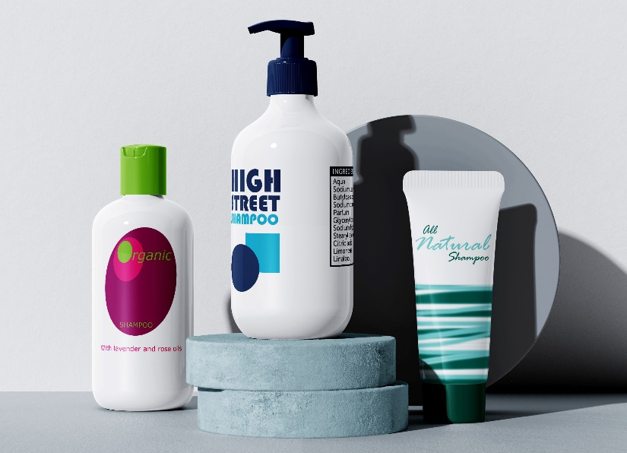
Introduction

Shampoo bottle labels have long lists of ingredients, some with complicated sounding chemical names. In this activity you will consider three different fictional brands of shampoo and scrutinise the labels for ingredients and allergens.

The ingredients of the three brands pictured are given in the table below:

Organic brand | High street brand | All-natural brand
Aqua  Cocos nucifera oil  Sodium laureth sulfate  Gyceryl cocoate  Lauryl alcohol  Methylparaben  Sodium hydroxide  Limonene  Citral  Lavandula angustifolia oil*  Rosa damascena oil* | Aqua  Sodium laureth sulfate  Butylparaben  Sodium chloride  Parfum  Glyceryl cocoate  Sodium hydroxide  Stearyl alcohol  Citric acid  Limonene  Linalool | Aloe vera leaf extract  Glycerin  Coconut oil  Crambe abyssinica seed oil  Lemongrass herb oil  Camellia leaf extract  Salvia sclarea extract  Xanthan gum  Aqua  Lemon peel  Lavender oil

*These ingredients have been produced in accordance with regulations for organic labelling.

Comprehension questions

Read the extract from the Education in Chemistry article ‘Cosmetics: what’s on the label?’ Use the information in the extract to help you answer the following comprehension questions about shampoo bottle labelling.

- Match the ingredients below to their purpose in the shampoo:

Butylparaben |  | Causes the shampoo to lather.
Sodium laureth sulfate |  | Makes the shampoo smell nice.
Aqua |  | Prevents mould from growing in the shampoo bottle.
Aloe vera leaf extract |  | Moisturises the hair to keep it sleek and shiny.
Glyceryl cocoate |  | Blends all the ingredients together.
Parfum |  | Plant ingredient which is claimed to have benefits for the hair and has a fragrance.

- Circle the ingredients that are mixtures:

sodium chloride aqua parfum glyceryl cocoate lavender oil
- The International Nomenclature Cosmetic Ingredient (INCI) list typically uses botanical names such as Lavandula angustifolia (lavender) for plant oils and extracts. Which of the shampoo brands is not compliant with UK and EU law?

__________________________________________________________________________________
- Circle the ingredients which are listed using their chemical name:

aqua sodium laureth sulfate citric acid coconut oil sodium chloride
- Olena has an allergy to citral which causes skin irritation to her scalp and a skin rash. Citral is a main component of citrus peel with a strong citrus fragrance.
- Look closely at the ingredients of the three shampoo brands. Choose the statement below that correctly identifies the brands Olena could safely use.

□ Any of the shampoo brands could be used without worry of irritation.

□ The high street brand and the all-natural brand could be used without worry of irritation.

□ Only the high street brand could be used without worry of irritation.

□ Only the all-natural brand could be used without worry of irritation.

□ None of the brands could be used without worry of irritation.

- Explain your choice of statement above, referring to the ingredients on the shampoo bottle labels:

__________________________________________________________________________________

__________________________________________________________________________________

__________________________________________________________________________________

__________________________________________________________________________________

__________________________________________________________________________________

- Consider the opinions shared below. Who do you agree with most? Why? Discuss with a partner and be ready to share your ideas with the class.
Everything is a chemical. Even water is a chemical. I am not worried about chemical names as long as the ingredients are safe.
I always choose organic because all the ingredients have been produced in a way that is kinder to the planet.
All-natural shampoo is the gentlest option for your hair and scalp because it doesn’t contain any nasty chemicals.
Not everything is listed on the ingredients list. Secret formulas mean people with allergies cannot shop with confidence.
All these long words are confusing. It would be so much easier if the companies used common names for the ingredients.

