Finding food fraud with chromatography, 11–14
Education in Chemistry
July 2018
rsc.li/2JbAXsJ
Scientists use chromatography every day in the fight against food fraud. Read the article Poisoned by milk to find out how key this technique was to solving one particularly high profile case in food fraud.

Full of natural goodness?
Now consider this scenario and attempt the questions that follow.
Sweets sold in the UK contain colourings and additives known as E numbers. These are safety tested and approved for food use. Some of them are naturally derived, for example beetroot is commonly used for pink or red colours. Some E numbers are synthetic, made by scientists in the lab. Although synthetic colourings are safety tested to the same standards, many customers prefer to buy sweets containing only natural colours.
The Jellyfish Sweet Co advertises its jelly sweets as ‘full of natural goodness’. The ingredients listed on their sweet packets are: sugar, glucose syrup, water, gelatin, fruit juices, citric acid, natural colours.

Putting them to the test
Some students wanted to see if The Jellyfish Sweet Co’s purple jelly sweet really did contain natural colour. They extracted the colour from a purple jelly sweet and carried out chromatography to separate out the colour into its individual components.
They took some chromatography paper and drew a line in pencil near one end to make an origin. They then spotted samples of the purple jelly sweet colour (X) and samples of some natural colours (B–E) and a synthetic colour (A) onto the origin. They put a small amount of water in a beaker and placed the chromatography paper into it, taking care not to submerge the origin and spots. The chromatography paper soaked up water and, when the water got near to the top of the paper, the students took the paper out and marked the solvent front with pencil. Their results are shown below.

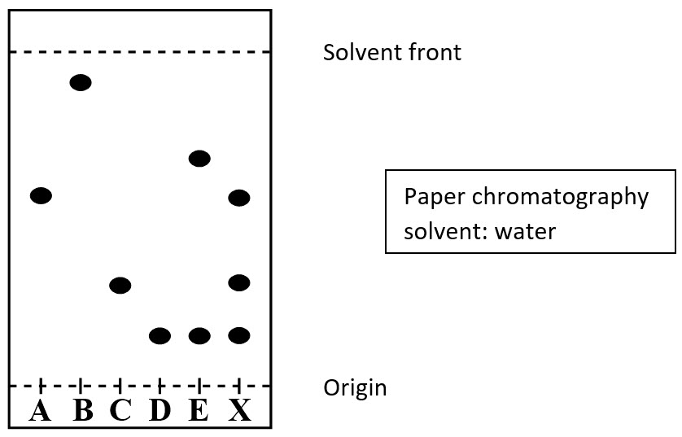

Questions

- Which of the natural colours they tested (B–E) are made up of two different colours? Explain your answer.

…………………………………………………………………………………………………

…………………………………………………………………………………………………
- How many colours are in the purple jelly sweet? Which of the other colours (A–E) does the purple colour contain?

…………………………………………………………………………………………………

…………………………………………………………………………………………………
- Is the ingredient list on Jellyfish Sweet Co sweet packets accurate? Explain your answer.

…………………………………………………………………………………………………

…………………………………………………………………………………………………
- One of the students says colour E is present in the purple jelly sweet. This is incorrect. Explain why the student may have come to this conclusion and explain how you can tell E is not in the purple jelly sweet.

…………………………………………………………………………………………………

…………………………………………………………………………………………………
- What was the mobile phase in the experiment?

…………………………………………………………………………………………………
- What was the stationary phase?

…………………………………………………………………………………………………
- Which of the colours was most soluble in the mobile phase? Explain your answer.

…………………………………………………………………………………………………

…………………………………………………………………………………………………
- What did the students use to draw their origin line? Explain their choice.

…………………………………………………………………………………………………

