Working with ratio
Education in Chemistry
January 2020
rsc.li/2r3j3RA

Working with shapes
- Count the number of different coloured shapes, then work out the following ratios.
Write your answers in their simplest whole number form.
Read the questions carefully.

- Light counters to dark counters.
- Light counters to the total number of counters.

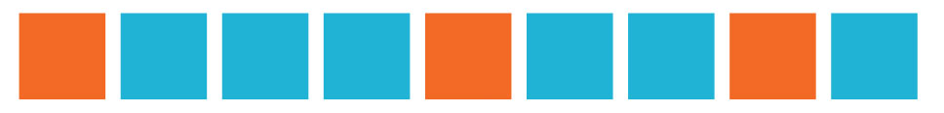
- Blue squares to orange squares.
- Orange squares to blue squares.
- Blue squares to the total number of squares.

- White squares to dotted squares.
- Hatched squares to light squares.
- Dotted squares to the total number of squares.

- Represent as a fraction the total number of triangles for each of these. Write your answers in their simplest form.

- White
- Black
- Dotted

- In this piece of modern art, there are six different colours used: red, white, yellow, black, blue and green. The ratio of the red area to the total area is 1:6. The ratio of the white area to the total area is 1:12.

- Calculate the fraction of the whole area represented by the following colours:

- Red
- White

- Given that the total area of the painting is 9.1 m², calculate the area of the:

- Red paint
- White paint

- Using your answers to b, calculate the total area of the yellow, black, blue and green areas.

Working with ratios in chemistry
These questions illustrate how ratio may be used at GCSE level, in chemistry.
- Analysing mixtures
A bronze alloy has a mass of 5.20 g.

It contains copper and tin in the ratio of 2:3, by mass.

- What is the fraction of copper in the sample?
- Using your answer to task a, calculate the mass of the copper in the sample.

Another sample of bronze contains copper and tin in the ratio of 2:5. The mass of tin in the sample is 10.2 g.

- What is the fraction of tin in this sample?
- Using your answer to task c and the mass of tin in the sample, calculate the total mass of the sample. Show your working.

- Empirical formulas
A compound X contains carbon, hydrogen and oxygen only. A sample of X of mass 1.56 g is found to contain 0.585 g of carbon and 0.195 g of hydrogen.

- Calculate the mass of oxygen in compound X.
- Complete the table that shows masses being changed to moles.
[A_{r} data: C = 12, H = 1, O = 16]

 | Carbon | Hydrogen | Oxygen
Mass of element in g
Moles of element
($\frac{mass in g}{A_{r}}$ )
Simplest whole number ratio
(divide each number by the smallest amount of moles)

So the simplest formula for X is:

- If the relative molecular mass of X is 32, calculate the molecular formula for X.
Show your working.
- Draw a possible structure for molecule X.

- Mole calculations
White phosphorus, P₄, reacts with fluorine to form phosphorus(III) fluoride:

P₄(s)+ 6F₂(g) 4PF₃(g)

In a reaction, 20.7 g of white phosphorus reacts with excess fluorine.

[A_{r} data: P = 31, F = 19]

In tasks a to c, give your answers to two significant figures and show your working.

- Calculate the number of moles of phosphorus used in the reaction.
- Deduce the number of moles of phosphorus(III) fluoride formed.
- Calculate the mass of phosphorus(III) fluoride formed.

