Chromatography: knowledge check
- Learners are completing an experiment to separate the coloured soluble substances in two different food dyes.
The diagram shows the apparatus used and the chromatogram produced.
Label the diagram using some of the words provided.
chromatography paper origin line solvent solution
solvent front food colouring solute

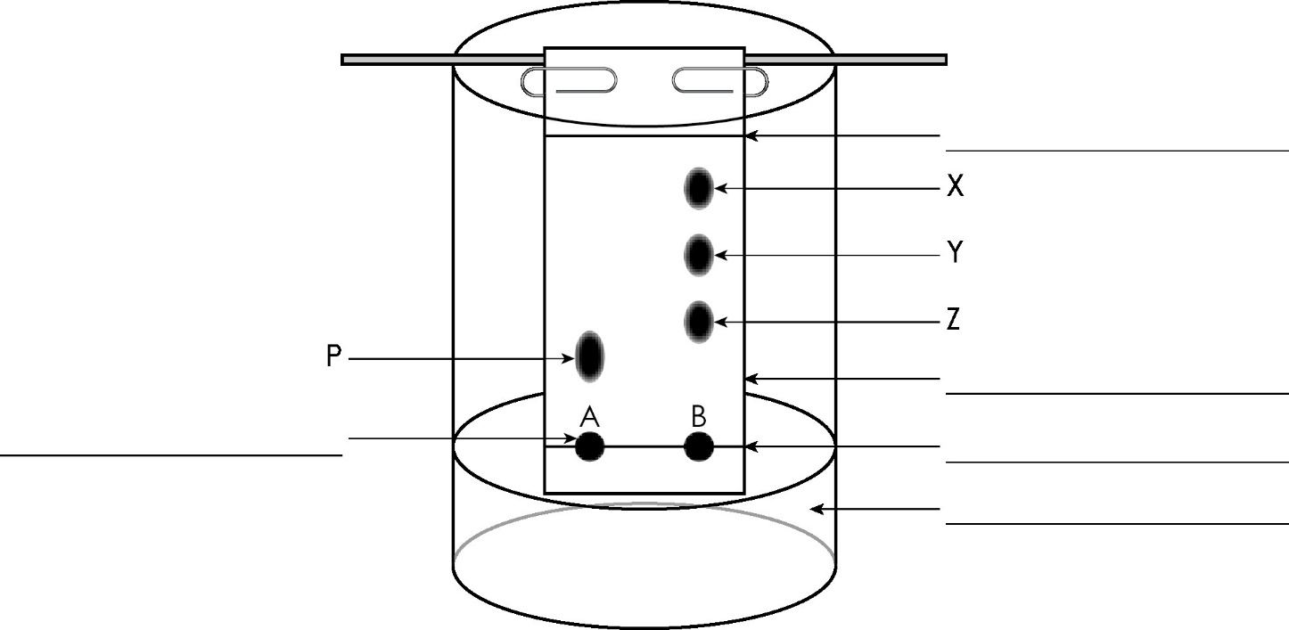

Questions 1.2 to 1.4 are about the experiment in question 1.1.

- The table shows the steps in the chromatography process used to separate the coloured substances, but they are given in the wrong order.
Add numbers to show the correct order for the steps. The first has been done for you.
1 | Draw an origin line in pencil about 1.5 cm from one end of the chromatography paper.
 | Place the paper inside the beaker. Make sure it just touches the water and it is vertical.
 | Check the paper is the right length by lining it up on the outside of the beaker so that the water is below the origin line.
 | Use a pipette to add small drops of food colourings A and B on the chromatography paper.
 | Allow the solvent to move through the paper, removing it before the solvent reaches the top.
- Use some of the words to complete the gaps in the following sentences.
rates mobile phase stationary phase
chromatography paper solvent solute solution
The chromatography paper is the __________________ __________________ . The solvent is the __________________ __________________ . The different dissolved substances in a mixture are attracted to the __________________ and the chromatography paper in different proportions. This causes them to move at different __________________ up the __________________ __________________ .

- Use some of the words to complete the gaps in the following sentences.
pure impure compound one
two or more three
A pure substance contains one type of element or __________________ only.
An impure substance contains _________________________ different elements or compounds. Food colouring A consists of one substance and is a __________________ substance.
Food colouring B contains __________________ different coloured substances. Food colouring B is an __________________ substance.

Chromatography: test myself
- What type of mixtures can paper chromatography be used to separate?
[Hint: Think about whether the substances would be soluble or insoluble.]

- This is a chromatogram of four different inks.
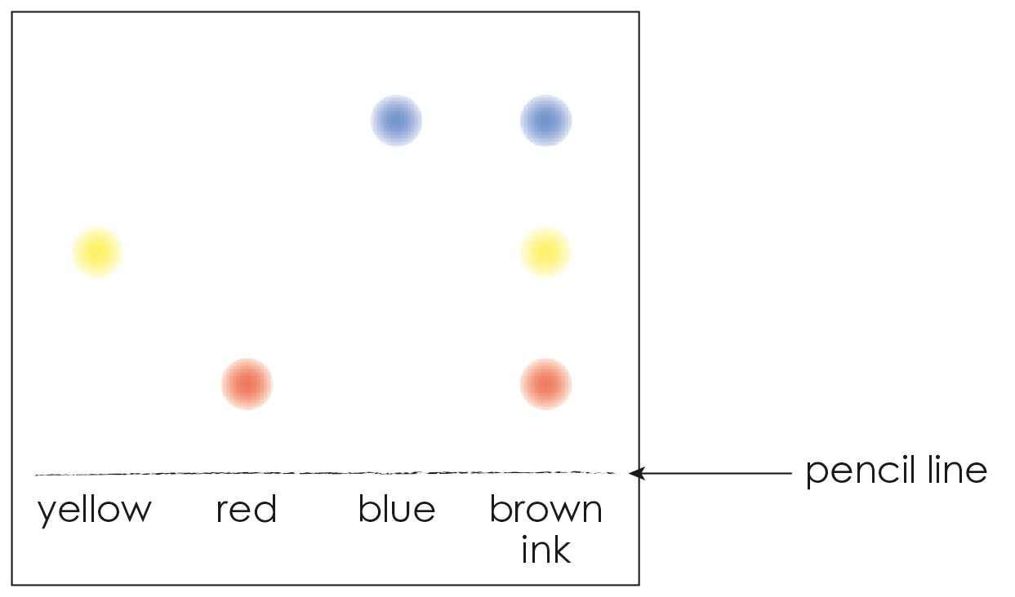
Circle the inks on the chromatogram that are pure substances.
- How is chromatography used to identify unknown substances?
[Hint: Think about what can be measured and compared on a chromatogram.]

- Thin layer chromatography uses a glass plate coated with alumina or silica gel.
What does this glass plate replace in the experiment in question 1.1?

- This is a chromatogram of dark blue ink.
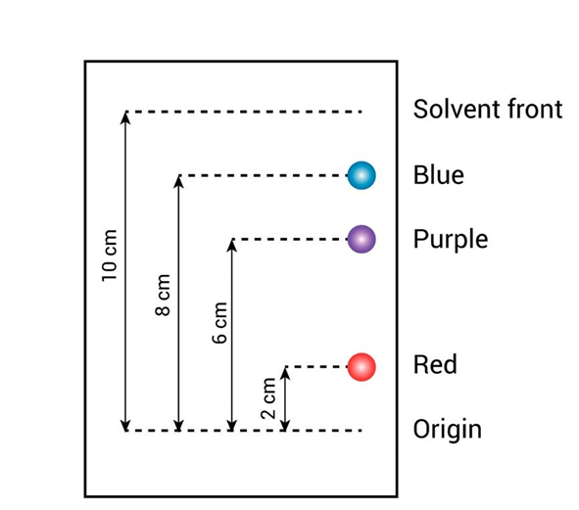
The equation used to calculate the R_{f} value is:
R_{f} = $\frac{distance travelled by substance}{distance travelled by solvent}$
Use the data shown in the chromatogram, along with the equation, to calculate the correct R_{f} values for the red, purple and blue substances.
Substance | R_{f} values
Red
Purple
Blue

- A compound has a R_{f} value of 0.6. If the solvent travels 16.0 cm up the chromatography paper, what is the distance travelled by the compound?
Use the equation to calculate the answer in cm.
$distance travelled by substance$ = R_{f} $×$ $distance travelled by solvent$

Chromatography: feeling confident?
- This is a chromatogram of different coloured inks.
What can you conclude about the black ink from the chromatogram shown?
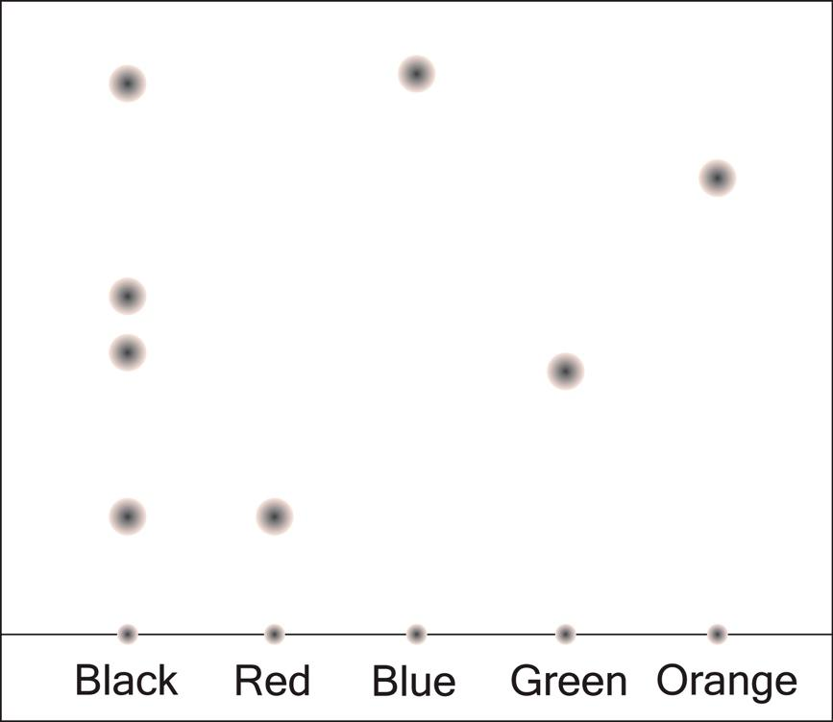
Use the words in your answer. The first sentence has been started to help you.
black ink red blue green orange
My conclusion is that the black ink contains

- Substances A, B and C are found in chlorophyll. The R_{f} values of these three substances can be determined using thin layer chromatography and an organic solvent.
The equation used to calculate the R_{f} value is:
R_{f} = $\frac{distance travelled by substance}{distance travelled by solvent}$
Use the equation to calculate the missing values in the table.
Substance | Distance travelled by the substance when the solvent travels 10 cm (cm) | R_{f} value
A | $$9.8$$
B | $$5.9$$
C |  | $$0.42$$

Chromatography: what do I understand?
Think about your answers and confidence level for each mini-topic. Decide whether you understand it well, are unsure or need more help. Tick the appropriate column.
Mini-topic | I understand  this well | I think I understand this | I need more  help
I can describe the process of paper chromatography.
I can describe how to prepare a chromatogram.
I can define a pure substance and an impure substance
I can interpret a chromatogram.
I can calculate R_{f} values.
I can use R_{f} values.
Feeling confident? topics | I understand  this well | I think I understand this | I need more  help
I can interpret chromatograms of coloured inks.
I can interpret and use information from chromatograms of chlorophyll.

