Bonding workshop
Covalent bonding and hydrocarbons
Contents
- Guidance notes
- Learning objectives
- Activity 1: hydrocarbons
- Activity 2: structure of hydrocarbons
- Activity 3: simple molecules
- Activity 4: alkanes
- Activity 5: reactions of alkanes
- Activity 6: alkenes
- Activity 7: reactions of alkenes
- Activity 8: functional groups
- Quick quiz
- Homework activity

Guidance notes
The workshop should take approximately three hours to complete in full. It was initially created for 14–16 year-old learners but can be adapted when teaching bonding to other age groups.
Download the PowerPoint presentation, technician notes and student workbook that accompany this resource at rsc.li/3ASiknU.
Read our health & safety guidance, available from rsc.li/3IAmFA0, and carry out a risk assessment before running any live practical. Find specific advice for the chemicals used in this project in the technician notes. The safety equipment suggested is in line with CLEAPSS requirements. For non-hazardous substances, wearing lab coats can help to protect clothes. The safety rules might be different where you live so it is worth checking local and school guidance.
Conduct the first two activities in the student workbook in small groups to find out what learners know at the start of the day. Answers are in these notes and on the PowerPoint which you can share with the group.
Use the PowerPoint to revise covalent bonding, using carbon and hydrogen as examples. Find career links throughout the activities, with video job profiles to watch.
Learning objectives
- Explain how a covalent bond is formed between two atoms.
- Construct models for at least three hydrocarbons.
- Draw the displayed structures for three alkanes and three alkenes.
- Work out the structures for at least two additional functional groups and draw their displayed formulas.

Acknowledgements
This resource was originally developed by Liverpool John Moores University to support outreach work delivered as part of the Chemistry for All Project.
To find out more about the project, and get more resources to help widen participation, visit our Outreach resources hub: rsc.li/3CJX7M3.
Unless explicitly stated, all images are © Royal Society of Chemistry.

Activity 1: hydrocarbons (5 minutes)
Answers (also on slide 5)
Elements – the simplest substances that cannot be broken down using chemical methods
Compound – a substance formed when two or more different chemical elements are chemically bonded together
Hydrocarbon – a compound containing hydrogen and carbon atoms only
Saturated hydrocarbon – a hydrocarbon containing only single bonds between the carbon atoms
Unsaturated hydrocarbon– a hydrocarbon containing one or more double or triple bonds between the carbon atoms
Science communicator
Show learners the video on slide 6 of the PowerPoint, also available from rsc.li/3CAOzIi, which introduces a science communicator. Fernando uses his scientific knowledge to uncover and translate complicated science for the public.
Activity 2: structure of hydrocarbons (5 minutes)
Answers (also on slides 8–10)
- (a) Carbon has six protons, six neutrons and six electrons.
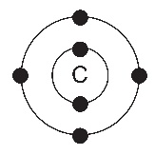

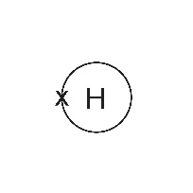
- Hydrogen has one proton, zero neutrons and one electron.

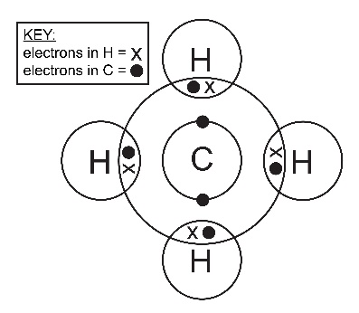

Activity 3: simple molecules (30 minutes)
Note: you will require molymod kits for this activity.
Demonstrate how the molymod kit works by making a model of a hydrogen atom. Make the link between the molecular formula, structural formula and molymod model (slide 12). Check that learners know how to fill in the table in the workbook before making their own models. Show learners how to draw a 2D displayed formula representation before they start.
Learners should add a tick in the third column when they have built the model and then draw a 2D displayed formula in the fourth column.
In small groups, learners make models of six other simple molecules. To ensure the class builds all the models, you may wish to assign specific molecules to each group.
Circulate and help learners, showing them the difference between single and double bonds. Ask learners to show and describe their models, then go through the answers on slides 14–19.

Answers

Molecule | Molecular formula | Molymod  model built?  X / | Displayed  formula
Example: hydrogen | H₂
chlorine | Cl₂
hydrogen chloride | HCl |  | 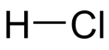
water | H₂O |  | 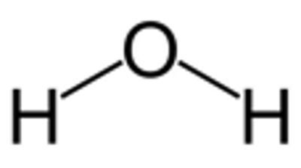
ammonia | NH₃ |  | 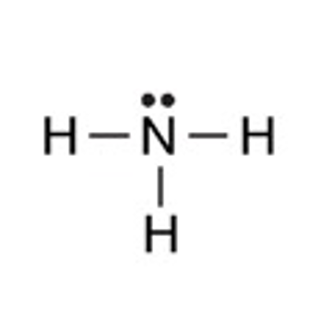
oxygen | O₂ |  | 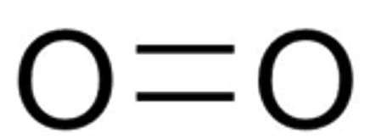
carbon dioxide | CO₂ |  | 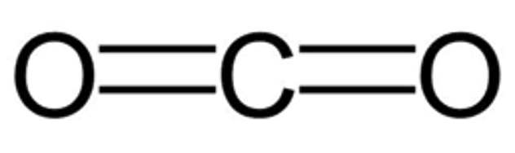

Activity 4: alkanes (30 minutes)
Introduce the idea of alkanes and relate this back to crude oil and hydrocarbons.
Project leader of enhanced experimentation
Inspire learners to pursue chemistry by showing them Stuart’s job profile, available from rsc.li/3GQvi87. He is a project leader of enhanced experimentation in oil and gas at Shell. Stuart uses robots, computer modelling and data to research and develop new ways to use crude oil and gas.
In small groups, learners then build models of the first four alkanes. Ask them to identify and use the pattern as they add more carbon and hydrogen atoms.
Discuss the answers to Activity 4 using slides 22–25.
Answers

Molecule | Molecular formula | Molymod model built?  X / | Displayed formula
methane | CH₄ |  | 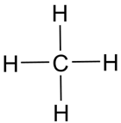
ethane | C₂H₆ |  | 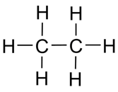
propane | C₃H₈ |  | 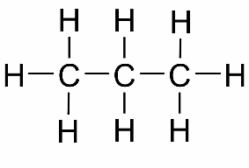
butane | C₄H₁₀ |  | 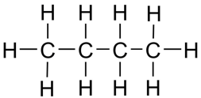

Learners should now be able to work out the general formula for an alkane, although some may need extra support here.
The PowerPoint slide following the answers to Activity 4 shows the general formula for alkanes.
Answers (also on slide 26)
- The number of hydrogen atoms is determined by doubling the number of carbon atoms and adding two.
- C_{n}H_{2n+2}
Learners use the general formula to predict the formulas for pentane, hexane, heptane and octane. They write the molecular and structural formulas and build models to check their predictions. Encourage learners to connect carbon atoms in a straight line first to avoid isomerism.
Answers (also on slides 27–30)
Molecule | Molecular formula | Molymod model built?  X / | Displayed formula
pentane  five carbon atoms | C₅H₁₂ |  | 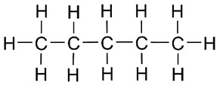
hexane  six carbon atoms | C₆H₁₄ |  | 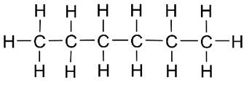
heptane  seven carbon atoms | C₇H₁₆ |  | 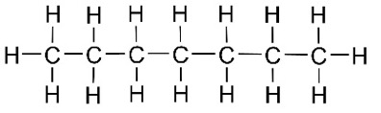
octane  eight carbon atoms | C₈H₁₈ |  | 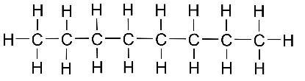
Challenge
Question 5 is a question for learners to try if they have time to spare. This question could also be given as homework if there is not enough time in the lesson.
You will need to use PowerPoint slide 31 here to introduce the term ‘intermolecular forces’ to learners and to help them answer question 5d.
Answers (also on slide 32)
- (a) Methane
    - Any three from: pentane; hexane; heptane; octane; nonane; decane.
    - As the molecular size increases, the melting point and boiling point increase.
    - As the carbon chain gets longer, there are stronger intermolecular forces between the molecules. It takes more energy to overcome these forces, so the melting and boiling points increase.

Activity 5: reactions of alkanes (30 minutes)
Introduce the activity by discussing the reactions of alkanes including complete and incomplete combustion. Use slide 34 to do this. Demonstrations provide an opportunity for learners to observe and record their observations. In this activity, you will be demonstrating the use of a Bunsen burner, a controlled explosion of methane and producing methane bubbles.
Ensure that you are familiar with all safety precautions before you start.
Demonstration 1: Bunsen burner flame
Light a Bunsen burner – turn the collar round and round and ask learners to observe what is happening to the flame. Prompt learners to explain and write down their observations. Introduce the terms complete combustion and incomplete combustion. Use slide 35 of the PowerPoint to summarise the demonstration and provide the answers to the questions in the student workbook.
Answers
- (a) Air hole closed; incomplete combustion
- Air hole open; complete combustion
Demonstration 2: controlled explosion of methane
Carefully read the safety notes and method, available from rsc.li/3vPcMqv, before attempting this demo. Practise the exploding can without learners present until you feel confident. The demonstration must be behind screens and learners must be a safe distance away. You must wear safety glasses and ear defenders when performing the demonstration.
Find the equipment and chemicals required in the accompanying technician notes and on the Exploding a tin can using methane experiment page. Support learners through discussion to describe and then explain what happened in the demonstration. Learners should record their observations and answer the questions in their workbook.

Answers
- Learners’ own observations, which may include: a yellow flame, a blue flame, the lid of the tin flying off, an explosion, a loud bang.
- The reaction that occurs inside the can is the complete combustion of methane with the oxygen in the air. The flame descends the chimney and the methane–air mixture ignites causing a small explosion. This produces heat, light, sound and energy which causes the lid of the can to fly off.
The equation for this reaction is:
CH₄ (g) + 2O₂ (g) → CO₂ (g) + 2H₂O (l)
Demonstration 3: methane bubbles
Use the method described on the Exploding soap bubbles experiment page (rsc.li/3GqsNIs) to produce bubbles that float to the ceiling. Use a lit splint on a long pole to ignite the bubbles. Use the demonstration to trigger class discussions about combustion and products.
Find the equipment and chemicals required in the accompanying technician notes.
Lead learners, through discussion, to answer the questions in the workbook. The idea that the combustion depends on the mixture of oxygen with methane is important, as is the fact that the bubbles float because methane is less dense than air.
Answers
- Learners’ own observations, which may include soap bubbles, yellow/orange flames and an explosion.
- The methane bubbles float upwards because methane gas is less dense than air.

Activity 6: alkenes (30 minutes)
Use the introductory key points for Activity 6 on slide 38 to explain what alkenes are. Learners label the double bond in an alkene and then make models of the first three alkenes using the molymod kits.
Answers (also on slides 39–48)
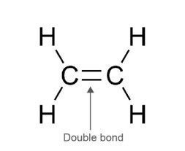
- (a)

Molecule | Molecular  formula | Molymod  model built?  X/ | Displayed formula
ethene | C₂H₄ |  | 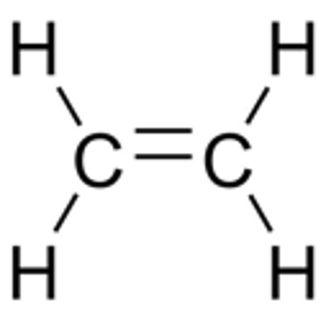
propene | C₃H₆ |  | 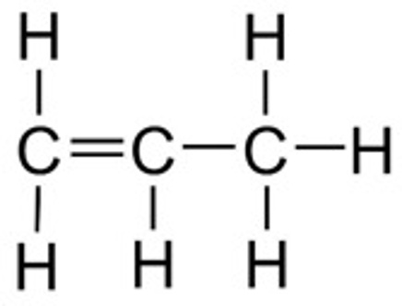
butene | C₄H₈ |  | 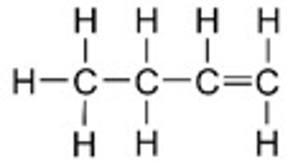  or  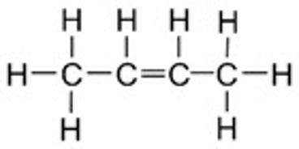

Isomers of butene can be pointed out to learners – but no detail is needed at this point.
- Methene does not exist because alkenes have a double bond between two carbon atoms – methene would have only one carbon atom.
- When one carbon atom is added to the chain, the number of hydrogen atoms increases by two. The number of hydrogen atoms is double the number of carbon atoms.
- The general formula of any alkene is: C_{n}H_{2n.}
- The displayed formulas provided in the table are for one isomer (pent-1-ene,
hex-1-ene, hept-1-ene and oct-1-ene), but for each molecule there are other isomers that learners could draw.
You could introduce the idea of isomers to learners at this point and show them some of the other possible structures, but they do not need to understand the concept at this level.
The isomers are:
Pentene: pent-1-ene, pent-2-ene
Hexene: hex-1-ene, hex-2-ene, hex-3-ene
Heptene: hept-1-ene, hept-2-ene, hept-3-ene
Octene: oct-1-ene, oct-2-ene, oct-3-ene, oct-4-ene

Molecule | Molecular  formula | Molymod  model built?  X/ | Displayed formula
pentene  five carbon atoms | C₅H₁₀ |  | 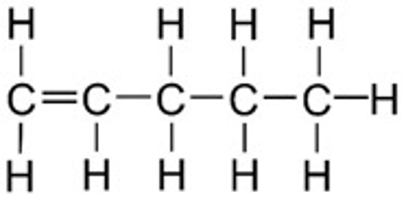
hexene  six carbon atoms | C₆H₁₂ |  | 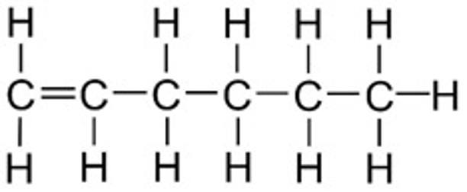
heptene  seven carbon atoms | C₇H₁₄ |  | 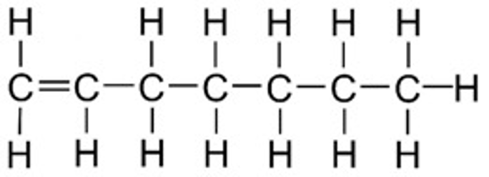
octene  eight carbon atoms | C₈H₁₆ |  | 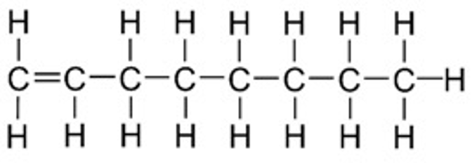
- Yes, the position of the double bond does matter.
This is because alkenes with more than four carbon atoms can have double bonds in various positions of the molecule (forming isomers). This affects the shape and often the properties of the molecule.
School science technician
Watch Sandrine’s job profile, available on slide 48 and from rsc.li/3ZpDhAv. She is a school science technician and uses her knowledge and skills to design, prepare and test practicals for chemistry lessons and extracurricular activities.

Activity 7: reactions of alkenes (20 minutes)
This can be run as a class practical or demonstration of how alkenes decolourise bromine water.
Make sure learners follow all practical procedure and safety instructions completely.
Use slide 51 of the PowerPoint to summarise learners’ findings.
Alkane or alkene | Appearance of bromine water (Br₂ (aq)) before adding the alkane/alkene | Appearance of bromine water (Br₂ (aq)) after adding the alkane/alkene
Hexane | orange | orange
Hexene | orange | colourless
Answers
- Bromine reacts with the carbon–carbon double bond, causing a colour change from orange to colourless. Alkanes do not contain this reactive bond so do not decolourise bromine water.

Activity 8: functional groups (20 minutes)
Learners should now be quite confident using the molymod kits with reference to the structural formulas given.
Learners may not be familiar with the term functional group, so it is worth going over the meaning using slide 53 on the PowerPoint which says ‘A functional group is an atom or a group of atoms that determines the chemical properties of the compound it is part of. Compounds that contain the same functional group will share similarities in their chemical properties.’
Teaching technical specialist
Highlight careers in chemistry with the job profile available from rsc.li/3CBTNDI. Mike is a teaching technical specialist in the Department of Chemistry at Manchester University. He uses his knowledge and skills to support chemistry undergraduates and postgraduates, by making sure that they have all the equipment, materials and chemicals they need to conduct experiments and investigations in a safe manner.

In this activity learners are asked to build models of molecules with different functional groups and to identify the functional group by circling them on their drawn displayed formulas. The PowerPoint slides can help to introduce a range of functional groups.
The answers to Activity 8 are shown on PowerPoint slides 54–58. Go through each slide with the learners and get them to check their answers.

Answers
1. and 2.
Functional group | Example compound name and formula | Molymod  model built?  X / | Displayed formula
alkene | butene  C₄H₈ |  | 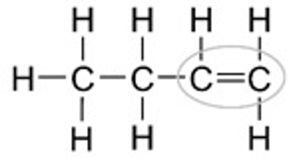
alcohol | ethanol  CH₃CH₂OH |  | 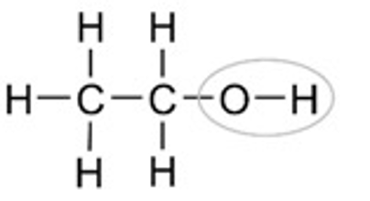
carboxylic acid | ethanoic acid  CH₃COOH |  | 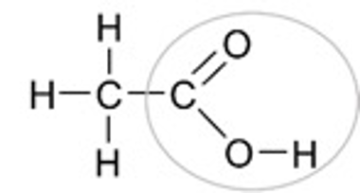
aldehyde | propanal  CH₃CH₂CHO |  | 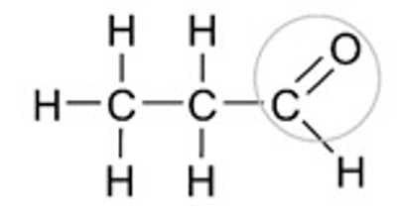
ketone | propanone  CH₃COCH₃ |  | 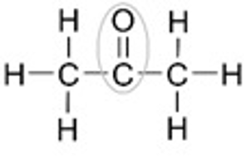
It is worth reinforcing here to learners that although the functional group for both aldehydes and ketone is the carbonyl group (C=O), they each have different chemical properties due to the different placements of the carbonyl group in their structures. In aldehydes, the carbonyl group is always found at the end of a carbon chain and in ketones it is always found between two carbon atoms.
Quick quiz (10 minutes)
Slide 59 of the PowerPoint has four questions for learners to answer on mini whiteboards, orally in small groups or by whole-class discussion.
Answers (also on slide 60)
- In covalent bonding two atoms share their outer shell electrons to achieve full outer shells.
- Pentane
- Alkanes contain only single carbon to carbon bonds, whereas alkenes contain at least one double carbon to carbon bond.
- Yes – that is the correct displayed formula of pentane.
Homework
Give the homework questions to learners to complete after the session.
Answers
- When there is a plentiful supply of oxygen, complete combustion takes place.
fuel + oxygen carbon dioxide + water
When the oxygen supply is limited, incomplete combustion takes place.
fuel + oxygen carbon monoxide + carbon + water

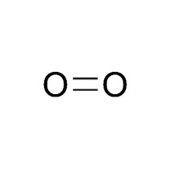 | 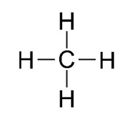 | 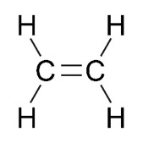
Name: oxygen  Formula: O₂ | Name: methane  Formula: CH₄ | Name: ethene  Formula: C₂H₄

