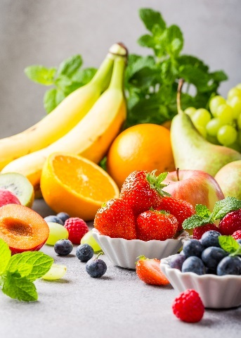
- Many fresh fruit and vegetables produce ethene.
This gas may then ripen other fruit which is unripe.

The table below shows how much ethene (in cm³) is produced from 1 kg of fruit each hour.
Source: Envato Elements
Name of fruit or vegetable | Volume of ethene produced by 1 kg of fruit in 1 hour (in cm³)
Apricot | 30
Avocado | 150
Rhubarb | 0.25
Banana | 3.2
Pineapple | 1.2 × 10^{–3}
Passion fruit | 235
Pear | 85
- Write the volume of ethene produced by 1 kg of pineapple per hour as a normal number (that is, one not in standard form).
Answer: 0.0012.
- Place the fruit in order of the volume of ethene they produce each hour, smallest first.
Answer: Pineapple, rhubarb, banana, apricot, pear, avocado, passion fruit.
- Calculate the volume of ethene produced by the following masses of fruit.
Remember to give units in your answers.
- 2 kg of bananas in 1 hour
Answer: 6.4 cm³.
- 200 g of apricots in 1 hour
Answer: 6 cm³.
- 4 kg of pears in 2 hours
Answer: 680 cm³.
- Ethene has the molecular formula C₂H₄.
Draw the structure of an ethene molecule showing the chemical bonds.
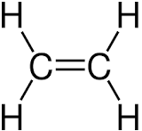

- Ethene is described as an unsaturated hydrocarbon, define each term in the table below.
Unsaturated | Answer: A molecule containing one or more carbon single bonds.
Hydrocarbon | Answer: A substance containing hydrogen and carbon only.
- State the name of a chemical substance that could be used to show that ethene is unsaturated.
Answer: Bromine water.
- Give the result of the test when using the substance in part f).
Answer: Bromine water goes from orange to colourless.

- This question is about the two molecules in the table below.

- Complete the table.
 | 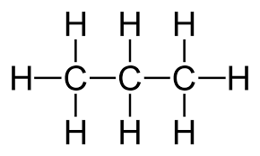  Molecule 1 | 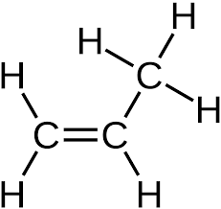  Molecule 2
Homologous series | Answer: Alkanes. | Answer: Alkenes.
General formula of homologous series | Answer: C_{n}H_{(2n+2)} | Answer: C_{n}H_{2n}
Name of substance | Answer: Propane. | Answer: Propene.
Molecular formula | Answer: C₃H₈ | Answer: C₃H₆
Burns with smoky flame (Y/N) | Answer: No. | Answer: Yes.
- Give the name of a substance that would change molecule 2 into molecule 1.
Answer: Hydrogen.
- Which of the molecules is the more reactive?
Give a reason.
Answer: Molecule 2.
It contains a carbon double bond.
Parts d) and e) are about the molecule shown.
- What is the name of this molecule?
Answer: Butene or but-1-ene.

- Which molecule in the table (molecule 1 or molecule 2) is this molecule most similar to?
Give a reason for your answer.
Answer: Molecule 2.
Molecule 2 and but-1-ene both have carbon double bonds, or contain the same functional group.

