- The diagram shows a fractionating tower used to separate crude oil.
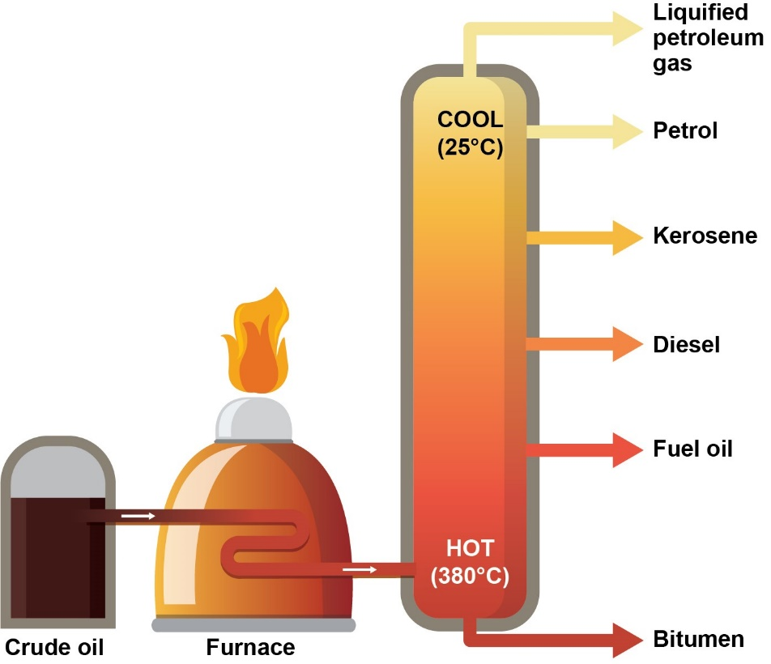
  - Explain how crude oil is separated into its constituent fractions.
Use the words in the box in your answer.
Heat energy
Boil
Vapour
Condense
Boiling point
Molecular size

Source: Royal Society of Chemistry

Answer: Heat energy is used to boil the crude oil and turn it into a vapour.
The molecules enter the fractionating tower.
Molecules are ‘sorted out’ according to their boiling point – this decreases on going up the column.
Molecules with a smaller molecular size move to the top of the column (where it is cooler).
Molecules with a larger molecular size move to the bottom of the column (where it is hotter).
The vapour condenses to form a liquid.
Each fraction is then collected over a small boiling point range.

  - Crude oil is a finite energy resource.
What does ‘finite resource’ mean?
Answer: Non-renewable resources that will run out.

  - Products from crude oil are of crucial importance to us, and our lives would be very different without these.
State two important products made from crude oil that are not mentioned in the above diagram.
Answers: Solvents, lubricants, polymers, detergents.
- Crude oil is a complicated mixture of hydrocarbons, many of which are alkanes.
Number of carbon atoms in alkane | Boiling point in °C
1 | –162
2 | –89
3 | –42
4 | –0.5
5 | 36
6 | 69
The boiling points of the first six members of the alkane homologous series are shown in the table below.

  - Plot the number of carbon atoms on the horizontal axis and the boiling point on the vertical axis on the graph below.

  - Draw a best fit line through these points.
Answer: See graph.
  - Use your graph to describe how the boiling point changes from two carbon atoms to six carbon atoms.
Answer: Almost linearly.
  - Use your graph to determine the boiling point of the alkane with seven carbon atoms.
Answer: c.a. 100 °C.
  - Which of the hydrocarbons are gases at room temperature, 20 °C?
Answer: The first four members are gases.
- A sample of petrol (gasoline) was analysed by a chemist.
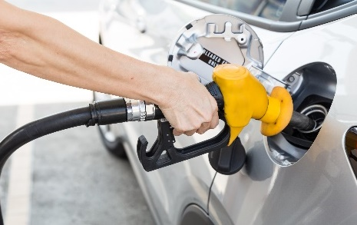
She recorded a mass of petrol of 5.20 g.

The analysis found a substance called decane in the petrol.

The percentage of decane in the petrol sample was 4.8%, by mass.

Decane is an alkane containing ten carbon atoms in its molecule.
Source: Envato Elements
  - Which two elements are present in alkanes?
Answer: Hydrogen and carbon.
  - What is the general formula for an alkane?
Answer: C_{n}H_{(2n+2)}
  - Use your answer to part b) to work out the molecular formula for decane.
Answer: C₁₀H₂₂

  - Complete the structure to show a decane molecule.
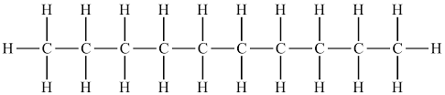

  - Explain why a decane molecule is described as ‘saturated’.
Answer: It contains carbon single bonds only.
  - Calculate the mass of decane in the petrol sample.
Give your answer to 3 significant figures.
Show your working.
Answer: The mass of decane = $\frac{4.8}{100}$ × 5.2 = 0.2496 g.
And to 3 significant figures, this would be 0.250 g.

