- Polymers are very useful for making protective armour in some high-impact sports, for example, American football.
The shoulder pads are made of a low density poly(ethene) foam inside a case of high density poly(ethene).

Other polymers like poly(vinyl chloride), poly(propene) and poly(styrene) also have important uses.
Source: Enavto Elements
- Explain what is meant by a polymer.
Answer: A very long chain molecule made of many smaller molecules, called monomers.
- Explain why polymers are ideal for making high-impact sports equipment.
Answer: Polymers can be engineered to have particular properties, depending on the particular use.
They are durable, water resistant, may be easily moulded, and can withstand high-impact shock.
- Name the substance that polymerises to form poly(ethene).
Answer: Ethene.

Poly(ethene), poly(vinyl chloride), poly(propene) and poly(styrene) all belong to a particular class of polymer.
- What is the name of this polymer class?
Answer: Addition polymers.
- What structural feature is common to the monomers that make the polymer type in part c)?
Answer: All contain a carbon double bond.
- Explain the difference in the arrangement of polymer chains in high density and low density poly(ethene).
Answer: The chains in high density poly(ethene) are packed more closely together than in low density poly(ethene).

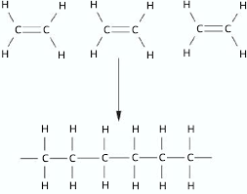
The diagram below shows three ethene monomers forming a section of a poly(ethene) polymer.

- Explain how the process takes place.
Think about how the bonds in the monomers change in order to form the polymer.
Answer: Carbon double bonds turn into single bonds.
Carbon atoms that were forming the double bond form single bonds to other monomers.
- Draw the repeat unit for poly(ethene).
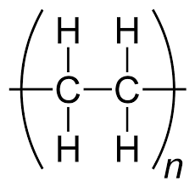

These two molecules may look similar, but they can behave very differently.
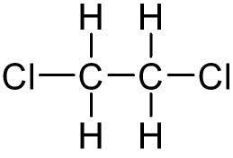
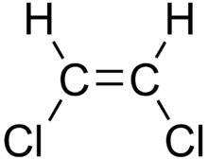

Molecule 1 Molecule 2
- One of these molecules is called dichloroethane and the other is called dichloroethene.
Which one is which?
Write your answer into the table below.
Name of molecule | Molecule 1 or molecule 2
Dichloroethane | Answer: Molecule 2.
Dichloroethene | Answer: Molecule 1.
- One of the molecules may polymerise, and the other will not.
State which will polymerise.
Give a reason.
Answer: Molecule 1.
It has a carbon double bond.
- Draw the repeat unit for the polymer that does polymerise.
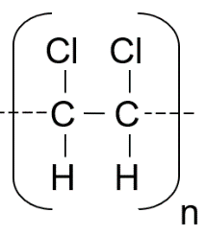

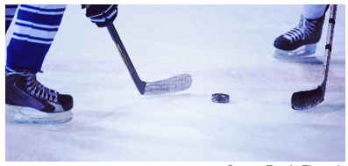
- Teflon™ is a brand name for the polymer made from a monomer called tetrafluoroethene.
Teflon has some special properties, for example, it is a very slippery polymer on some surfaces.

It is used to make ice hockey pucks.

Teflon has the structure shown below.
Source: Enavto Elements

- Draw the structure of the monomer that would make Teflon.
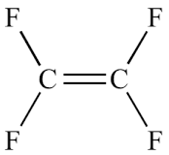

- State the empirical (simplest whole number ratio) formula of:

- The monomer
Answer: CF₂
- The polymer
Answer: CF₂
- The average relative molecular mass of a sample of Teflon was found to be 120,000.
Calculate the average number of monomers in one polymer chain of Teflon.
(RAM data: C = 12, F = 19)
Answer: 1,200 monomer units.

A polymer that is used to make high-impact protective equipment in ice hockey has the structure below.
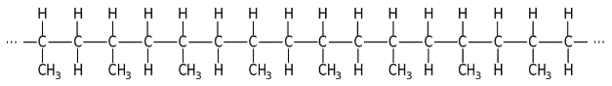

- Draw the structure of the monomer that forms this particular polymer.
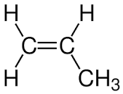

- Name the monomer and polymer.
Answer: The monomer is propene.
The polymer is poly(propene).

