Sustainable consumption: individual action
Education in Chemistry
Sustainability in chemistry 2021
Goal 12: ensure sustainable consumption and production patterns
rsc.li/2ULAaWW
How can your individual actions reduce your ‘material footprint’ (the amount of primary materials needed to meet the basic needs for food, clothing, water, shelter, infrastructure and other aspects of life) to help tackle the climate crisis and ensure a sustainable future for our planet?

Learning objectives
- You will be able to reflect on your individual actions to determine how you could reduce consumption of materials.
- You will understand the impact these individual actions can have on the climate and society.

Task 1
Read each of the following and answer the questions as honestly as possible. You can use the links in the guidance sheet to help you learn more about the impact of each individual action.
Individual action | Would you do this? | Why? | Who might object if lots of people did this? | Why might they object? | Where might this be difficult for people to do?
Switch to energy efficient light bulbs
Recycle your electrical devices rather than keep them in a drawer
Individual action | Would you do this? | Why? | Who might object if lots of people did this? | Why might they object? | Where might this be difficult for people to do?
Choose ‘ugly’ fruits to help reduce waste
Campaign for better recycling in your school/area
Choose a ‘green energy tariff’ despite it being more expensive
Buy good quality, second hand clothes
Use reusable plastics or sustainable alternatives

Task 2
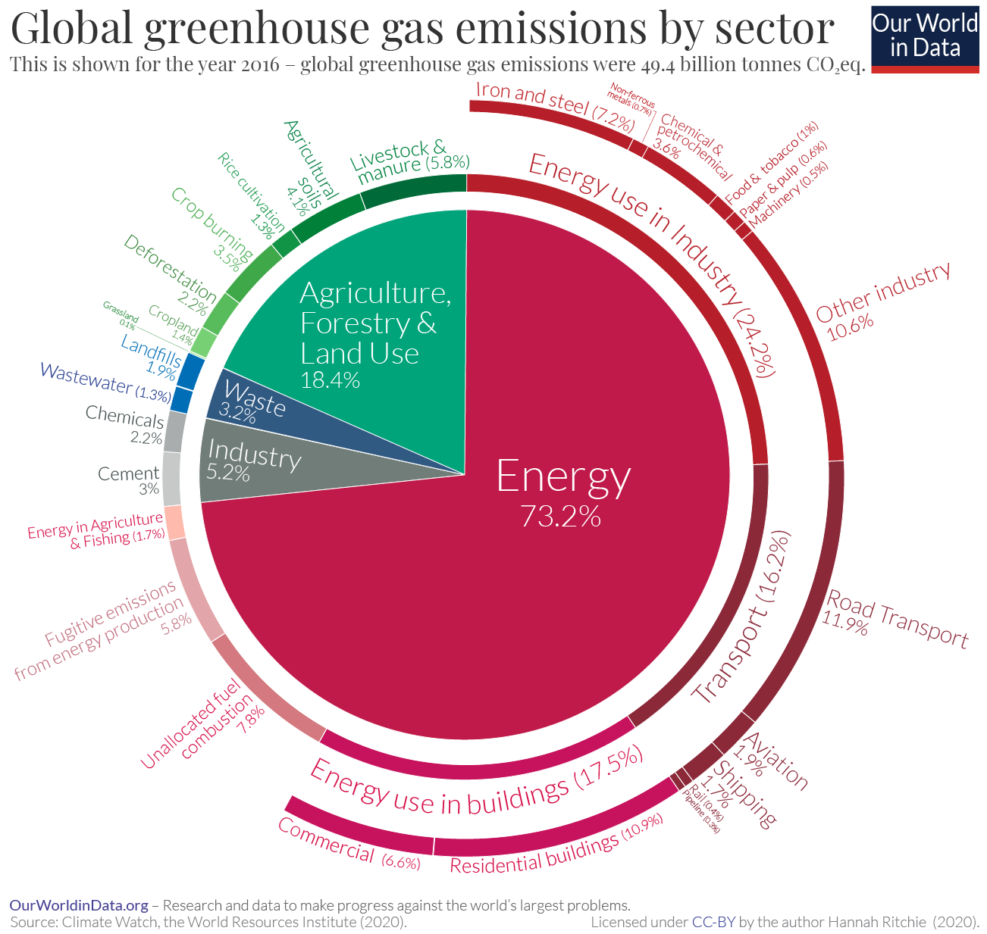
Link each of these actions to some data on global greenhouse gas emissions. Below is a pie chart with some data about the proportion of global greenhouse gas emissions by sector. For more information, visit: https://ourworldindata.org/emissions-by-sector#energy-electricity-heat-and-transport-73-2
Licenced under CC by the author Hannah Ritchie (2020). Source Climate Watch, the World Resource Institute 2020. Published online at OurWorldInData.org. Retrieved from: 'https://ourworldindata.org/co2-and-other-greenhouse-gas-emissions' [Online Resource]
Individual action | Which sector does this contribute to? | Put the actions in order of global greenhouse gas emissions from 1 (largest) – 7 (smallest)
Switch to energy efficient light bulbs
Recycle your electrical devices rather than keep them in a drawer
Choose ‘ugly’ fruits to help reduce waste
Campaign for better recycling in your school/area
Choose a ‘green energy tariff’ despite it being more expensive
Buy good quality, second hand clothes
Use reusable plastics or sustainable alternatives

Guidance sheet
Individual action | Where to find more information
Switch to energy efficient light bulbs | Go to the ‘Facts and figures’ section of the Goal 12’s webpage and find out about energy efficient lightbulbs:  https://www.un.org/sustainabledevelopment/sustainable-consumption-production/
Recycle your electrical devices rather than keep them in a drawer | Use this infographic to learn some key statistics about electronic waste:  https://sdgs.un.org/sites/default/files/2021-07/SDG_report_2021_Goal%2012.png  Read Target 12.5 of this report, which provides more information about where e-waste production is highest and how it is managed in different places around the world:  https://unstats.un.org/sdgs/report/2021/extended-report/Goal%20(12)_final.pdf
Choose ‘ugly’ fruits to help reduce waste | Find out how much food is wasted each year with the ‘Food’ section on the UN’s goal 12 webpage:  https://www.un.org/sustainabledevelopment/sustainable-consumption-production/
Campaign for better recycling in your school/area | Speak up about issues that are important to you. Get inspiration from the UN’s ActNow Climate Campaign:  https://www.un.org/en/actnow/
Choose a ‘green energy tariff’ despite it being more expensive | Understand the considerations and complexities when it comes to making environmentally conscious decisions:  https://www.bbc.co.uk/news/business-56602674
Buy good quality, second hand clothes | Think about where and what you buy and how the production of clothes affects the climate:  https://www.un.org/sustainabledevelopment/wp-content/uploads/2019/07/12_Why-It-Matters-2020.pdf  https://edu.rsc.org/resources/assessing-the-life-cycle-of-fashion-14-16-years/4010470.article
Use reusable plastics or sustainable alternatives | Read about how developments in chemistry will help find alternative, sustainable plastics:  https://www.rsc.org/new-perspectives/sustainability/progressive-plastics/

