Reaching dynamic equilibrium: storyboard

Learning objectives
- State what a reversible reaction is.
- Describe how a reversible chemical reaction reaches dynamic equilibrium.

Introduction

Most chemical reactions you have studied so far are irreversible, where the reaction only takes place in one direction.

However, many chemical reactions are reversible: the products can react together to reform the original reactants. The forwards reaction and the reverse reaction are both occurring.

In dynamic equilibrium, the forwards reaction and reverse reaction occur at the same rate in a closed system. The concentrations of substances at equilibrium are constant, they are not changing.

Equilibrium is an important process in industry. To make reversible reactions as efficient and sustainable as possible, manufacturers need to understand equilibrium. Because the equilibrium position – the concentrations of substances present at equilibrium – affects the yield of the product.

True or false? Checking understanding
Q. | Statement | True or false?
 | Combustion is an example of an irreversible reaction.
 | The symbol for a reversible reaction is .
 | Products must be allowed to leave the flask in a reversible reaction.
 | A reversible reaction can only reach dynamic equilibrium in a closed system.
 | A reaction at equilibrium has stopped.
 | At equilibrium, the rate of the forwards reaction is equal to the rate of the reverse reaction.
 | If a reaction is at equilibrium, it means that all reactants have been fully converted into products.
 | A system at equilibrium will show measurable changes in the concentrations of reactants and products over time.
 | If the forwards reaction is exothermic, then the reverse reaction will be endothermic.

Instructions

Create a storyboard to describe how a chemical reaction reaches dynamic equilibrium. A storyboard contains an illustration and a short section of text underneath to describe what is happening in the picture. The storyboard shows a sequence of events.

What does a storyboard look like?

Use the table to show how the stages progress:
1 | 2 | 3 | 4
5 | 6 | 7 | 8

Complete the activity on the storyboard sheet. Follow the instructions below to write a short description then draw or choose an appropriate illustration above the description.
- Describe a common example of an irreversible reaction.
- Explain what a reversible reaction is and write an example of one.

HINT: you may use letters to represent chemicals eg A, B, C and D.
- Describe what is meant by the forwards and reverse reaction. Write equations for these in the space for the illustration.
- State whether dynamic equilibrium needs an open or closed system.
- Discuss the concentrations of substances and rate of the forwards reaction at the beginning.
- Discuss how the concentrations of substances and the rates of the forwards and reverse reaction change during the reaction.
- Describe what happens to the rates of the forwards and backwards reaction when equilibrium is reached. Sketch a graph to show how the rates of the forwards and reverse reaction change with time.
- Describe what happens to the concentrations of substances as equilibrium is reached. Sketch a graph to show how concentrations change from the beginning of the reaction to equilibrium being reached.

Complete the storyboard to show how equilibrium is reached. Use the numbered prompts and/or the keywords for support.
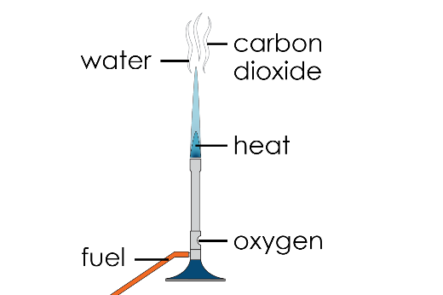

Combustion is an example of an irreversible reaction, where a fuel reacts with oxygen to form carbon dioxide and water.
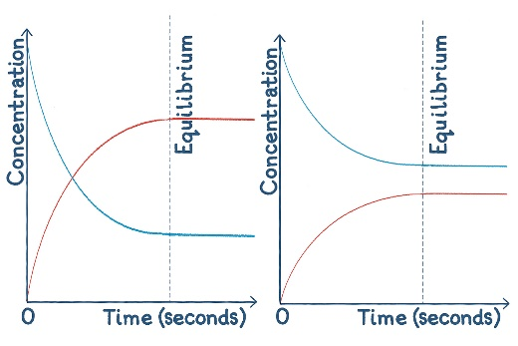

Particles are still reacting, but as A and B react to produce C and D, another C and D react to produce A and B, maintaining a constant concentration.

Complete the storyboard to show how equilibrium is reached. Use the numbered prompts and/or the keywords for support.

Support

Use these images to complete the storyboard. You will need to put them into the correct order in the sequence.
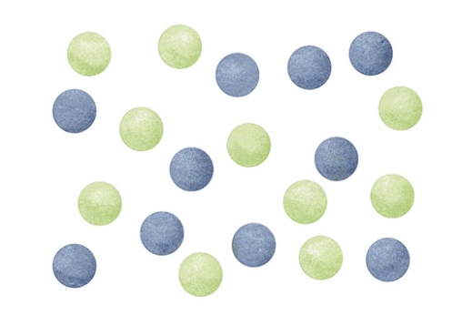
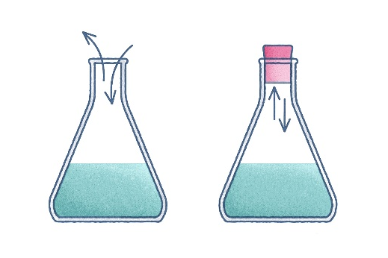
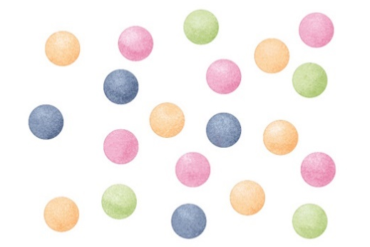
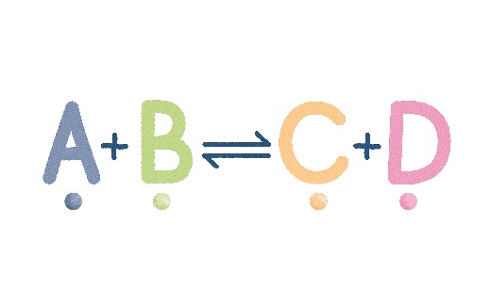

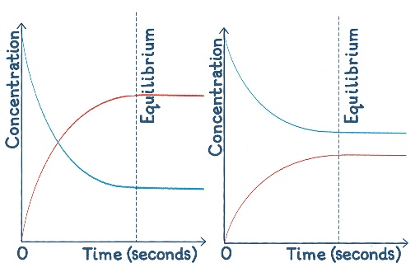
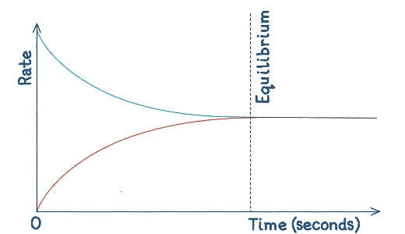

Forwards reaction:

A + B $→$ C + D

Reverse reaction:

C + D $→$ A + B

Suggested keywords
☐ carbon dioxide ☐ closed ☐ combustion ☐ reversible ☐ products ☐ time ☐ reverse
☐ concentrations ☐ decrease ☐ equal ☐ product ☐ rate ☐ reacting ☐ reactants
☐ equilibrium ☐ forwards ☐ increasing ☐ irreversible ☐ escape ☐ oxygen ☐ open

