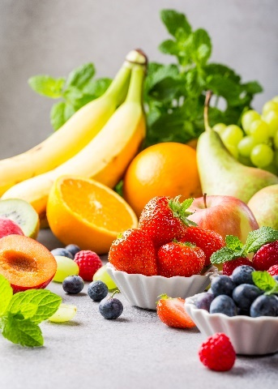
- Many fresh fruit and vegetables produce ethene.
This gas may then ripen other fruit which is unripe.

The table below shows how much ethene (in cm³) is produced from 1 kg of fruit each hour.
Source: Envato Elements
Name of fruit or vegetable | Volume of ethene produced by 1 kg of fruit in 1 hour (in cm³)
Apricot | 30
Avocado | 150
Rhubarb | 0.25
Banana | 3.2
Pineapple | 1.2 × 10^{–3}
Passion fruit | 235
Pear | 85
- Write the volume of ethene produced by 1 kg of pineapple per hour as a normal number (that is, one not in standard form).
Answer: 0.0012.
- Calculate the volume of ethene produced by the following masses of fruit.
Remember to give units in your answers.
- 2 kg of bananas in 1 hour
Answer: 6.4 cm³.

- 200 g of apricots in 1 hour
Answer: 6 cm3.

- 4 kg of pears in 2 hours
Answer: 680 cm³.

- 150 g of apricots in 30 minutes
Answer: 2.25 cm³.

- Calculate the mass of passion fruits that will produce exactly 1.00 dm³ (1 litre) of ethene in 1 hour.
Give your answer to 3 significant figures.
Answer: 4.255… kg = 4.26 kg (to 3 significant figures).
- Scientists have produced ethene scavengers that are based on the metal called palladium.
These can reduce the ethene concentration by 95%.
i) A sample of gas contains 5000 dm³ of ethene.
Calculate the volume of ethene that remains after the ethene scavengers have been used.
Show your working.
Answer: There will be 5% of the ethene remaining.
So $\frac{5}{100}$ × 5000 = 250 dm³
ii) Explain why companies that transport fruit and vegetables may use palladium-based ethene scavengers.
Answer: Ethene causes the fruit and vegetables to ripen and soften.
During transit, it is important that produce is unripe, as it is more resistant to being damaged and bruised (as it is harder).
So ethene is removed to prevent produce from ripening, but then added once the produce needs ripening.

- Propene has the molecular formula C₃H₆.

- Draw the structure of a propene molecule showing the chemical bonds.
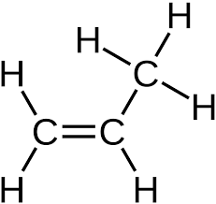

- Propene is described as an unsaturated hydrocarbon, define each term in the table below.
Unsaturated | Answer: A molecule containing one or more carbon single bonds.
Hydrocarbon | Answer: A substance containing hydrogen and carbon only.

- State the name of a chemical substance that could be used to show that propene is unsaturated.
Answer: Bromine water.
- Give the result of the test when using the substance in part f).
Answer: Bromine water goes from orange to colourless.
- Consider some reactions of propene with other molecules.
Draw the structure of the product molecules in each case.
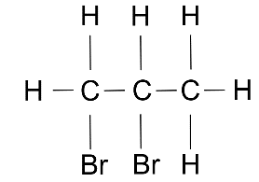
Bromine, Br₂

- [Edexcel/AQA]
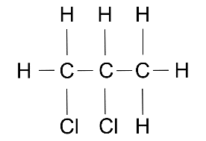
Chlorine, Cl₂

- [AQA]
Hydrogen gas and nickel catalyst at 150ºC
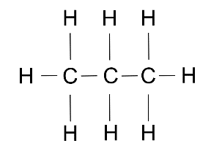

- [AQA]
Steam with a phosphoric acid catalyst
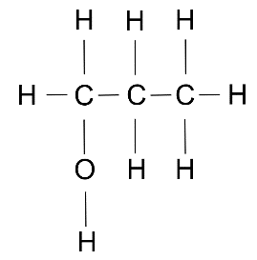
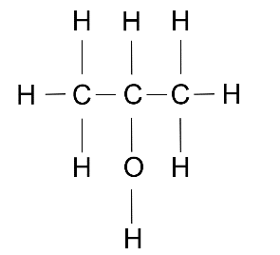
or

- Explain why alkenes often burn with a smoky flame, whereas the corresponding alkanes do not.
Answer: Alkenes are more reactive than alkanes, as a result of the presence of a carbon double bond.
When an alkene burns, it therefore needs a rapid supply of oxygen.
However, if the oxygen is not supplied fast enough, the alkene will burn with a limited oxygen supply and incomplete combustion will result.
One product of the incomplete combustion of hydrocarbons is carbon monoxide, and the other is soot (carbon).
Soot is responsible for producing a smoky flame.

