The determination of copper in brass – student sheet A

In this experiment you will be finding out how much copper there is in brass (an alloy of copper and zinc). You will dissolve the brass in nitric acid and compare the colour of the solution with that of solutions of various concentrations of copper.

You must wear appropriate eye protection.

Instructions

Preparing the brass solution

- Weigh out, accurately, about 0.3 g of brass in a 10 cm³ beaker.
- Put the beaker in a fume cupboard.
- Add 10 drops of nitric acid.
- When the reaction subsides add a further 10 drops of nitric acid.
- Repeat until all the brass has dissolved.
- Using the pipette, transfer the solution to a 10 cm³ volumetric flask. Add drops of water to the beaker to rinse and then transfer the washings to the flask. Make the volume in the flask up to the line with more water. Stopper the flask and then invert it a few times to mix.

Preparing the standard copper solutions

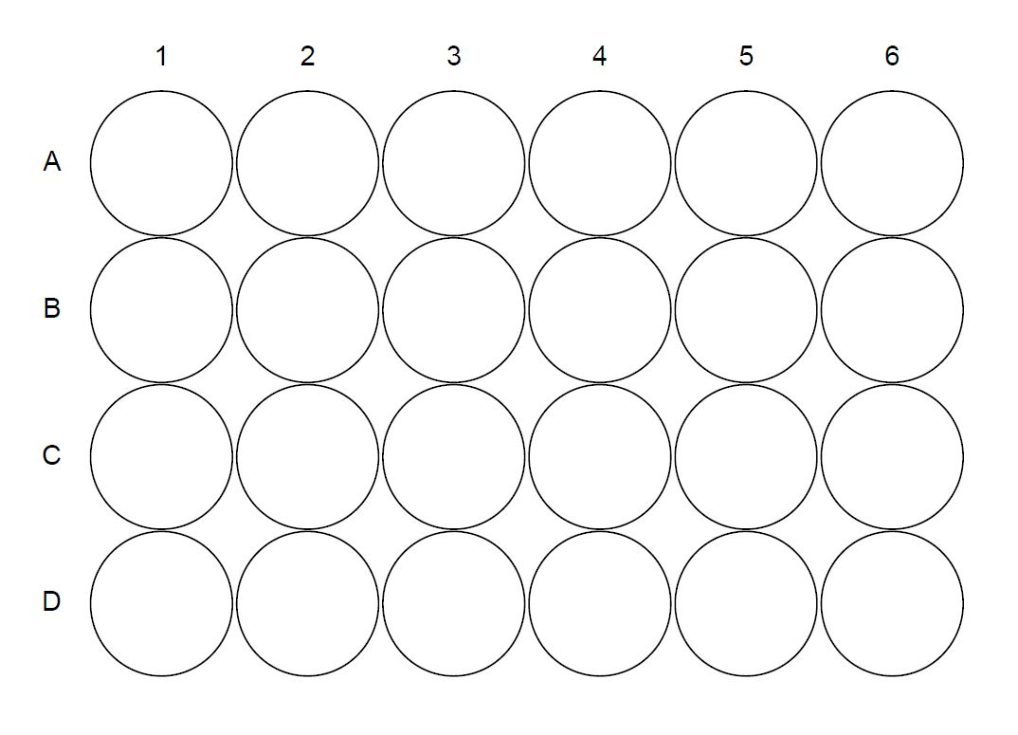
- Fill the well plate with solutions as indicated in the table below. There should be a total of 40 drops in each well.

Well # | A1 | A2 | A3 | A4 | A5 | A6 | C1 | C2 | C3 | C4 | C5 | C6
Drops of 0.50 mol dm^{–3} copper nitrate solution | 8 | 22 | 24 | 10 | 12 | 14 | 16 | 18 | 20 | 26 | 28 | 30
Drops of water | 32 | 30 | 28 | 26 | 24 | 22 | 20 | 18 | 16 | 14 | 12 | 10

- Add 40 drops of the brass solution to well B3 (see diagram).
- Compare the intensity of the colour of your brass solution with the wells around it. The well that matches the intensity of colour of your brass solution represents the copper concentration in your brass solution – eg if well A6 matches the colour of your brass solution then the copper concentration will be 0.50 × 18/40 mol dm⁻³.

Calculations

- Calculate the number of moles of copper in 10 cm³ (the volume of the brass solution).
- Multiply the value you obtained in (1) by the relative atomic mass of copper (63.5) to give the mass of copper in the brass solution.
- Divide by the mass of brass used and express the result as a percentage.

Questions

- Does the zinc interfere in any way in this analysis? Give reasons for your answer.

- Can you suggest any way to improve the accuracy of this experiment?

Health, safety and technical notes

- Wear eye protection throughout (splash-resistant goggles to BS EN166 3).
- Nitric acid, 5M HNO₃ (aq) is CORROSIVE. Consider wearing protective gloves.
- Disposal: collect and retain copper/zinc solutions for appropriate disposal.

The determination of copper in brass – student sheet B

In this experiment you will be finding out how much copper there is in brass (an alloy of copper and zinc). You will dissolve the brass in nitric acid and compare the colour of the solution with that of solutions of various concentrations of copper.

You must wear appropriate eye protection.

Instructions

Preparing the brass solution

- Weigh out, accurately, about 0.3 g of brass in a 10 cm³ beaker.
- Put the beaker in a fume cupboard.
- Add 10 drops of nitric acid.
- When the reaction subsides add a further 10 drops of nitric acid.
- Repeat until all the brass has dissolved.
- Using the pipette, transfer the solution to a 10 cm³ volumetric flask. Add drops of water to the beaker to rinse and then transfer the washings to the flask. Make the volume in the flask up to the line with more water. Stopper the flask and then invert it a few times to mix.

Preparing the standard copper solutions

- Fill the well plate with solutions as indicated in the table below. There should be a total of 40 drops in each well.

Well # | A1 | A2 | A3 | A4 | A5 | A6 | C1 | C2 | C3 | C4 | C5 | C6
Drops of 0.50 mol dm^{–3} copper nitrate solution | 8 | 22 | 24 | 10 | 12 | 14 | 16 | 18 | 20 | 26 | 28 | 30
Drops of water | 32 | 30 | 28 | 26 | 24 | 22 | 20 | 18 | 16 | 14 | 12 | 10

- Add 40 drops of the brass solution to well B3 (see diagram).
- Compare the intensity of the colour of your brass solution with the wells around it.
- From your results, calculate the copper content of your brass expressing your answer as a percentage.

Questions

- Does the zinc interfere in any way in this analysis? Give reasons for your answer.

- Can you suggest any way to improve the accuracy of this experiment?

Health, safety and technical notes

- Wear eye protection throughout (splash-resistant goggles to BS EN166 3).
- Nitric acid, 5M HNO₃ (aq) is CORROSIVE. Consider wearing protective gloves.
- Disposal: collect and retain copper/zinc solutions for appropriate disposal.

