Atomic Structure

Development of theories about atomic structure

Our current understanding of atomic structure is a result of the discoveries of several scientists over many years, each scientist adding to the model.
Complete the table below by adding the name of the scientist and the discovery made.
Choose from the lists below the table.
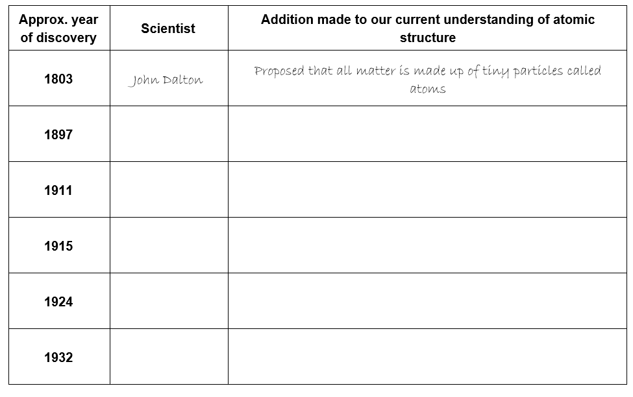
(9 marks)
Scientists:
Ernest Rutherford; Wolfgang Pauli; J. J. Thomson; James Chadwick; Niels Bohr

Discoveries;
Proposed that the electrons orbit around the nucleus in orbits with a set size and energy.
Discovered that atoms contain neutral particles called neutrons in their nucleus.
Realised that atoms are divisible and contain very tiny, negatively charged particles called electrons.

Discovered that an atom is made up of a nucleus and an extra-nuclear part. The central nucleus is positively charged and the negative electrons revolve around this central nucleus.
Proposed the concept of electron spin.

BONUS MARK: Which of the scientists listed above was a famous football goalkeeper in his country?

2 Isoelectronic species

For each of the species below, write out the full electronic configuration and then identify an anion and a cation which is isoelectronic with the initial species.

e.g. neon, Ne; 1s² 2s² 2p⁶

Isoelectronic anion; F ¯ Isoelectronic cation; Mg²⁺

(1 mark for each correct electronic configuration, 1 mark for each correct isoelectronic anion and cation)

1. helium, He;
Isoelectronic anion; ……………..........................
Isoelectronic cation; ……….................................

2. krypton, Kr;
Isoelectronic anion; ……………..........................
Isoelectronic cation; ……….................................

3. calcium ion, Ca²⁺;
Isoelectronic anion; ……………..........................
Isoelectronic cation; ……….................................

BONUS 10th mark Identify a pair of common transition metal ions that are isoelectronic;

Electrons and orbitals

Aufbau’s principle states that “electrons fill orbitals starting with the lowest energy orbital first”

Hund’s rule states that “when filling a set of orbitals of identical energy, electrons are added with parallel spins to different orbitals rather than pairing two electrons in the same orbital”

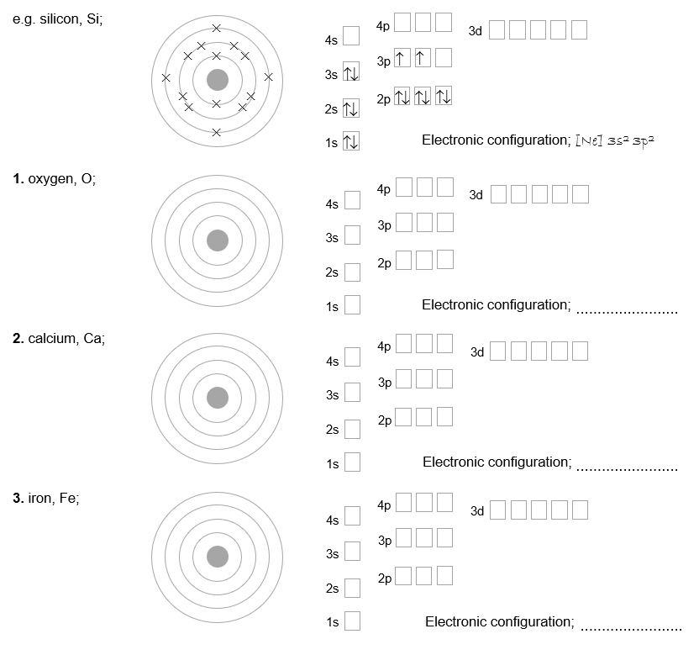
For each of the elements, draw the electrons in the atom as you would have represented them at GCSE level (1 mark) followed by an A-level representation (1 mark) and a short hand form of the electronic configuration (1 mark);

Give one limitation of the way you were taught to draw electrons in atoms at GCSE level
(1 mark)

Trends in ionisation energy

An atom’s ionisation energy is defined as;
‘The amount of energy required to remove one mole of electrons from one mole of atoms in the gaseous state’

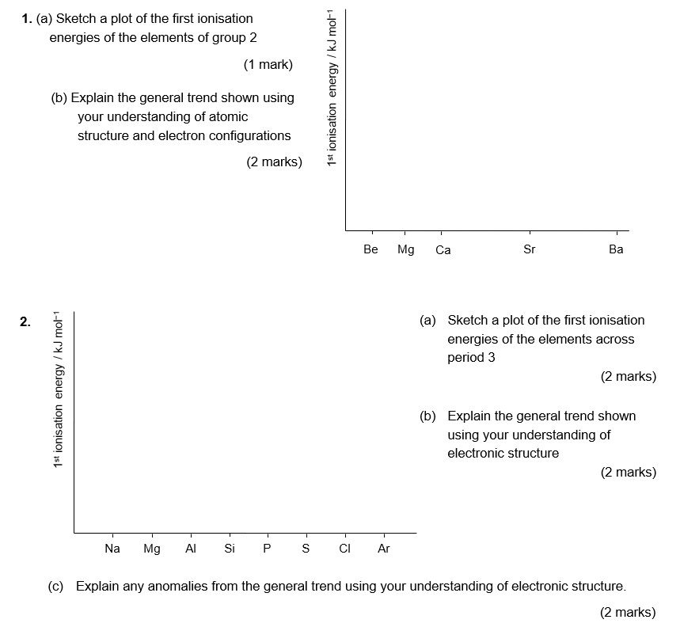
The first ionisation energy is the energy required to remove the first electron [X(g) → X⁺(g) + 1 e⁻].

(d) Which anomaly provides evidence for Hund’s rule?
(1 mark)

Answers

Development of theories about atomic structure
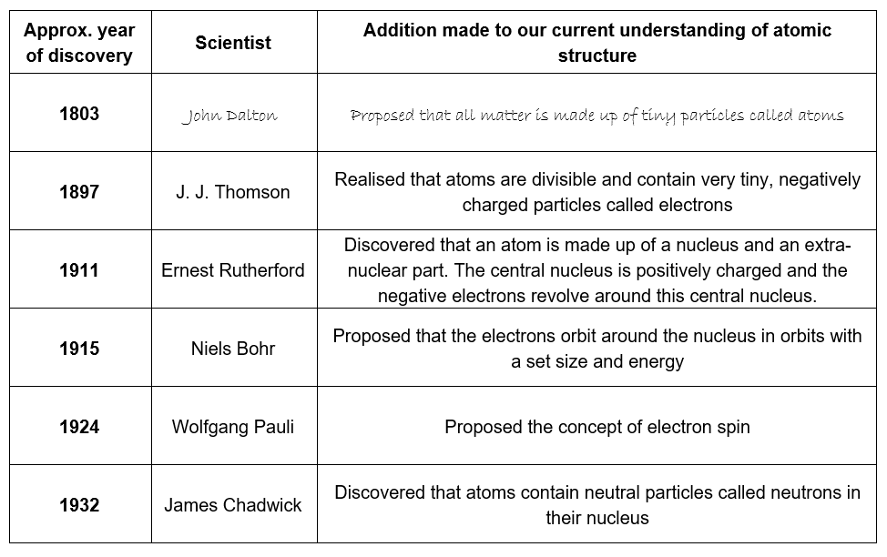
(1 mark for each correct row; 4 marks for the correct order of statements, 3 marks if one statement in incorrect position, 2 marks if two statements in incorrect position, 1 mark if any pair of statements follow on correctly from each other)

BONUS MARK: Niels Bohr was indeed a keen football player and was the goalkeeper in the Danish team Akademisk Boldklub. Although Akademisk Boldklub were, at the time, one of the best clubs in Denmark, he never made it to the national team.

Isoelectronic species

1. helium, He; 1s²
Isoelectronic anion; H⁻
Isoelectronic cation; Li⁺, Be²⁺

2. krypton, Kr; 1s², 2s², 2p⁶, 3s², 3p⁶, 4s², 3d¹⁰, 4p⁶
Isoelectronic anion; Se²⁻, Br⁻
Isoelectronic cation; Rb⁺, Sr²⁺, In³⁺, Sn⁴⁺

3. calcium ion, Ca²⁺; 1s², 2s², 2p⁶, 3s², 3p⁶
Isoelectronic anion; S²⁻, Cl⁻
Isoelectronic cation; K⁺, Ga³⁺

4. Fe³⁺ and Mn²⁺; 1s², 2s², 2p⁶, 3s², 3p⁶, 4s⁰, 3d⁵
Fe²⁺ and Co³⁺; 1s², 2s², 2p⁶, 3s², 3p⁶, 4s⁰, 3d⁶
Zn²⁺ and Cu⁺; 1s², 2s², 2p⁶, 3s², 3p⁶, 4s⁰, 3d¹⁰

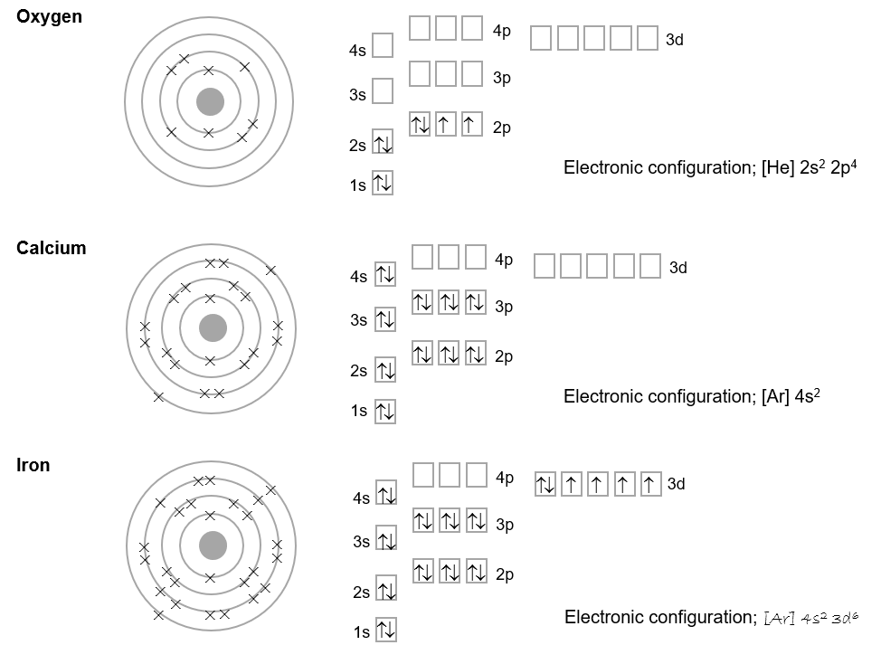
Electrons and orbitals

Possible limitations of the GCSE representation of electronic structure (1 mark for any sensible point);
- The GCSE representation doesn’t account for d-orbitals. At GCSE electron shells occupy a maximum of 8 electrons (hence why we only ever go as high as atomic number 20).
- The GCSE diagram doesn’t allow for the fact that the 3d orbital is higher in energy than the 4s orbital and hence the 4s orbital is filled first.
- The GCSE model gives no indication of electron spin (important when trends in ionisation energies are discussed).

Trends in ionisation energies

1.
(a) 1 mark for overall correct downward trend
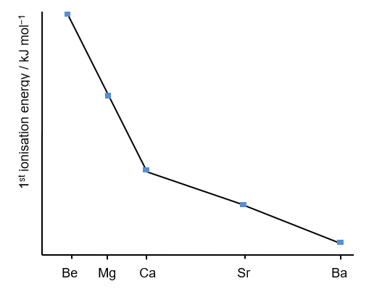
(b) As you go down the group there is a general decrease in the first ionisation energy. This is because;
- the outer electron is in a successively higher energy orbital and is further away from the positive pull of the nucleus. Hence less energy is needed to remove it.
- the number of electrons shielding the outer shell electron from the nuclear charge increases (increased shielding)

2.
(a) 1 mark for overall correct upward trend 1 mark for dips at both Al and S
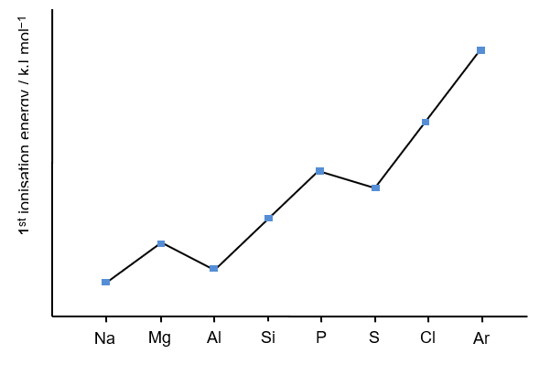
(b) As you go across the group there is a general increase in the first ionisation energy. This is because there is an increase in the nuclear charge (1 mark) as we go across the group and the electrons are being removed from the same principal energy level / the electrons are approximately the same distance from the nucleus (1 mark for either point)

(c) The drop from Mg-Al is because the outer electron in Al is in a 3p orbital whereas the outer electron in Mg is in a 3s orbital. The 3p orbital is slightly higher in energy and so the electron is removed more easily (1 mark)
The drop from P to S is a result of mutual repulsion. In P, the 3 electrons in the 3p orbitals are in singly occupied orbitals. In S there are 4 electrons in the 3p orbitals meaning that one of the 3p orbitals must contain a pair of electrons. These repel each other slightly meaning that it is easier to remove this electron than would be expected (1 mark).

(d) The drop from P to S is evidence of Hund’s rule.

