Ionic bonding

This resource is part of the Structure strip series of resources, designed to support literacy in science teaching. More resources in this series can be found at: rsc.li/49uLFDe

Learning objectives
- Describe ion formation.
- Draw dot and cross diagrams of ionic bonding and explain how an ionic lattice is held together.
- State the limitations of a range of models used to represent ionic bonding.

Introduction

Ionic bonding occurs when atoms lose and gain electrons to form ions and then the positively and negatively charged ions are attracted to each other. In this activity, your learners will gain understanding of the models and diagrams used to represent this and their limitations.

How to use structure strips

Structure strips are a type of scaffolding you can use to support learners to retrieve information independently. Use them to take an overview at the start of the topic, to activate prior knowledge, or to summarise learning at the end of a teaching topic.

Structure strips have sections containing prompts which are sized to suggest the amount that learners must write. Learners glue the strips into the margin of an exercise book and write their answers next to the sections, in full sentences. When learners have finished using the structure strip, they should have an A4 page set of notes and examples.

Scaffolding

To further support learners to answer the questions you can include a list of keywords or add prompts to the structure strip.

As learners grow in confidence, they may be able to answer the question without the structure strip or attempt the question first and then use the structure strip to improve or self-assess their answer.

Metacognition

This activity supports learners to develop their metacognitive skills in three key areas.
- Planning: the strips provide scaffolding to plan the written response. Learners will decide where to gather information from (textbooks, own notes, revision websites). Ask learners: is the source of information you are using reliable?
- Monitoring: learners are prompted by the questions in the structure strip and can check their answer against the prompts. Ask learners: have you covered all of the questions in the space provided? Do you need to change anything to complete the task?
- Evaluation: learners can self-assess or ask a peer to check their work against the answers. Ask learners: did you achieve what you meant to achieve? What might you do differently another time?

Keywords

Bonding, dot and cross diagram. electron, ionic, ions, lattice, limitation, negative, positive.

Answers

Suggested answers for the structure strip activity are given in the frame on page three.

Follow-up question

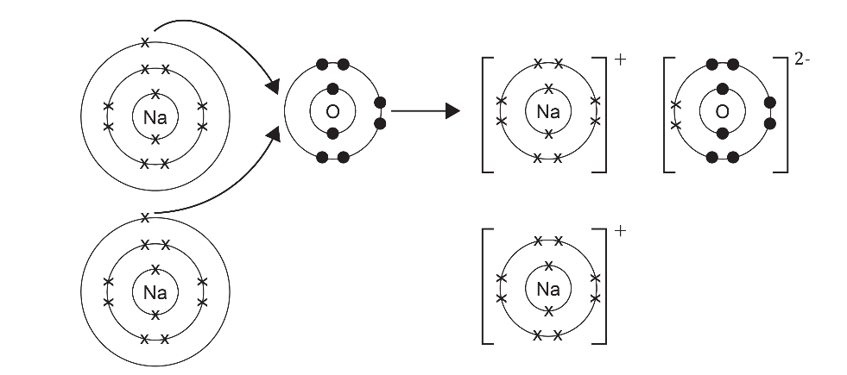

Explanation of charges: Each sodium ion has lost one electron, it now has 11 protons (+ charge) and 10 electrons (- charge) so has an excess charge of +1 leading to a 1+ charge on the ions.

The oxide ion has gained two electrons (one from each of the two sodium atoms), it now has 8 protons (+ charge) and 10 electrons (- charge) so has an excess charge of -2 leading to a 2- charge on the ion.

Evaluation of models: Dot and cross diagrams are good as they show what has happened in terms of electron transfer and make it clear that electrons have been lost and gained. They are limited because they do not show the giant lattice structure.

Structure strip  Ionic bonding | Example answer
Explain how and why metals form positive ions. | Metals lose electrons to achieve a full outer shell of electrons. This leaves the metal atom with more protons (+) than electrons (-) and hence a positive charge.
Explain how and why non-metals form negative ions. | Non-metals gain electrons to achieve a full outer shell of electrons. This leaves the non-metal atom with more electrons (-) than protons (+) and hence a negative charge.
Draw dot and cross diagrams to show how electrons are transferred between the following pairs of atoms.  - Na and F  - Mg and O  - Mg and Cl  Give the formula of the salts formed. | Formula = NaF  Formula = MgO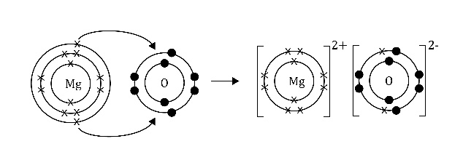  Formula = $Mg{Cl}_{2}$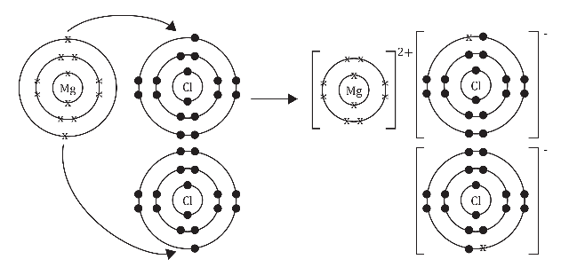
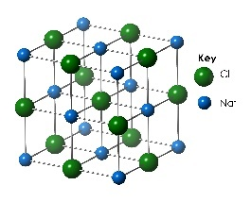  Describe how an ionic lattice is held together using the diagram to help you write your answer. | An ionic lattice is held together by a strong electrostatic attraction between oppositely charged ions. This attraction happens in all directions throughout the lattice. It takes a lot of energy to overcome these attractions.  In this diagram the attraction is between Na⁺ and Cl⁻ ions.
Describe the limitations of using the following models to represent a giant ionic structure:  - Dot and cross  - Ball and stick  - 2D and 3D diagrams | - Dot and cross – only shows one ionic unit eg a Na+ ion and a Cl- ion so does not represent the lattice structure.  - Ball and stick – the ions are shown with a gap between them whereas, in reality, they are very close/touching. The stick could be misinterpreted as being a covalent bond as a line in a covalent structure = a shared pair of electrons. It does not show what happened with the electrons.  - 2D diagram – only shows one layer of the lattice. Doesn’t show what happens to the electrons. 3D diagram – doesn’t show what happens to the electrons.

