- A teacher shows a class an experiment in which liquid paraffin is cracked.
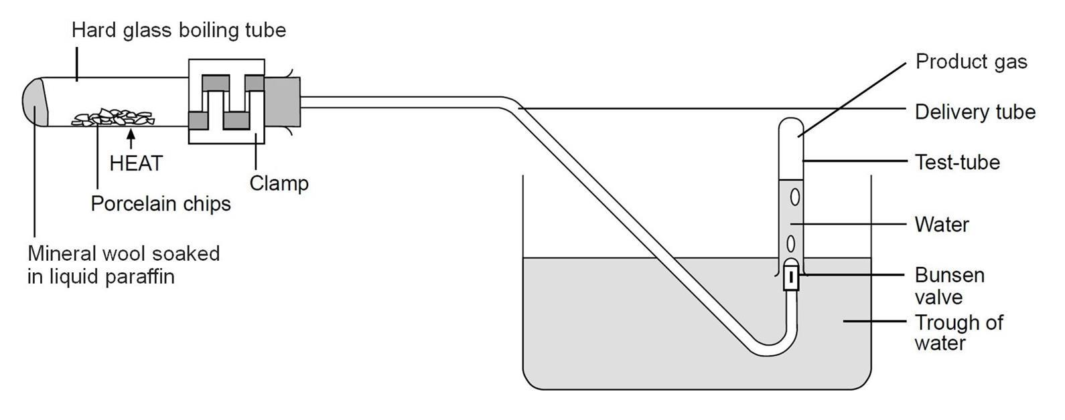
Here is a diagram of the equipment used.
Source: Royal Society of Chemistry
- Suggest what happens to liquid paraffin when it is ‘cracked’.

- Porcelain chips are used because they catalyse the reaction.
What is the meaning of the word ‘catalyse’?

- Using the diagram, what evidence is there that smaller molecules are made in the experiment?
Explain your answer.

- Using the diagram, describe how you think the experiment works.

- What evidence is there from the diagram that the product gas is insoluble in water?

Paraffin is a mixture of large molecules.
The structure of one of these molecules is shown below.
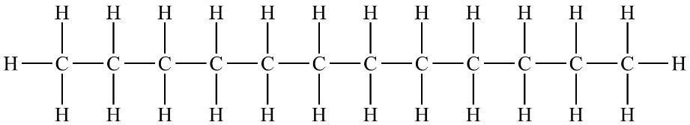

- Which elements are present in the molecule?

- What is the name of substances containing the elements in part f)?

- This molecule is also a member of a homologous series.
What is a homologous series?

- What is the name of this homologous series?

- What is the general formula of the homologous series in part i)?

- The molecule above is called dodecane.
What is the molecular formula of dodecane?

- Which of these molecules do not belong to the same homologous series as dodecane?
Write ‘Yes’ or ‘No’ into the right-hand column in the table.

Molecular formula of substance | The same homologous series as dodecane (‘Yes’ or ‘No’)
C₈H₁₆
C₁₃H₂₈
C₅H₁₂
C₂₃H₄₆
C₅₀H₁₀₂
- The molecules made from cracking long chain molecules can be very useful.
Give a use for these molecules.
Smaller alkanes
Alkenes

- When a long chain molecule is cracked, a substance called ethene is normally made.

- Draw the structure of an ethene molecule.

- To which homologous series does ethene belong?

Another molecule that has a similar name to ethene is ethane.

One of these molecules is described as ‘saturated’ and the other as ‘unsaturated’.
- Define each of these terms?

- Write ‘unsaturated’ or ‘saturated’ in the correct spaces next to the names below:

Ethene
Ethane
- Complete the word equation that shows octane being cracked to make ethene.
Write the name of the other product into the space.
Octane + ethene

