Structure determination

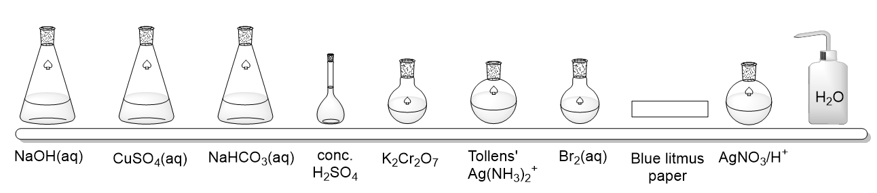
Simple chemical tests
On the shelf above is a selection of reagents that can be used in simple tests to identify particular functional groups. Identify the regent(s) that can be used to distinguish between the pairs of organic compounds shown below.
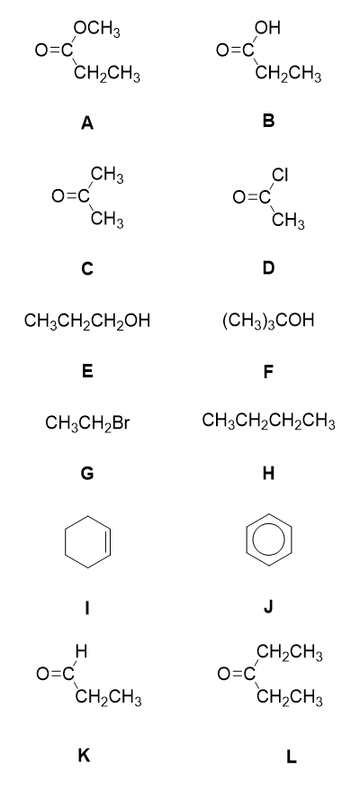

Functional group test match up

Match up the reagents with the functional groups they test for and the observation for a positive test

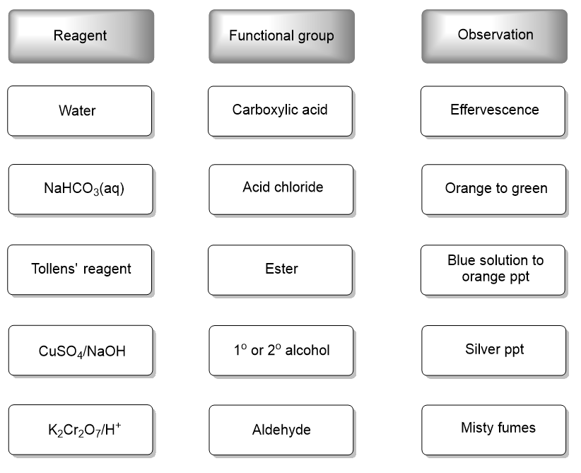

1H NMR spectra

1H NMR spectroscopy tells us about the environment of the hydrogen atoms in organic molecules.

- Outline how you would prepare a sample of an organic substance for analysis in an NMR spectrometer.
(5 marks)
- The axes below show the 1H NMR spectrum for 2-aminopropane. Label the features of the spectrum shown by the arrows and boxes.
(4 marks)
- On the structure of 2-aminopropane, indicate which proton(s) give rise to the peak labelled a.
(1 mark)
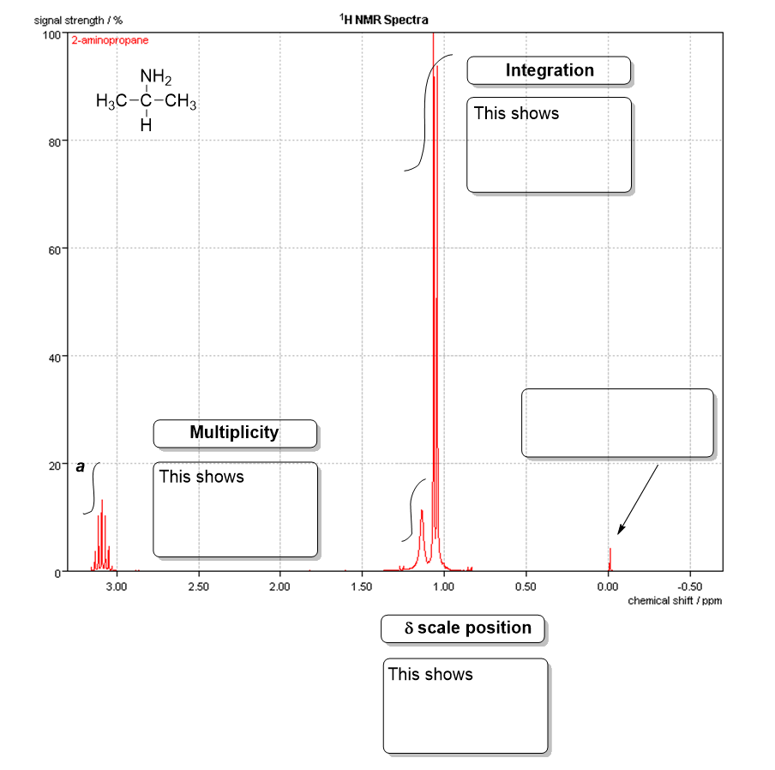

Fragmentation in the mass spectrometer
- The table below shows the m/z values of fragmentation ions formed from fragmentation of an ester, methyl butanoate in a mass spectrometer. Complete the table to show the structural formula of the ions that correspond to the m/z given.
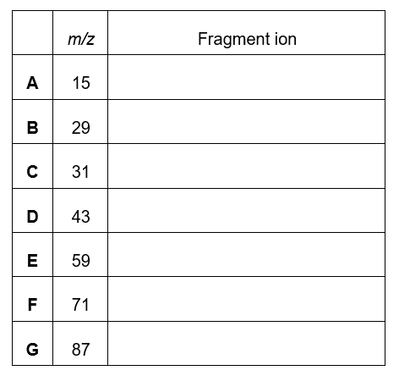

2. α cleavage is the primary mode of fragmentation of compounds containing carbonyl groups in the mass spectrometer. This is when the R groups attached to the carbonyl group break off. Which 2 peaks from those labelled A to G are formed as a result of α cleavage?

3. Write an equation to show how fragment F is formed from the molecular ion

13C NMR spectroscopy

Sort the molecules below into the number of peaks that would be displayed in its 13C NMR spectrum
(1 mark each).
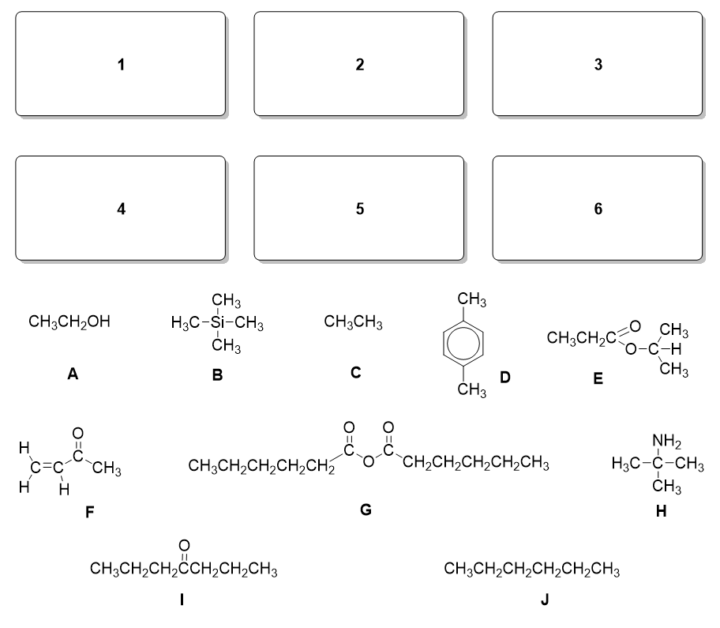

Molecular true or false

Look at the structure of molecule A and indicate whether the statements 1 to 10 are true or false.
(1 mark each)
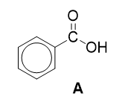
- It has a major fragment in its mass spectrum at m/z = 105.
- It decolourises bromine water.
- There are 5 distinct peaks in its 13C NMR spectrum.
- There are only 2 unique proton environments in the molecule.
- One of the peaks in the 1H NMR spectrum will disappear when a little D₂O (deuterated water) is added to the tube and it is reanalysed.
- Its molecular ion appears at m/z = 121 in the mass spectrum.
- When reacted with Tollens’ reagent, a silver mirror forms.
- The molecule will turn blue litmus paper red.
- Its IR spectrum will contain a broad peak at 2800-3500cm⁻¹.
- A sample of A will be immiscible with water.

Thin layer chromatography

Thin layer chromatography can be used to separate mixtures. Look at the chromatogram shown below.

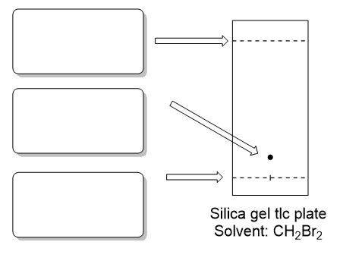
- Fill in the features indicated by arrows on the chromatogram.
(3 marks)
- Label the stationary phase and mobile phase on the diagram.
(2 marks)
- Calculate Rf for the sample shown, show your working.
(3 marks)
- Not all samples are visible after a chromatogram has been run. Give 2 ways in which the sample can be visualised on the silica gel plate.
(2 marks)

Gas chromatography-mass spectrometry

- How does the liquid stationary phase separate organic compounds?
- mark)
- What is the mobile phase when in GC-MS?

(1 mark)
- What kind of mixtures is GC-MS useful for separating?

(1 mark)

- A mixture of ethyl ethanoate, propyl ethanoate, ethanol and hexane is analysed by GC-MS. Suggest the order in which the substances would be eluted and indicate what the output from the GC-MS would be.

(7 marks)

Structure determination – Answers

Simple chemical tests
A and B – NaHCO₃(aq)
C and D – Water and blue litmus paper
E and F – K₂Cr₂O₇ and H₂SO₄
G and H – AgNO₃/H⁺
I and J – Br₂(aq)
K and L – Tollens and CuSO₄/NaOH
One mark for each correct reagent. This starter provides a good opportunity to discuss what the results of these tests would be.

Functional group test match up
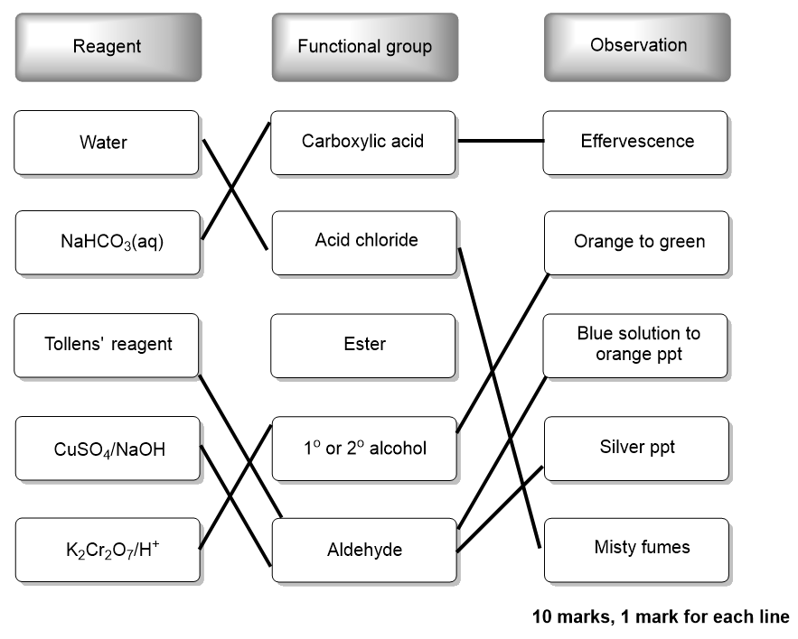

1H NMR spectroscopy

- Dissolve between 10-20mg /a small quantity of the substance (2 marks, QoL for dissolve, plus quantity)
- In a small volume/1-2cm³ of CDCl₃ (one mark for suitable deuterated solvent)
- Add one drop of TMS reference solution (one mark for TMS)
- Transfer to a clean, dry NMR tube using a Pasteur pipette (one mark for NMR tube)

Total = 5

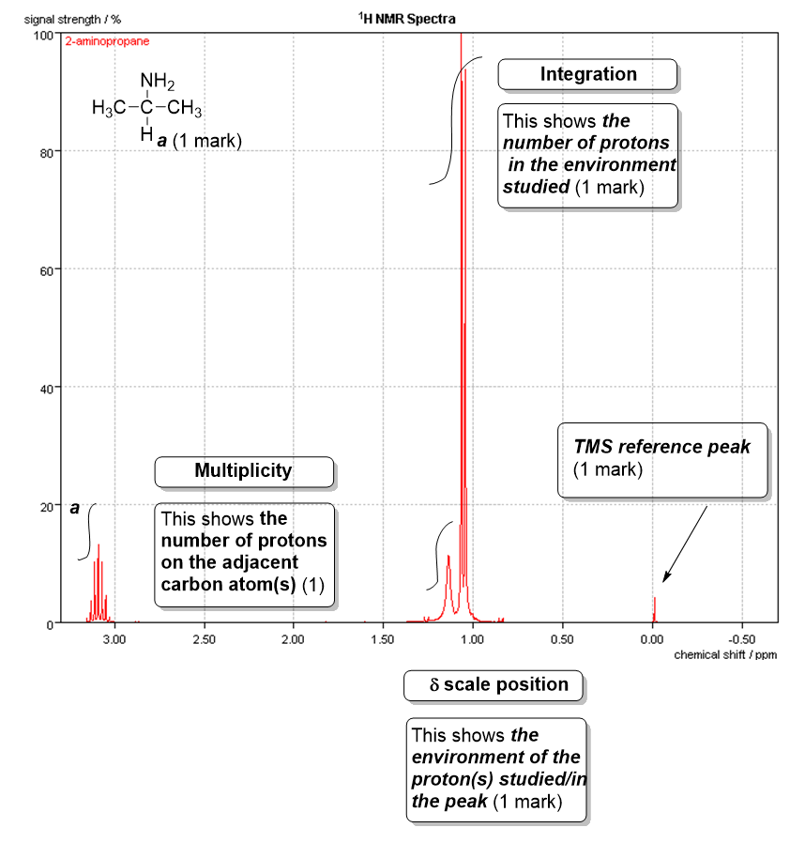

Fragmentation in the mass spectrometer
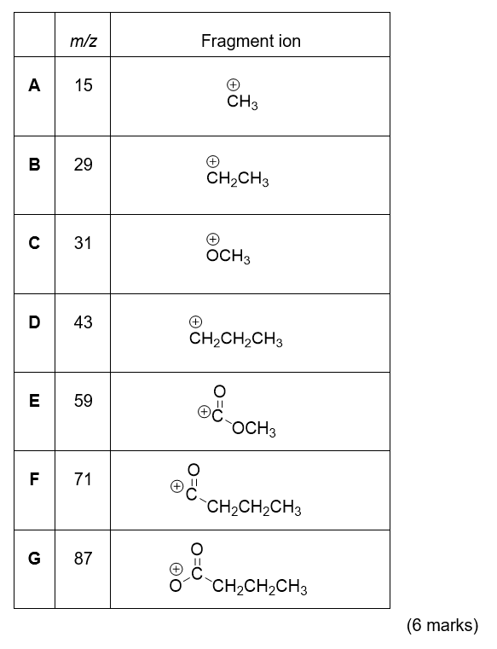
2. C and D (1 mark for both)

3.

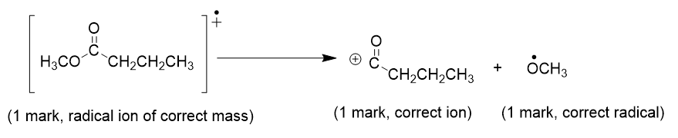

13C NMR spectroscopy
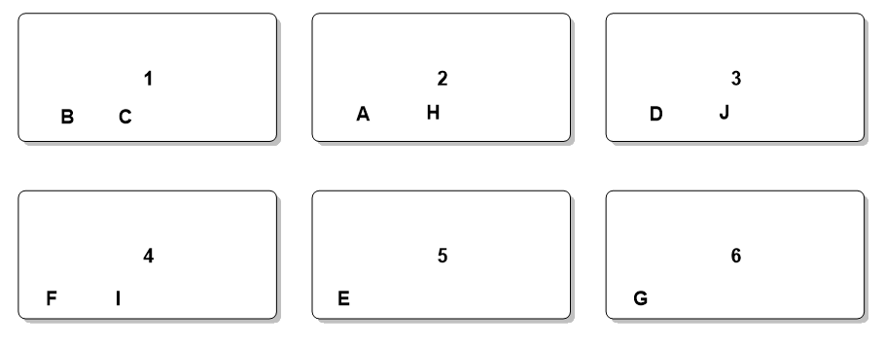

Molecular true or false

1. T
2. F
3. F
4. T
5. T
6. F
7. F
8. T
9. T
10. F

Thin layer chromatography
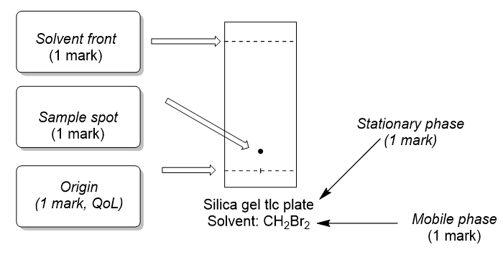
1 and 2 as above total = 5 marks
3. Measurement from origin to centre of spot (1 mark), measurement of origin to solvent front (1 mark) division of measurement 1 by measurement 2 (1 mark)
4. UV light (1 mark) and staining/names stain such as DNP/DCPIP (1 mark)

Gas Chromatography – Mass Spectrometry

1. (relative) solubility (1 mark)
2. The gas stream (1 mark)
3. Mixtures of volatile organic compounds (1 mark, QoL for volatile)
4.
- Ethanol first
- Hexane last
- Each substance appears as a single peak

m/z for each ethyl ethanoate (88), propyl ethanoate (102), ethanol (46), hexane (96) (1 mark each)

