The microscale synthesis of azo dyes – student sheet

In this experiment you will be synthesing an azo dye and using it to dye a piece of cotton. The reactions are:

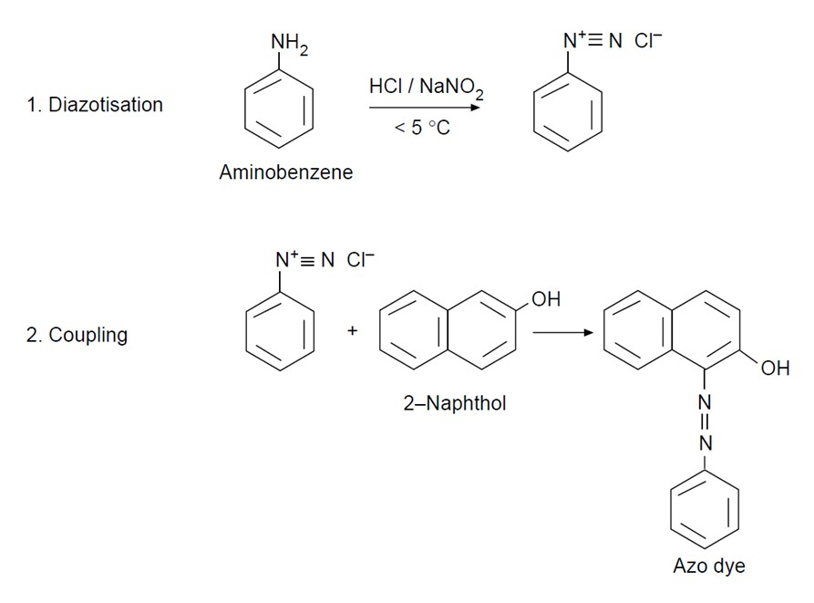

Instructions

- Put eight drops of aminobenzene in a 10 cm³ beaker and add 30 drops of deionised water followed by 15 drops of concentrated hydrochloric acid. Swirl the beaker and then put it in an ice bath.
- Weigh 0.15 g of sodium nitrite into another beaker and add 1 cm³ of deionised water. Cool the beaker in the ice bath. Add one spatula of urea (this prevents side reactions occurring).
- Mix the contents of the two beakers together and keep in the ice bath.
- Weigh 0.45 g of 2-naphthol into another beaker and add 3 cm³ of sodium hydroxide solution. Swirl to dissolve.
- Take a piece of cotton cloth 2 × 2 cm² and, using tweezers, dip it into the 2-naphthol solution. Allow the solution to completely soak the cotton.
- Dip the cloth completely into the diazonium salt solution. A red dye forms in the fibres, dyeing the cloth.
- Take the cloth out, wash it under the tap and leave to dry.

Health and safety

- Students must wear suitable eye protection (splash resistant goggles to BS EN166 3).
- This experiment should be done in a fume cupboard.
- Aminobenzene (aniline) is TOXIC by all routes, a carcinogen and mutagen, a skin sensitiser, causes eye damage and is toxic to aquatic life.
- Hydrochloric acid, HCl(aq), is CORROSIVE and a respiratory irritant.
- Sodium Nitrite, NaNO² is an OXIDISER, toxic if swallowed and hazardous to aquatic life.
- 2-Naphthol is HARMFUL if swallowed or in contact with skin and toxic to aquatic life.
- Sodium hydroxide solution, 2 mol dm^{–3} NaOH(aq), is CORROSIVE.
- Ethanol is highly FLAMMABLE.
- Urea is of low hazard

