Volcanoes, meteorites and catalysts for life’s origins

Original article by Rebecca Trager. Adapted by Emma Davies.

Iron-rich nanoparticles can catalyse the conversion of carbon dioxide to complex organic molecules

Before life could exist on Earth, there had to be reactive organic molecules. Researchers in Germany believe iron-rich nanoparticles from meteorites and volcanism could have catalysed the conversion of CO₂ in the atmosphere into such molecules on early Earth.

There are several theories as to how the precursors to life came to be on Earth including arriving on asteroids or comets, lightning strikes catalysing reactions in the early atmosphere, and through reactions taking place deep under the sea at hydrothermal vents. But no conclusive evidence has yet confirmed which of these, if any, is correct.

Replicating early Earth

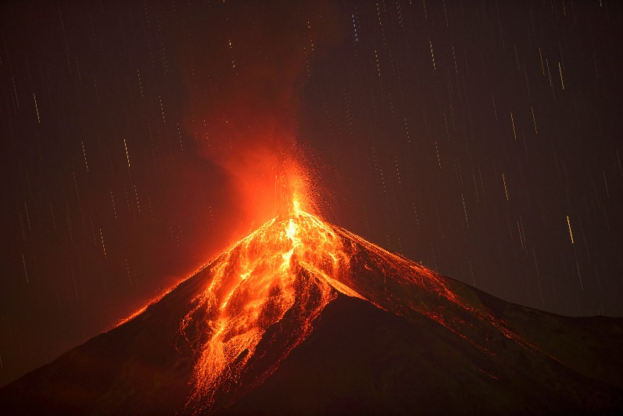
Now, Oliver Trapp, a chemist at Ludwig-Maximilians University Munich, has proposed an alternative scenario – that nanoparticles rich in iron (coming from meteorites and volcanoes) catalysed reactions between the CO₂, hydrogen gas and water vapour in the atmosphere to form the key starting materials for life.

Source: © Getty Images

How did the tumultuous environment of early Earth forge the building blocks for the carbohydrates, amino acids and nucleic acids that form the foundation of life today?

Oliver’s team tested this theory in the lab. The gases were placed in a heated and pressurised machine (an autoclave) with crushed samples of meteorites and volcanic ash. The autoclave replicated the conditions of early Earth’s atmosphere with temperatures ranging from 150 to 300°C and pressures from 9 to 45 bars.

The researchers found that the iron-rich nanoparticles in the samples were able to catalyse the formation of various aldehydes, alcohols and hydrocarbons under these conditions. ‘We got a lot of formaldehyde, acetaldehyde and also methanol and ethanol, as well as long chain and branched alkanes,’ says Oliver. Forming oxygenated compounds was particularly exciting as these are important building blocks for carbohydrates, amino acids and nucleic acids.

An industrial scale

The team estimates that 600,000 tonnes of reactive organic molecules could have been formed this way during the Hadean aeon – a period around 4.5 billion years ago when huge quantities of CO₂ were likely present in the atmosphere.

Jim Cleaves, a researcher at the Earth-Life Science Institute in Tokyo, Japan, who was not involved in this research agrees that ‘this is another [idea] to consider’ when thinking about how reactive organic molecules first came to be on Earth. But a major mystery remains: how these molecules then came together to make a living thing. ‘The community is still stuck on that,’ he adds.

This is adapted from the article Volcanoes and meteorites may have delivered catalysts for life’s beginning in Chemistry World. Read the full article: rsc.li/3NRdf5h

