Ionic bonding mats

Learning objectives
- Draw dot and cross diagrams for ionic compounds.
- Show how electrons are transferred in ionic bonding.

Introduction

When a metal and a non-metal react, the metal atom loses electrons to become a positively charged ion and the non-metal gains electrons to become a negatively charged ion. An ionic bond is the strong electrostatic force of attraction that forms between the metal and non-metal ions because of their opposite charges. A dot and cross diagram is one way to model the transfer of electrons that occurs in this process.

Instructions

Use the template on the question sheet to construct the dot and cross diagrams for different ionic compounds. You will need to show the electron configuration and add the charge for each ion and show the ratio of the ions. You can find a step-by-step guide to the process at rsc.li/3AMzz9J

Once you are confident that you have got the correct arrangement, copy the diagram into your exercise book and move onto the next question.

Example

The photo below shows how the worksheet can be completed using a whiteboard marker with the worksheet inside a plastic wallet.

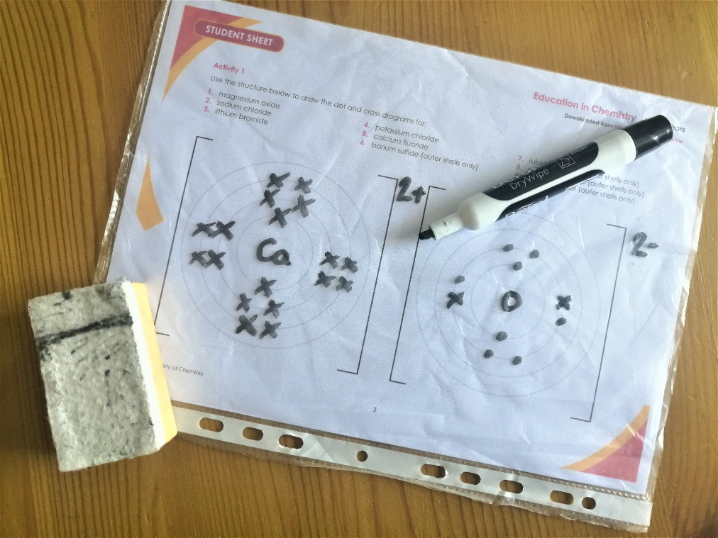

Alternatively, you can complete the worksheet using small counters, plasticine or other items that can be moved around.

Activity 1

Use the outlines below to draw the dot and cross diagrams for:

- Magnesium oxide
- Sodium chloride
- Lithium fluoride
- Potassium chloride
- Calcium oxide
- Magnesium sulfide
- Lithium chloride
- Potassium fluoride
- Calcium sulfide

Activity 2

Use the outlines below to draw the dot and cross diagrams for the following ionic compounds (you will need to add the ratio of the ions):

- Lithium oxide
- Magnesium fluoride
- Sodium sulfide
- Calcium fluoride
- Sodium oxide
- Potassium sulfide
- Calcium chloride
- Potassium nitride
- Magnesium nitride

Activity 3

Each of the dot and cross diagrams below are incomplete. Find and add the missing features to complete each diagram.

- Lithium oxide
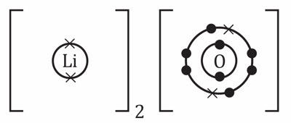

- Sodium chloride
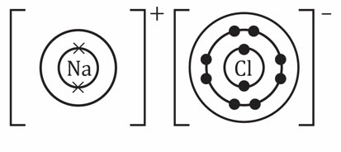

- Calcium oxide
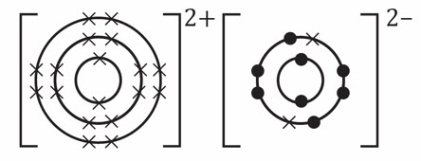

- Magnesium fluoride
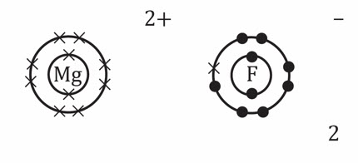

- Calcium chloride
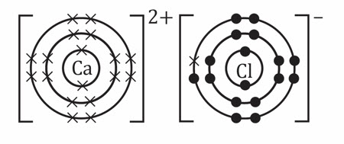

- Potassium sulfide
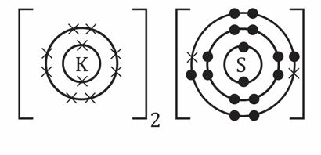

- Sodium fluoride
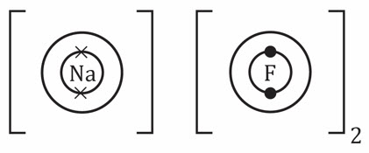

- Magnesium nitride
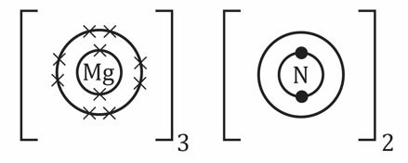

- Lithium hydroxide
