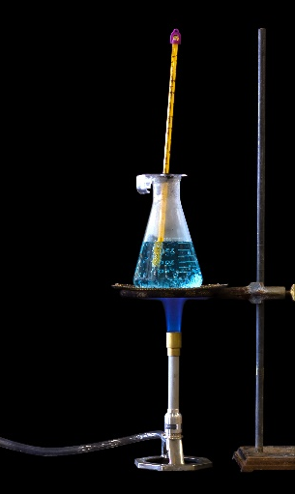
Simon says…
- Simon heats some copper sulfate solution using a Bunsen burner.
The gas used in the Bunsen burner is called methane, and the molecular formula of methane is CH₄.

He makes some statements about this process.

State which statements are true, and which are false.
Write ‘T’ or ‘F’ into the box.
Source: Adobe Stock
- Methane is a hydrocarbon

- Methane reacts with oxygen to make heat energy.

- Heat energy passes from the copper sulfate solution
to the Bunsen flame.

- Methane is oxidised in the reaction.

- When methane burns, no chemical products are formed,
only heat energy.

- The chemical reaction taking place is a neutralisation.

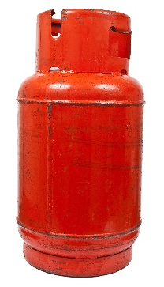
- This shows a cylinder of propane.
The propane in the cylinder can be used to provide heat for barbecues and heating for houses.

Propane has the molecular formula C₃H₈.

- Complete the structure below to show a propane molecule.
Source: Envato Elements
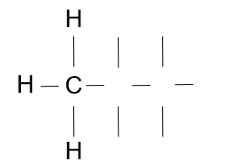

Michelle and Sarah would like to write some equations to show propane burning.
- Complete their word equation:

Propane + carbon dioxide + water
- Complete their symbol equation for the reaction by writing the missing chemical formulae.

C₃H₈ + + H₂O
- Now balance the symbol equation by writing the correct whole numbers in front of some of the chemical formulae.
Write your answer below.

C₃H₈ + + H₂O

- When a hydrocarbon burns in a limited or short-supply of oxygen, a toxic gas may form.
The boxes below are short questions about this toxic gas.

Draw straight lines from the questions on the left to the correct answer on the right.
Statement
Answer

The name of the gas?
Carbon monoxide

Carbon dioxide
The chemical formula of the gas?
CO

CO₂
Complete
The type of combustion taking place forming the gas?

Incomplete

- This question is about types of air pollution.
Complete the sentences using some of the words in the box.
Greenhouse effect acid rain carbon dioxide nitrogen dioxide
nitrogen oxygen lower alkali
acid sulfur dioxide higher

- Sulfur is an impurity in many fossil fuels.

- When the fossil fuel burns, sulfur reacts with to make a gas called . .
- This gas dissolves in water to make a solution that has a pH than 7.
- This means it is an .

- When this gas dissolves in rain water it makes a type of pollution called .
- This pollution may fall into rivers and lakes as well as land, and can kill wildlife like fish and plants.

- Some car and lorry engines produce a pollutant called nitrogen dioxide.

- Name the two gases that react together to make nitrogen dioxide.

- State the name of the substance that contains these two gases before the engine is used.

- Explain how nitrogen dioxide is formed inside an engine.

- Petrol may produce a lot of pollution when it burns.
Hydrogen is seen as a better fuel to use as it does not make any pollution.
- Give the names of two pollutants produced from burning petrol.

- Complete the word equation to show what happens when hydrogen burns in air:

Hydrogen + oxygen .
- Use your answer to part b) to explain why hydrogen does not make any pollution when it burns.

