Bridging the macroscopic and sub-microscopic worlds
Education in Chemistry
September 2019
rsc.li/2LVUXjW
Aim: to explicitly link the macroscopic observations from a practical to the sub-microscopic explanations from an animation. Equations and formulas are used to bridge the two levels of thinking.
Instructions: Print this in A3 (you can edit this activity to make it easier by removing some of the formulas). It’s important that students realise that in solution, there are no ionic solids here because they are all soluble and so exist as aqueous ions. Students work in pairs to carry out the practical and complete the Macroscopic column – see AQA for an example method. Please perform your own risk assessment. Students then use an animation (such as this), video or simulation to complete the Sub-microscopic column. This could be done for homework. An example is overleaf:

 | Macroscopic | Symbolic | Sub-microscopic
Before electrolysis  Add 1.5 g of sodium chloride to 50 cm³ of water in a beaker and stir. | - Complete the diagram during the practical to show what you observed after sodium chloride was added to water and stirred. Label the diagram – making sure you use some of the formulas from the Symbolic column. The salt container has been done for you.  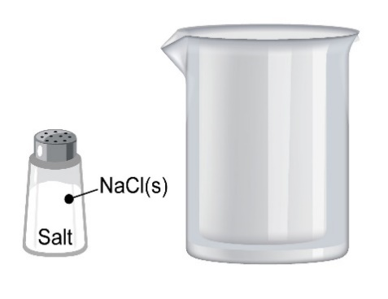 | NaCl(s) Na⁺(aq) + Cl⁻(aq)  H₂O(l) ⇌ H⁺(aq) + OH⁻(aq) | - Complete the diagram once you have watched an animation imagining you can see the ions and molecules present in a beaker of sodium chloride solution. Label the diagram – making sure you use some of the formulas from the Symbolic column.
During electrolysis  Now carry out electrolysis on this solution | - Complete the diagram during the practical to show what you observed during electrolysis. Label the diagram – making sure you use some of the formulas from the Symbolic column. | 2H⁺(aq) + 2e⁻ H₂(g)  2Cl⁻(aq) Cl₂ (g) + 2e⁻  Na⁺(aq)  OH⁻(aq) | - Complete the diagram once you have watched an animation imagining you can see the ions, electrons and molecules during electrolysis. Label the diagram – making sure you use some of the formulas from the Symbolic column.

