Preparing and testing ethyne – student sheet

In this experiment you will be generating ethyne gas inside a plastic Petri dish and testing its properties using a solution of potassium manganate(VII) in propanone.

Instructions

- Cover the worksheet with a clear plastic sheet.
- Place the base of the Petri dish over the large circle on the diagram (see below).
- Cut off the ends of two plastic pipettes (as shown below) and place them inside the Petri dish.

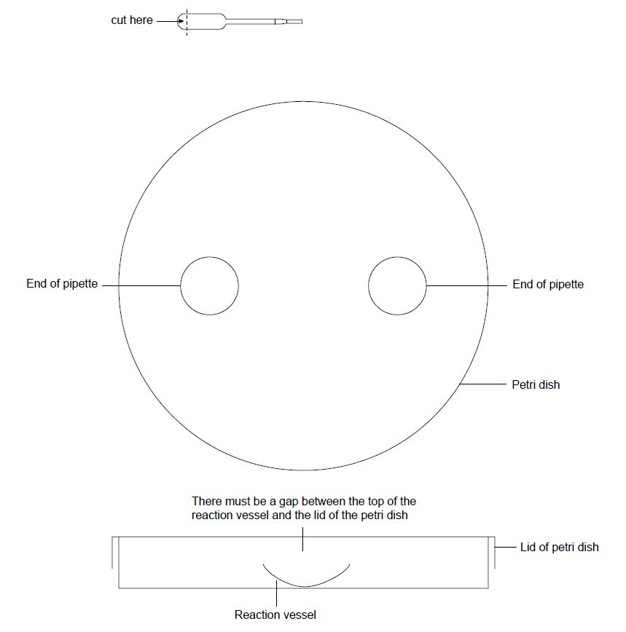

- Cut off the bulb of a plastic pipette as shown below and place it in a beaker.

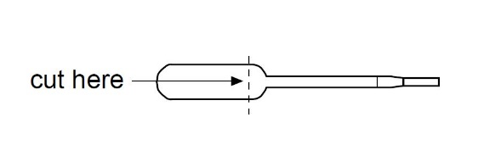

- Carefully add a few crystals of potassium manganate(VII) to the pipette.
- Add propanone to the pipette until it is about half-full.
- Using a pipette, add four drops of the potassium manganate(VII) in propanone solution to one of the pipette ends in the Petri dish.
- Using tweezers carefully place one small lump of calcium carbide into the other pipette end.
- Carefully add four drops of deionised water to the calcium carbide and quickly place the lid on the Petri dish.
- Observe any changes over the next few minutes.
- When no more gas is formed add one drop of full-range indicator solution to the residue of the calcium carbide and observe.

Health, safety and technical notes

- Wear eye protection throughout (splash-resistant goggles to BS EN166 3) and work in a well-ventilated area.
- Propanone is highly FLAMMABLE.
- Calcium carbide, CaC₂ (s), can produce flammable gasses when in contact with water, which may ignite spontaneously. Wear splash-proof goggles and ensure sufficient ventilation.
- Potassium manganate(VII) is an OXIDISER, harmful if swallowed and toxic to aquatic life. Avoid direct contact and store in the dark, stains glass, plastic, clothing and skin.

