Mass changes in chemical reactions – student sheet

In this experiment, you will be doing two chemical reactions to see whether any mass changes occur.

Instructions

Part 1: the reaction between sodium carbonate and calcium nitrate

- Put two plastic pipettes containing the solutions of sodium carbonate and calcium nitrate in the outer two wells of the mini well-plate (see the diagram below).
- Place on a balance and record the mass.
- Put 20 drops of sodium carbonate solution into the middle well followed by 20 drops of calcium nitrate solution.
- Record any changes you see and write an equation for the reaction.
- Reweigh the complete apparatus and record the mass. Is there a difference in the masses before and after the reaction? Explain your answer.

Part 2: the reaction between marble and hydrochloric acid

- Place one piece of marble chip and the pipette containing the hydrochloric acid in two of the wells in the mini well-plate.
- Add ten drops of hydrochloric acid to the well containing the marble chip.
- Record any changes you see and write an equation for the reaction.
- When the reaction has finished reweigh the complete apparatus and record the mass. How do your answers compare with those in part 1? Explain your answers.

Mini well-plate diagram
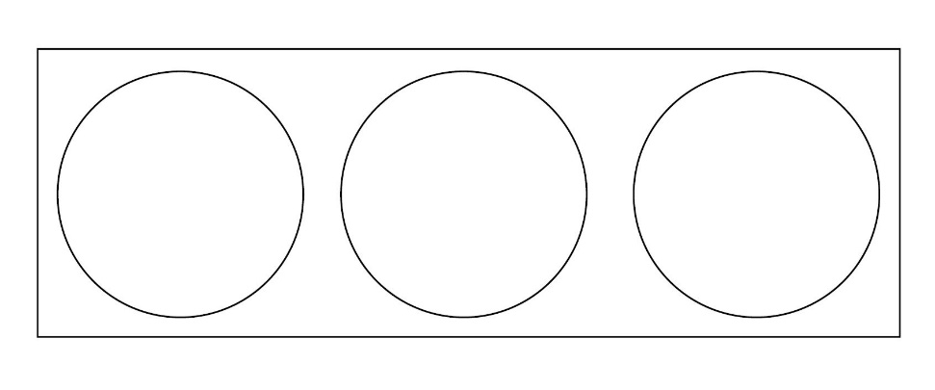

Health, safety and technical notes

- Wear eye protection throughout.
- Cut a three-well plate from the standard 24-well plate using a hacksaw. A class set can be cut from a single well-plate.
- Sodium carbonate, Na₂CO₃.10H₂O, 0.5 mol dm^{–3} is of low hazard at this concentration.
- Calcium nitrate, Ca(NO₃)₂.4H₂O, 0.5 mol dm^{–3} is of low hazard.
- Hydrochloric acid, HCl(aq), 1 mol dm^{–3} is of low hazard.

