Displacement reaction snap
Education in Chemistry
March 2020
rsc.li/2OfpmtQ
Consolidate students’ understanding of the reactivity series with a twist on the familiar card game, snap.

Preparation:
- Print out on card (laminate if you wish) and cut out the individual cards.
- Using a different coloured card for each set will help with clearing up and keeping the packs together.

Play:
- Play in pairs (or threes – one player can be referee).
- Shuffle and deal the cards face down.
- Each player then places a card face up. If they don’t match:
  - Two metals: shout out the most reactive metal.
  - Two compounds: shout out ‘mixture’.
  - Metal and compounds: shout out ‘reaction’ if the metal is more reactive than the metal in the compound. Shout out ‘no reaction’ if the reverse.

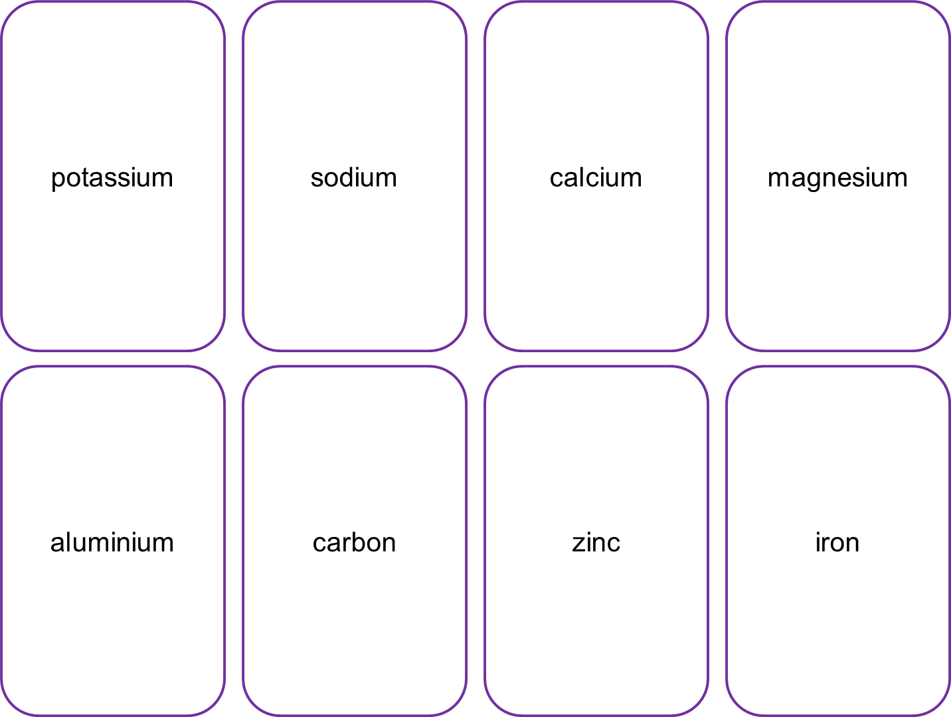
magnesium
iron
