Ionic bonding: knowledge check
- What type of bonding does this diagram represent? Circle the answer.

covalent bonding ionic bonding metallic bonding
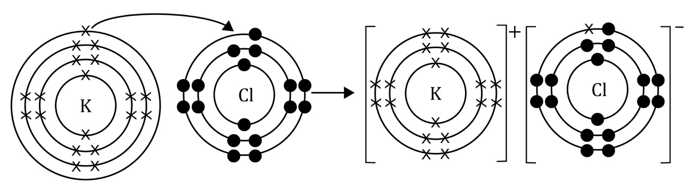
- Use the words to complete the sentences.

attracted electrostatic forces ionic

negatively non-metal transferred

______________________________________ bonding – this bond is formed when electrons are ______________________________________ from a metal to a ______________________________________, forming positively charged and ______________________________________ charged ions. Strong ______________________________________ attract the oppositely charged ions to each other.

Ionic bonding: test myself
- What types of elements are involved in ionic bonding?

Circle the correct answer.

metal and non-metal metals only non-metals only
- Are ionic bonds strong or weak? Use the correct word to complete the sentence.

strong weak

Ionic bonds are ______________________.
- What type of forces hold the particles together in an ionic bond? Use the correct word to complete the sentence.

covalent forces electrostatic forces ionic forces

______________________________________ of attraction hold the particles together in an ionic bond.
- What do the curly arrows represent in the diagram?

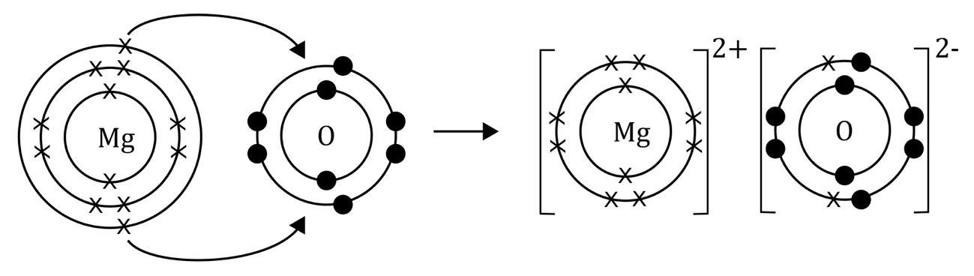

Use the correct word to complete the sentence.

atoms electrons ions shared transferred

The curly arrows represent ______________________ being ______________________ from one atom to another.

Ionic bonding: feeling confident?
- Complete the bonding diagram of the reaction between sodium and fluorine.
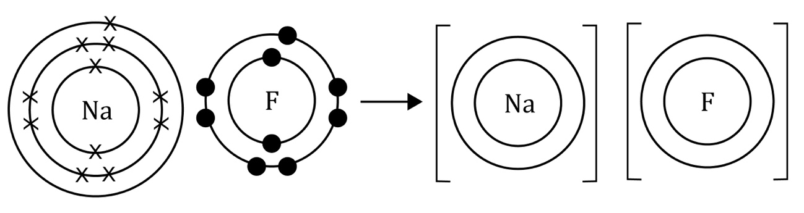

Ionic bonding: what do I understand?

Think about your answers and confidence level for each mini-topic. Decide whether you understand it well, are unsure or need more help. Tick the appropriate column.
Mini-topic | I understand  this well | I think I understand this | I need more  help
I can interpret diagrams representing ionic bonds.
I know that there are ions in ionic bonds.
I know about electrostatic forces in ionic bonds.
I know the types of elements involved in ionic bonds.
Feeling confident? topics | I understand  this well | I think I understand this | I need more  help
I can complete a diagram to represent the formation of an ionic bond.

