- Crude oil is made of many hydrocarbons.

- Complete the sentence:
Hydrocarbons contain two elements only.
They are called hydrogen and carbon.
- Which of these molecules are hydrocarbons?
Tick the boxes.

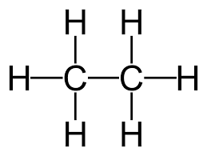 | 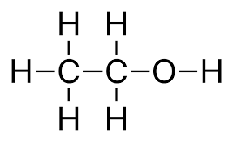 | 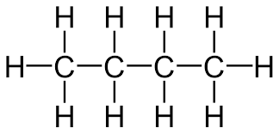
Answer: |  | Answer:

- One family of hydrocarbons found in crude oil is called the alkanes.
Here are the first four members of the alkane homologous series (family):
 | 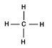 | 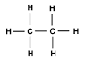 | 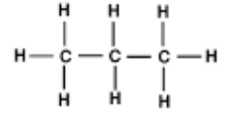 | 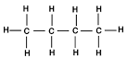
Name | Answer: Methane. | Answer: Ethane. | Answer: Propane. | Answer: Butane.
Molecular formula | Answer: CH_{4.} | Answer: C₂H_{6.} | Answer: C₃H_{8.} | Answer: C₄H_{10.}
- Name each of these alkanes.
Write your answers in the table.
- What is the molecular formula for each of these alkanes.
Write your answers in the table.
- What is the molecular formula of the next alkane in the family?
Answer: C₅H_{12.}

- The alkanes have a general formula.
The letter n is the number of carbon atoms in an alkane molecule.
- How many hydrogen atoms would there be in in alkane?
You may wish to use the information in the table in question 2 to help you.
Answer: (2n + 2) hydrogen atoms.
- Complete the general formula for the alkanes:
General formula for the alkanes = C_{n}H2n+2

- Use the names, formulae or structures to work out which of the molecules are hydrocarbons and which are alkanes.
Place a tick or cross in the box.

 | Hydrocarbon | Alkane
H₂O | Answer: x | Answer: x
C₅H₁₂ | Answer: | Answer:
C₄H₈ | Answer: | Answer: x
C₂H₅OH | Answer: x | Answer: x
Pentane | Answer: | Answer:
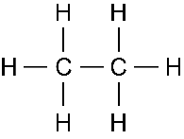 | Answer: | Answer:
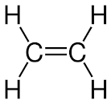 | Answer: | Answer: x
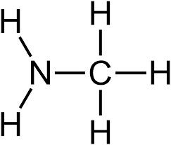 | Answer: x | Answer: x

- Alkanes are saturated hydrocarbons.

- What is meant by saturated?
Answer: A hydrocarbon made of carbon single bonds only.
- Which molecules in the table in question 3 are saturated hydrocarbons?
Answer: Molecules 2, 5 and 6 are saturated hydrocarbons.

