Anti-gravity bottle

Anti-gravity bottle demonstration: A demonstration video can be viewed at
rsc.li/3yVLfDb
The investigation allows learners to explore the concept of air pressure in a similar way to that used in the video.

Age group: 7–9

Learning objectives
- To understand that we notice the force of air when it moves objects, but particles of air are moving all the time and create forces that we usually don’t notice.
- To appreciate that air creates a force and this force acts in all directions, not just ‘downward’ towards Earth.
- To learn that when we consider force of air over a specific area, we call this air pressure.
- To understand that air pressure of a sufficient magnitude acting upwards on an object can overcome the effects of gravity.
Enquiry skills:
- Making predictions, observations and comparisons.

Background science
Learners will have experienced force (push or pull) from the wind (moving air) and may give examples such as trees blowing, kites flying, etc.
Pressure is a measure of the force of the air on a given area. Learners may have experience of pushing into something with their finger compared to using the flat of their hand to make a dent. This shows that a force on a small area creates more pressure than the same force on a larger area.
Learners will have experienced wind but may not have noticed that they are being pushed all the time by the air, because it is pushing all around them and when ‘still’, its forces are balanced.
Learners will have experienced the effects of gravity on objects but may not realise that it is always present. When objects are not falling, it is because an equal force is pushing in the opposite direction. They should be able to describe examples of objects overcoming gravity and travelling upwards through the air (eg insects/ birds/ planes flying, a ball being kicked upwards). In these instances, the force upwards is equal to or greater than the force of gravity pulling downwards.

Prior learning
Learners should be able to articulate that a force is a push or pull which acts on objects. They should also be familiar with gravity being a type of force that pulls objects towards the Earth.
Learners should be aware of what ‘area’ means (a measure of surface covered), particularly in relation to rectangles and squares.

Links
The concept of air pressure is also explored in the other investigations Sticky cups and The leaky bottle.

Key words and definitions
Force – a push, pull, or combination of both which occurs whenever objects (solids, liquids or gases) come into contact with each other. A force can cause an object to speed up, slow down or change direction. Forces which are ‘balanced’ cancel each other out and there is no movement.
Pressure – a measure of a force over a specific area. A force on a large area creates less pressure than the same force on a much smaller area.
Gravity – the force which pulls all objects downwards towards the centre of Earth.
Area – the space occupied by a flat shape or an object’s surface.
Teachers may wish to hide the meanings/examples on the PowerPoint slide and discuss the learner’s ideas first.

Equipment list
- A drinking glass or tumbler – this can be made of a hard plastic but not one which will ‘crush’ in the hand
- A flat piece of card that will fit over, and extend beyond, the opening of the glass
- Water to fill the glass
- A deep sided tray or basin to catch spillages

Method
This experiment is simply an old party trick that learners may have seen before.
Show the video or demonstrate the anti-gravity bottle. Ask why the term ‘anti-gravity bottle’ is used but ensure they don’t think the bottle can float or rise up.
Ask the learners to explain what they think is going on. Discuss, but don’t draw any definitive conclusions.
Tell the class that they are now going to do a similar experiment, but instead of a glass milk bottle (which may be hard to source) and ping-pong balls, they are going to use a glass with water in it and cover the opening with a piece of card.

- Allow the learners to fill about a third of the glass with water.
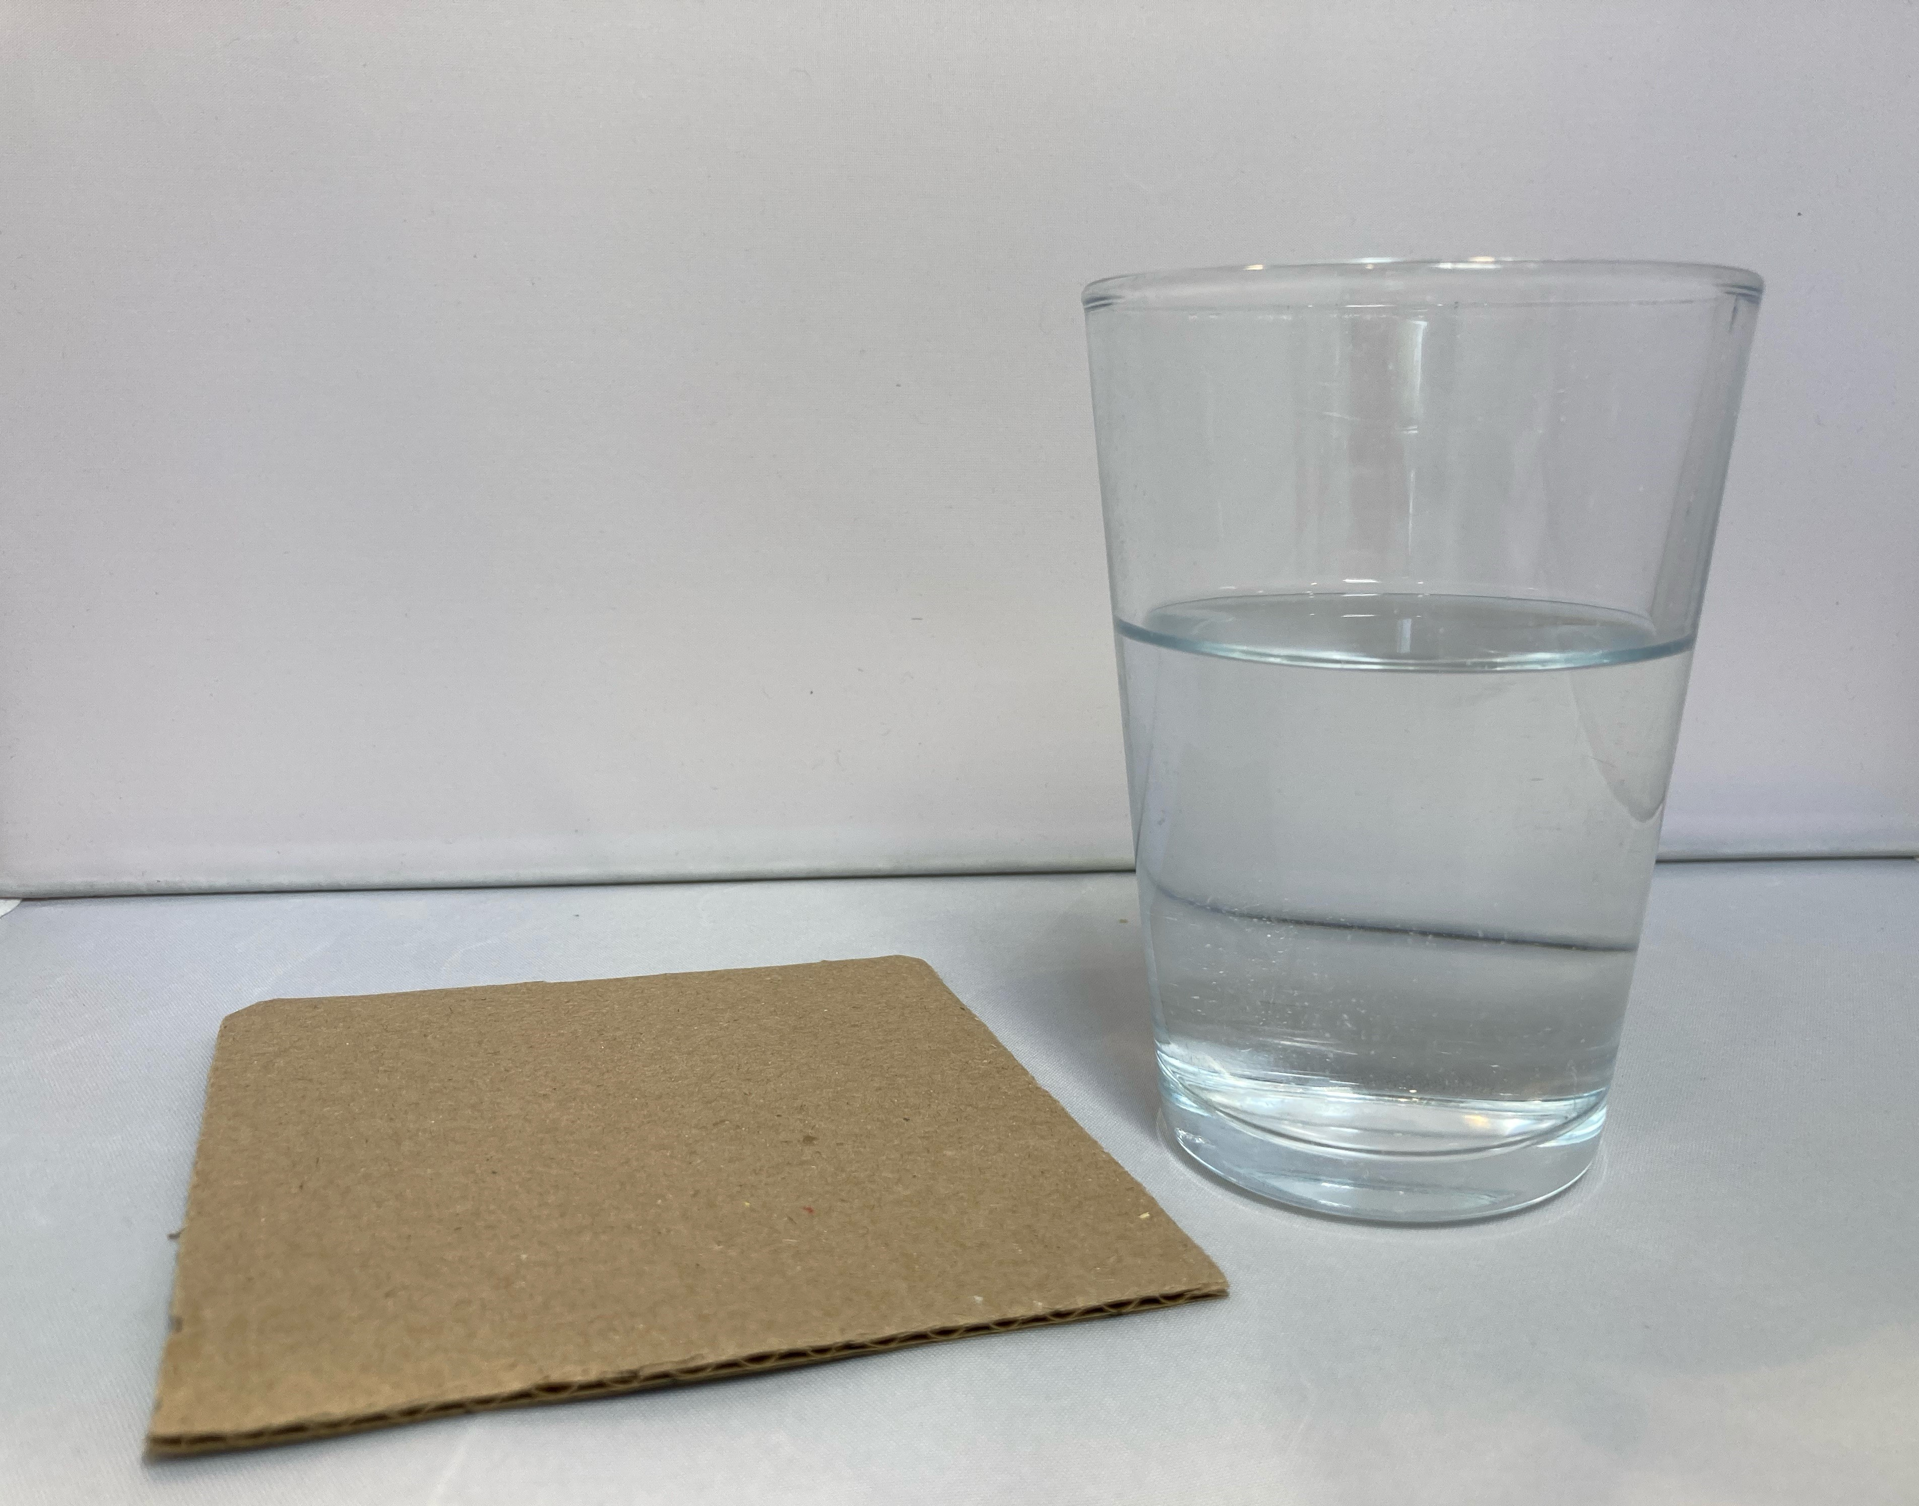
- Place the card over the opening.
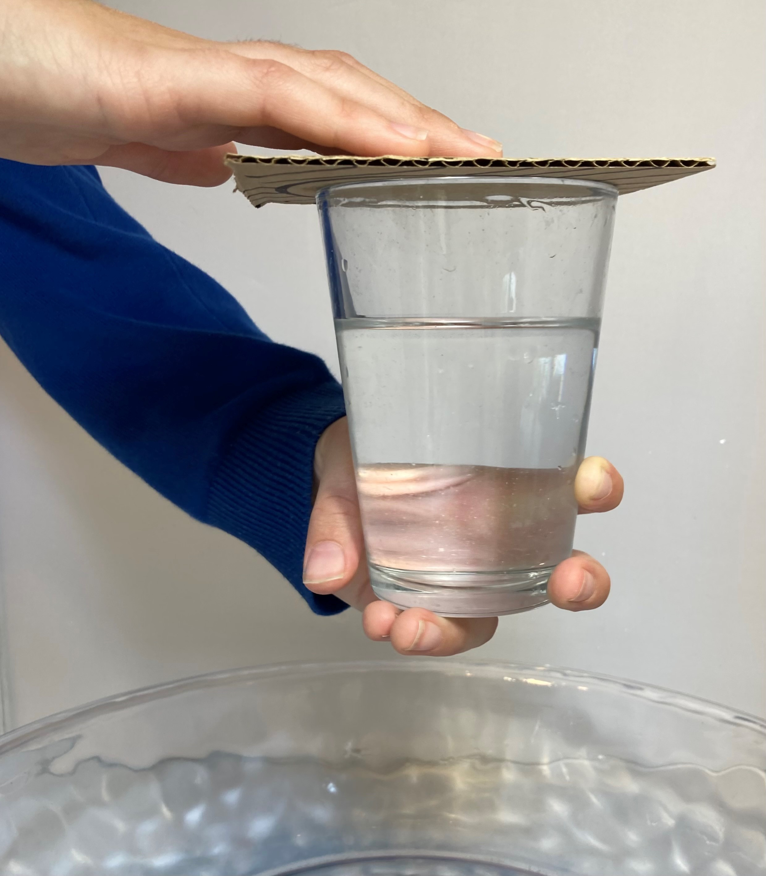
- Now, keeping the palm of one hand on top of the card, invert the glass.
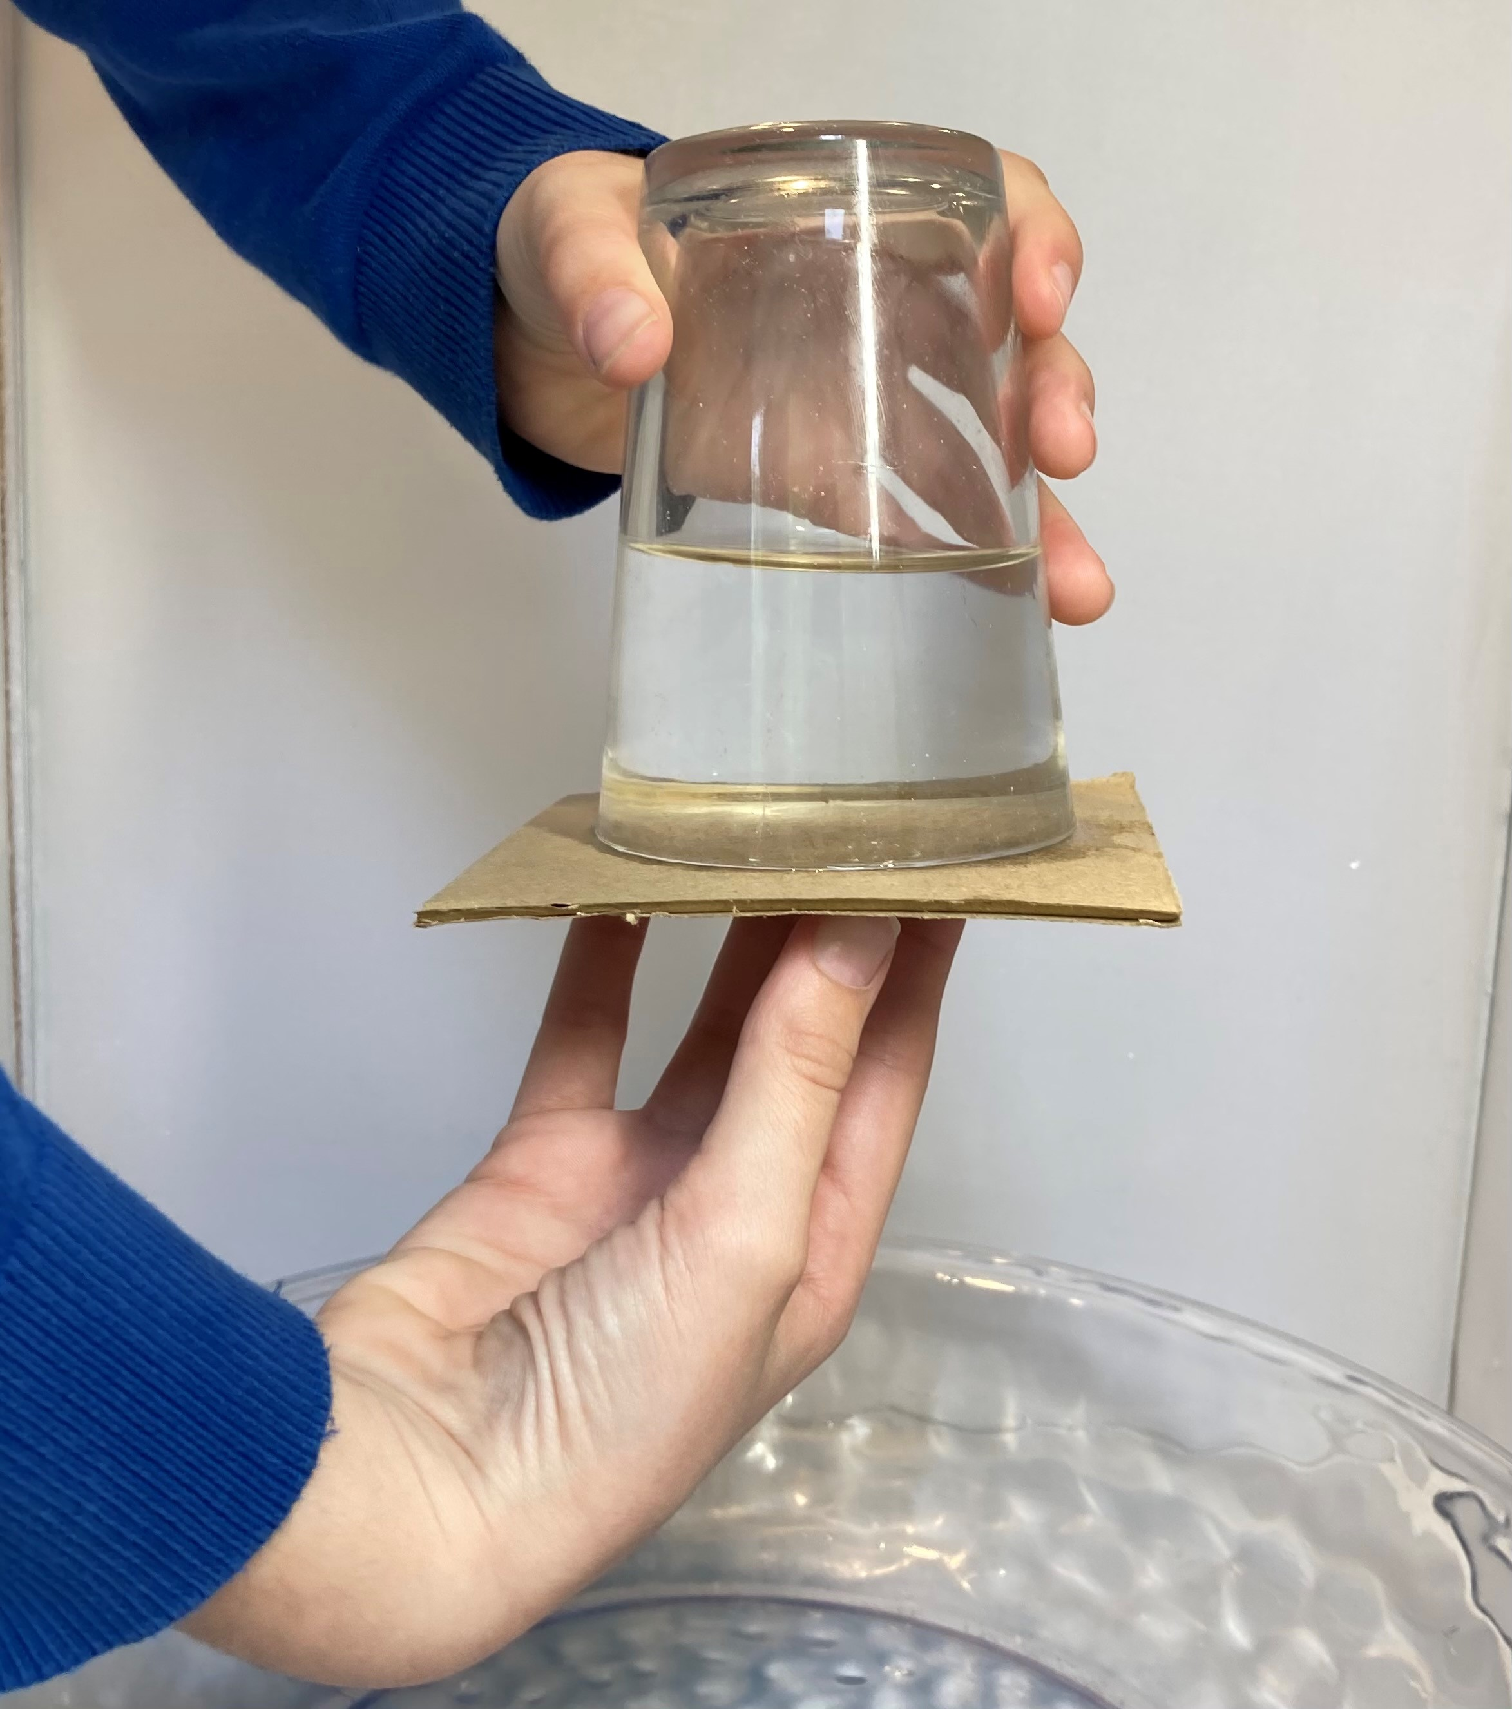
- Remove the hand, and the card should stay in place.
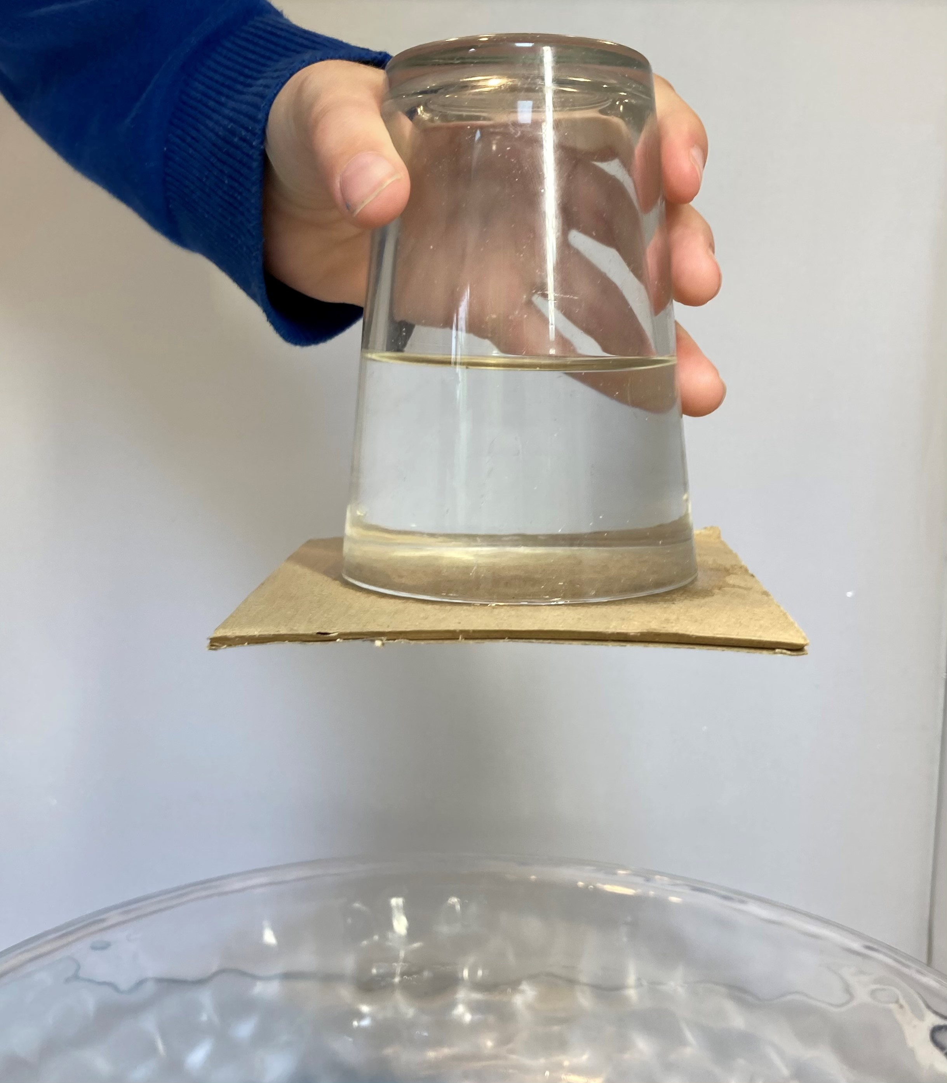
- Ask learners to point out variables that could be changed and allow them to experiment, eg with the quantity of water used and different tumbler sizes. [Make dry card available as it becomes too wet.]
It is natural to assume that gravity and the weight of the water (also a type of force) will be too great for the air pressure acting upwards against the card. However, the pressure from air pushing up is greater than the combined pressure from air and water being pulled downwards by gravity in the glass, and this holds the card in place.

Question prompts
- What do you think will happen when glass is inverted over the card? Why do you think this?
- What forces are acting on the card?
Gravity pulls the air, water and the card down (this is their weight); air pushes up on the card.
- Is there any difference when the glass contains more/less water?
- Why is there a greater air pressure outside the glass than inside?
There is a much greater volume of air, and so pressure, outside the glass.
- Does the size of the card make any difference? Why?
The card needs to be sufficiently large for the air pressure to act upwards against it, but not so large that the air pressure acting downwards pushes it out of the way.
- Would paper work instead of card? Why not?
Too flimsy for the air pressure to act against.

FAQs
- Why doesn’t this work when the card gets soaked?
As the card becomes sodden the fibres in the card expand and the card increases in weight. This is enough to overcome the upward force from the air.
- If I use a bigger piece of card, will it hold better?
Have the learner draw around the top edge of the glass onto the card. Examine and compare the surface area open to the air on the underside of the card with the upper side which is mostly covered with the glass.
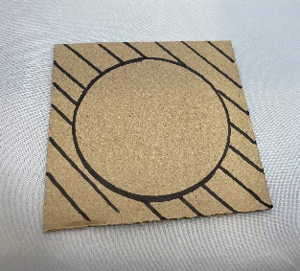
- If I gently flick the top of the card it falls off. Why?
Flicking the card is adding an extra downward force – enough to exceed the air pressure acting upwards. For the same reason, you must use a rigid glass, as the squeeze of your hand may be enough to increase the downward pressure.

All images © Royal Society of Chemistry

